Introduction: Worksheet 1 Answers

Matching hazard symbols
Write the name of each hazard next to its symbol.
Hazard | Symbol
Health hazard/ Hazardous to the ozone layer | 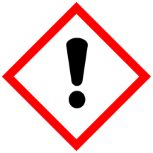
Hazardous to the environment | 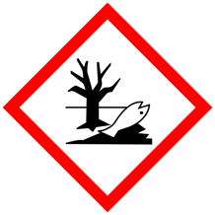
Explosive | 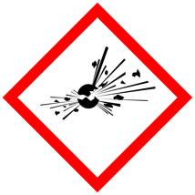
Flammable | 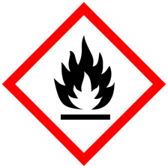
Oxidising | 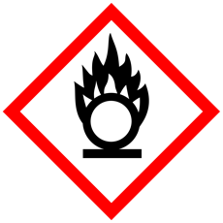
Serious health hazard | 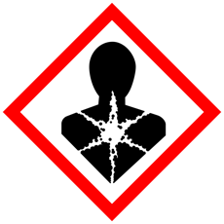
Hazard symbols are available at https://www.hse.gov.uk/chemical-classification/labelling-packaging/hazard-symbols-hazard-pictograms.htm
Contains public sector information published by the Health and Safety Executive and licensed under the https://www.nationalarchives.gov.uk/doc/open-government-licence/version/3/

Hazard | Symbol
Corrosive | 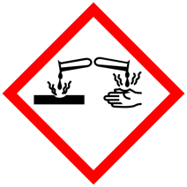
Acute toxicity | 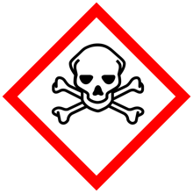
Gas under pressure | 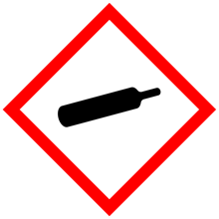

Hazard symbols are available at https://www.hse.gov.uk/chemical-classification/labelling-packaging/hazard-symbols-hazard-pictograms.htm
Contains public sector information published by the Health and Safety Executive and licensed under the https://www.nationalarchives.gov.uk/doc/open-government-licence/version/3/

