Traceroute

The **Traceroute** command (tracert) is a utility designed for displaying the time it takes for a packet of information to travel between a local computer and a destination IP address or domain.

Traceroute for Windows

If you are using Windows, follow the steps below to run Traceroute:

1. Press the Windows key
2. Type **Command Prompt**,and press Enter to launch
3. Type tracert raspberrypi.org

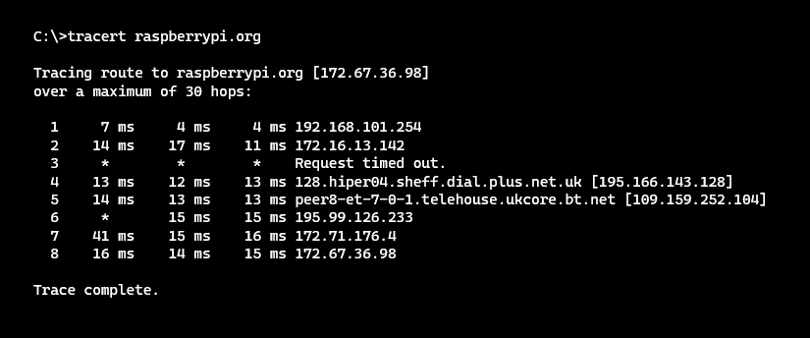

You should see a list of ‘hops’ that the data packets take along their path to the domain.

Traceroute for macOS

If you are using macOS, follow the steps below to run Traceroute:

1. Open the **Applications** folder
2. Open the **Utilities** folder
3. Open the **Terminal** app
4. Type traceroute raspberrypi.org



|  |
| --- |
| example-computer ~ % traceroute raspberrypi.org  traceroute: Warning: raspberrypi.org has multiple addresses; using 172.67.36.98  traceroute to raspberrypi.org (172.67.36.98), 64 hops max, 52 byte packets  1 192.168.1.254 (192.168.1.254) 7.951 ms 5.936 ms 3.594 ms  2 * * *  3 * * *  4 62.172.102.68 (62.172.102.68) 15.076 ms 14.360 ms  62.172.102.78 (62.172.102.78) 13.440 ms  5 peer8-et4-1-6.telehouse.ukcore.bt.net (62.172.103.195) 14.844 ms  peer8-et3-0-6.telehouse.ukcore.bt.net (62.172.103.133) 14.217 ms  peer7-et4-0-7.telehouse.ukcore.bt.net (62.172.102.29) 25.619 ms  6 195.99.126.233 (195.99.126.233) 16.952 ms *  109.159.253.95 (109.159.253.95) 24.501 ms  7 172.70.160.4 (172.70.160.4) 12.844 ms  172.71.176.4 (172.71.176.4) 15.694 ms 13.883 ms  8 172.67.36.98 (172.67.36.98) 13.849 ms 14.313 ms 14.999 ms |

Tasks:

Use the instructions provided to trace some domain names and record the number of hops:

|  |  |  |
| --- | --- | --- |
| **Domain** | **Destination IP** | **No. of hops** |
| raspberrypi.org | 172.67.36.98 |  |
|  |  |  |
|  |  |  |
|  |  |  |

Explorer task .

IP addresses are assigned to each device connected to a network.

Most IP addresses are allocated **dynamically**, using DHCP (Dynamic Host Configuration Protocol). DHCP will assign an IP address to a device when it joins the network for a set period of time (typically 24 hours). When the time period ends, the device must ask for the address to be renewed. Otherwise the address is freed up and can be allocated to another device.

Some devices are given **static** IP addresses. This means that a specific address is allocated and will remain with the device until it is reconfigured or the device is removed from the network.

Use an internet search to find an example of when a **static IP address** might be required. Write your findings below.

|  |
| --- |
|  |