
Processor components
To help you remember how the processor works, you can use this activity sheet to capture your notes.

Arithmetic logic unit  Performs calculations and logical operations such as checking if two values are the same. | 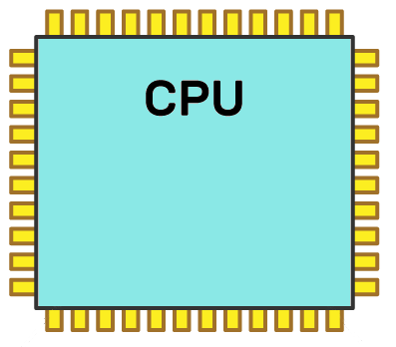  ALU  Control Unit  Clock  Registers  Bus  Bus  Bus  Bus | Clock  Sends pulses to regulate the processing cycle.
Buses

Wires connecting components.
Control unit  Runs the show – tells other components what to do. |  | Registers  Fast access memory locations.



A games developer has been to see their manager to report issues with their laptop. The games developer explains that it is taking twice as long to build each section of code as it has done in the past. The games developer has a reliable and fast internet connection, so this is not the reason for the issue. Explore the possible reasons why the games developer may be experiencing issues with build time.

The games developer may be using an older laptop. Computer technology changes so rapidly that computers can quickly become obsolete. Processor speed and memory size have approximately doubled every one to two years over the past 50 years, meaning that older devices perform much slower than newer devices. Newer releases of software are also often designed for higher-specification computer systems, meaning that running them on lower-performance devices can cause issues. Many organisations adopt a 3-year replacement policy to ensure that productivity does not drop due to issues with device and processor performance.

