Autodesk® Revit support instructions
- If you have less experience using Autodesk® Revit, use this document to support understanding of the steps involved.
- It is not designed to be used as a general class tool, but as support for your teaching.
- If a student has missed teaching on the basics of Autodesk® Revit, they could access this tool to help them to catch up.
- The main teaching slides assume that teachers have prior experience of drawing using Autodesk® Revit for traditional construction.

Activity guide
Activity 2  RESOURCES:  - L6, 7 & 8 Slide deck – slides 5–6  - L6, 7 & 8 Autodesk® Revit support instruction sheet – pages 2–25 | - Start by opening a new project in Autodesk® Revit, using an architectural template.  - Using the dimensions and materials from your research, create a new wall type –- starting with duplicating the nearest wall type in the properties list.  - Edit the structure of the wall to specify the materials and thickness of the wall components. Using the wall type you have created, draw a plan of a building module to suitable dimensions from your module research.  - Next using the Elevation view from the Project Browser adjust the level to the module height from your research.  - You can now “copy” your module on plan to create your house shape. (You will need to delete repeated walls.) You can also copy vertically using the Elevation view. Check the overall look in 3D view.
Activity 3  RESOURCES:  - L6, 7 & 8 Slide deck – slide 7  - L6, 7 & 8 Autodesk® Revit support instruction sheet – pages 26–55 | - Add floors, doors, windows, stairs and furnishings.  - Add bathroom and kitchen fittings via Architecture – Components – Edit family – Plumbing – Fixtures then WC, sink and shower (using Architecture – Components for each new fitting).  - Add stairs, making sure there is correct access and egress.  - Position First Floor around stairs.  - Use the same wall type to divide rooms in modules.  - Add a roof (draw on Level 1 but change base level to Level 2) – apply an overhang of 200 mm.
Activity 4  RESOURCES:  - L6, 7 & 8 Slide deck – slides 8 – 9  - L6, 7 & 8 Autodesk® Revit support instruction sheet – page 56–77 | - Printing – Floor Plans and 3D Front and Side, 3D Back and Side.

Activity 2: Designing a modular house using Autodesk® Revit
The following instructions correspond to Activity 2, with instructions on Slide 5 of Lesson 6, 7 & 8 slide deck.
Start by opening a new project in Models using an architectural template: Models – New – Template – Architectural Template – click ‘OK’.
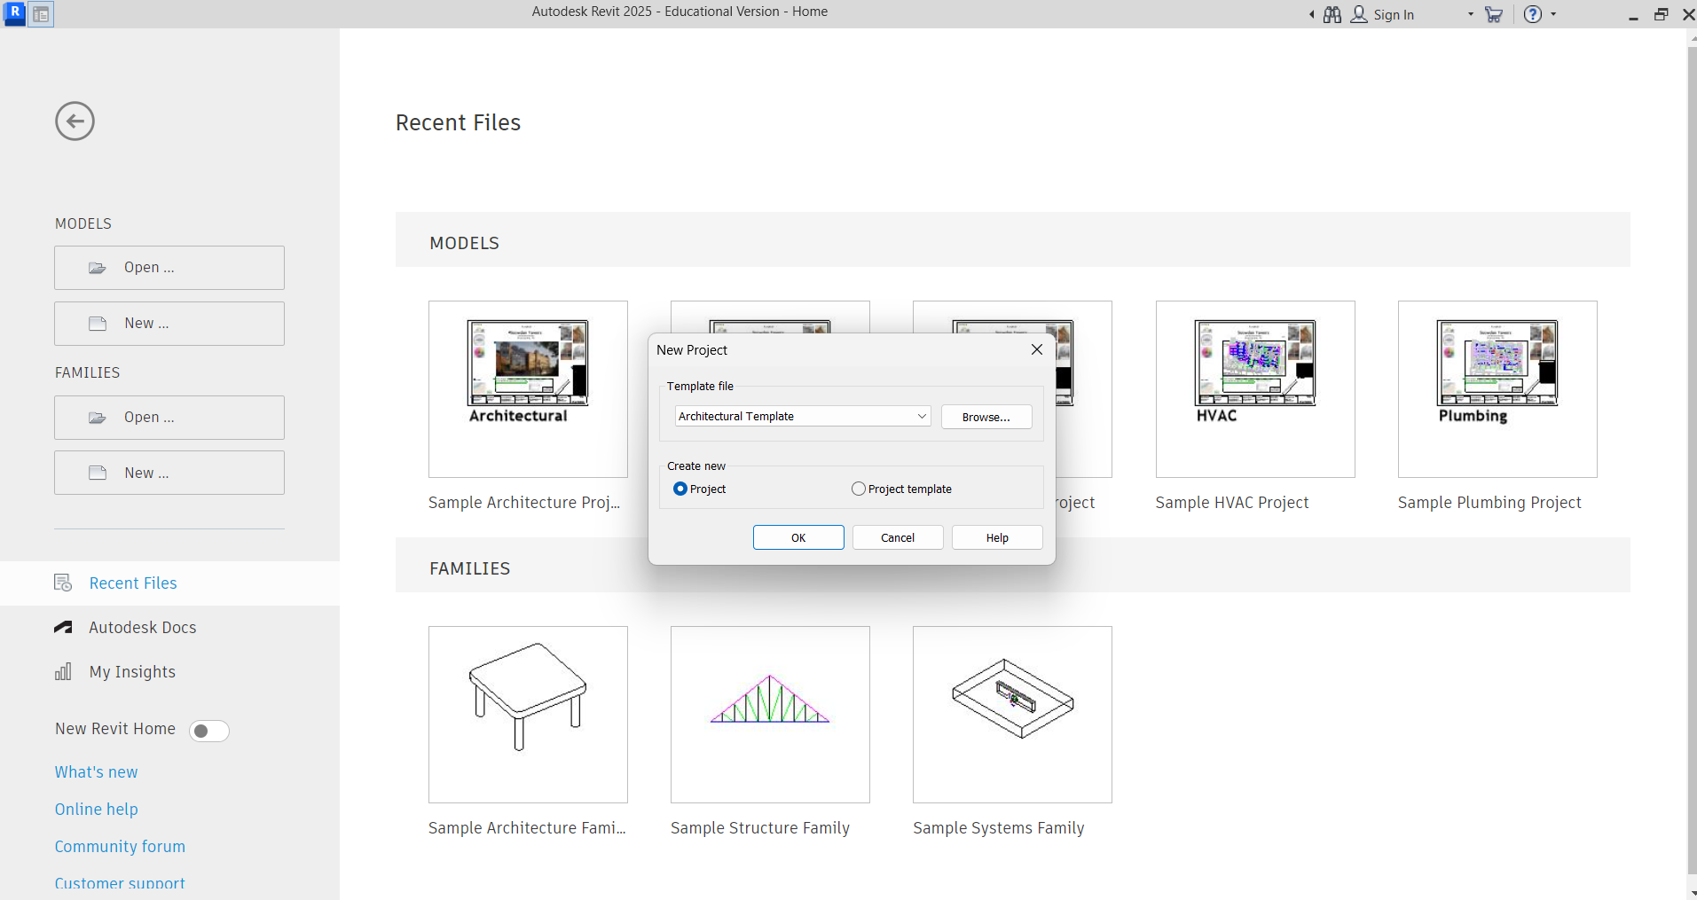
Save the project to your user area at this point, otherwise the project will save to the computer.
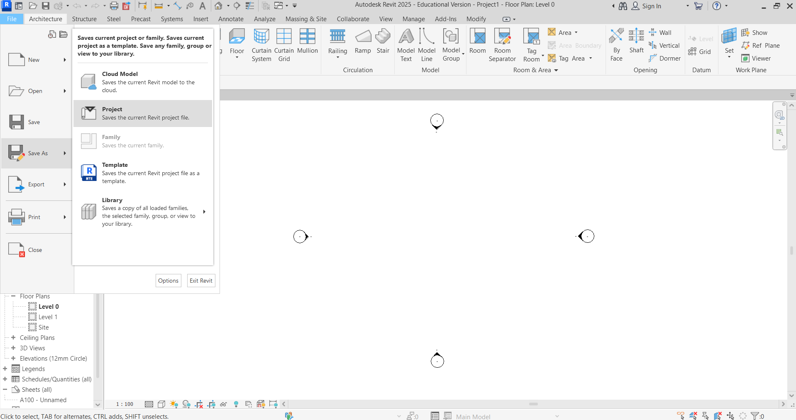

Introduction to the drawing screen
Note: Properties and Project Browser panels should always show. If one disappears, then click on View (top grey panel) – User Interface – Properties/Project Browser.
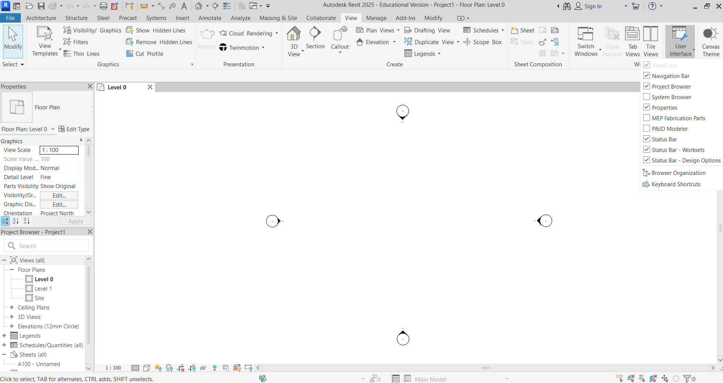
The drawing space in the centre is set to Level 0 (ground level). We draw between the North, South, East, and West indicators so that elevations show clearly.
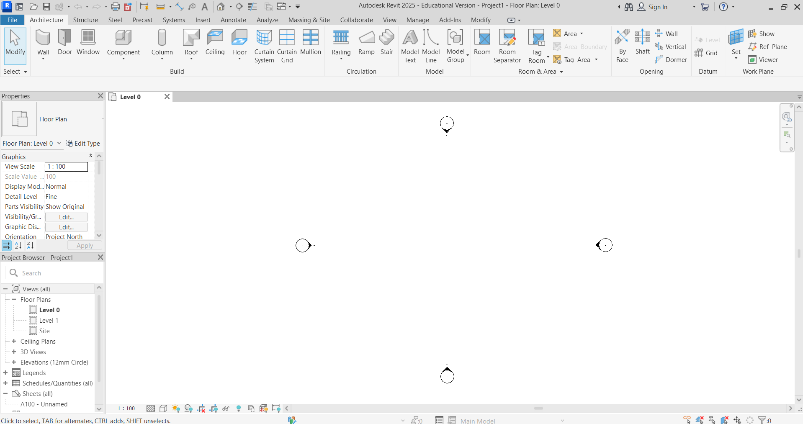
We draw in the Architecture tab to select Wall/Door/Window components here.
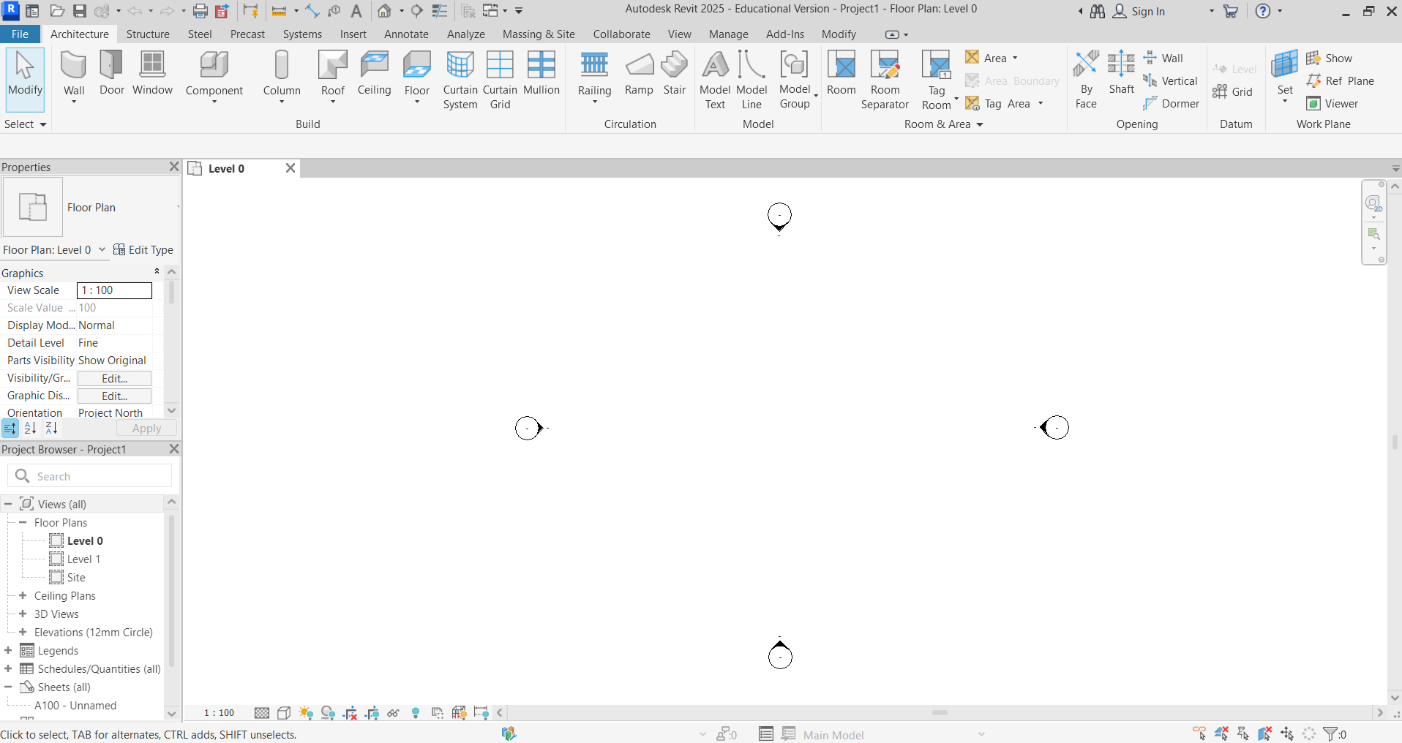

Using the dimensions and materials from your research create a new wall type – start by duplicating the nearest wall type in the properties list. Click Wall and select Wall: Architectural.
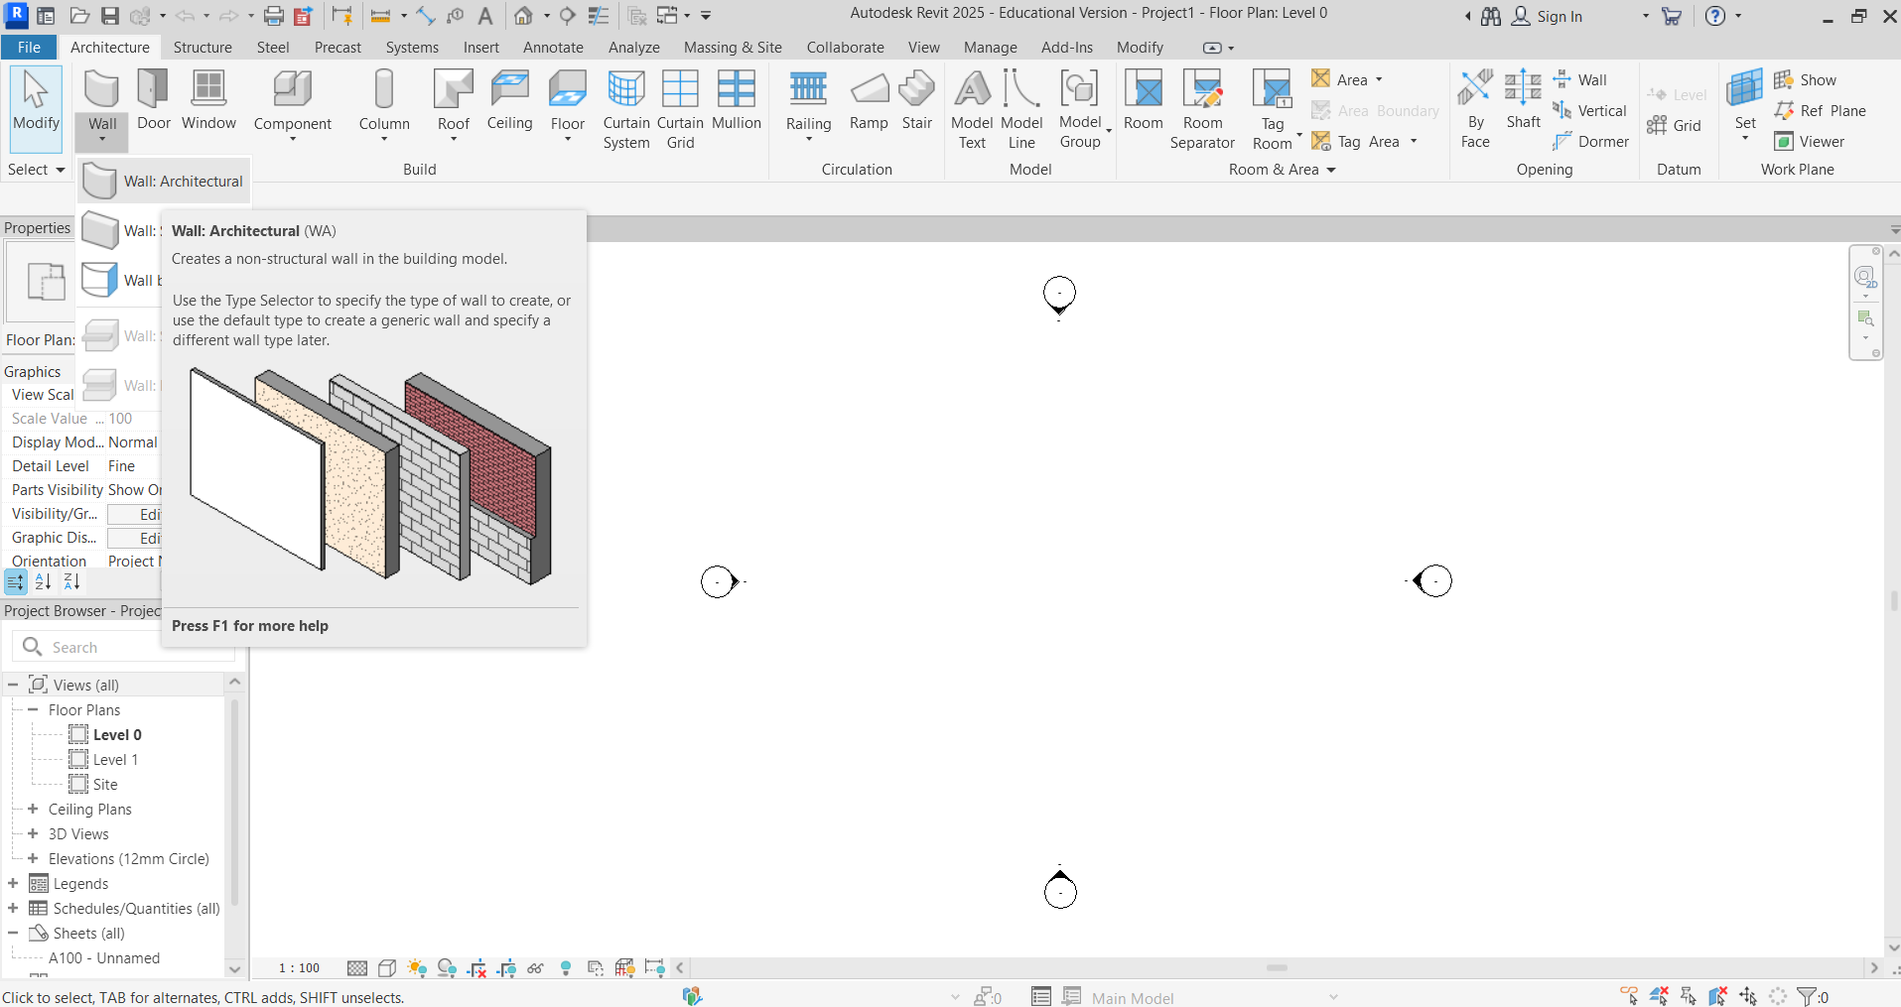
From the list of wall types, select the nearest wall to the wall type from your research (in the dropdown menu).
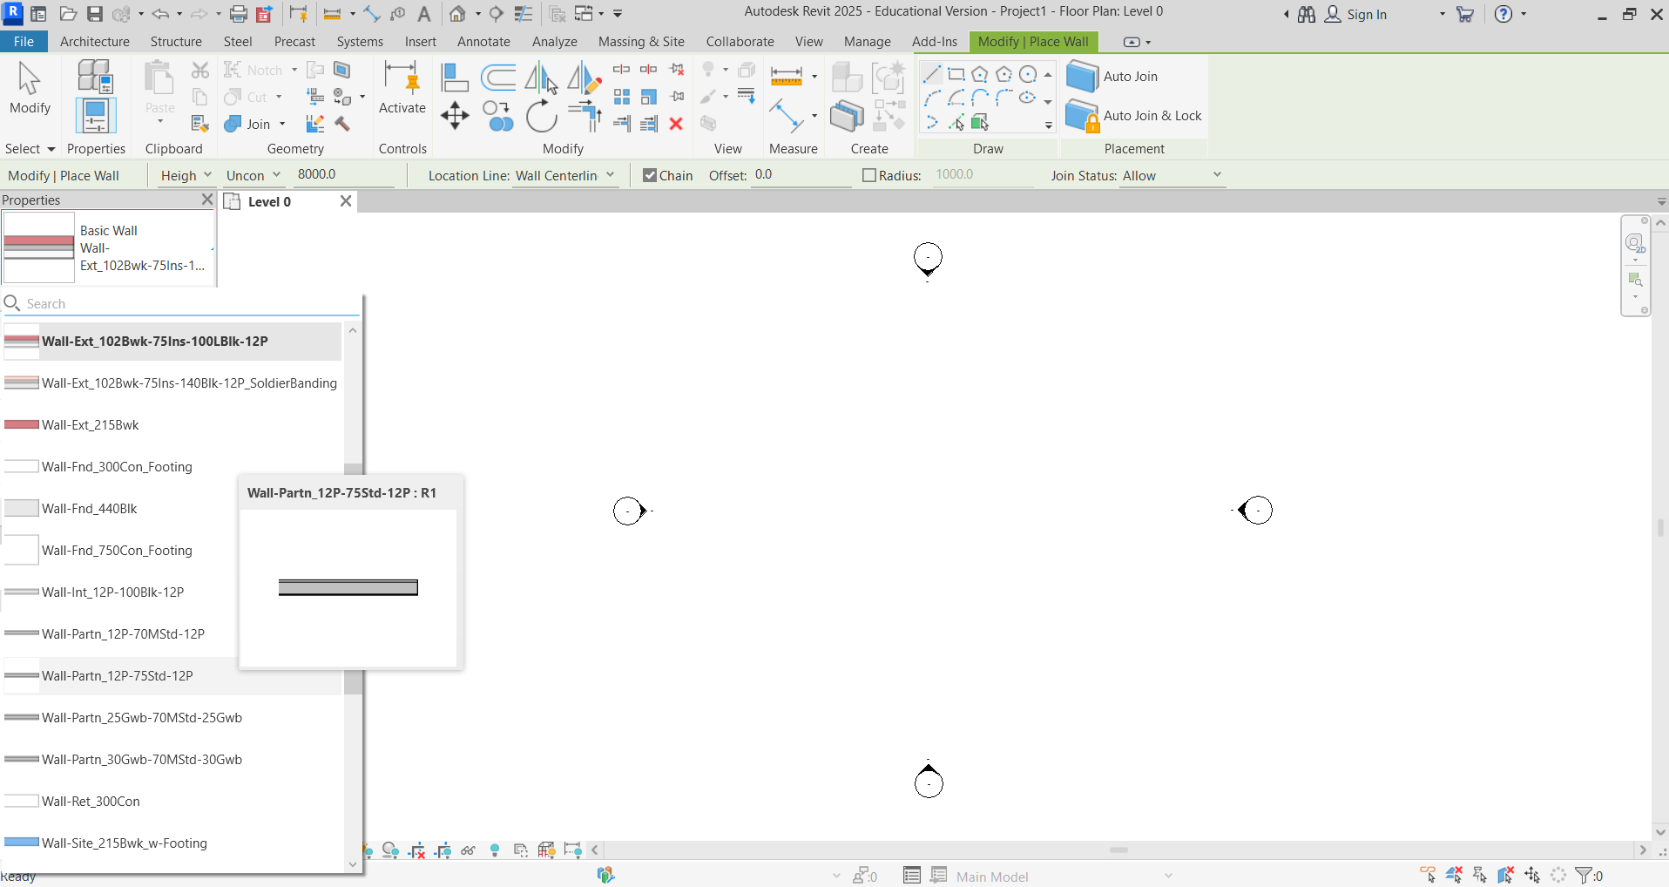

Click Edit Type and the Type Properties box will appear. Click Duplicate.
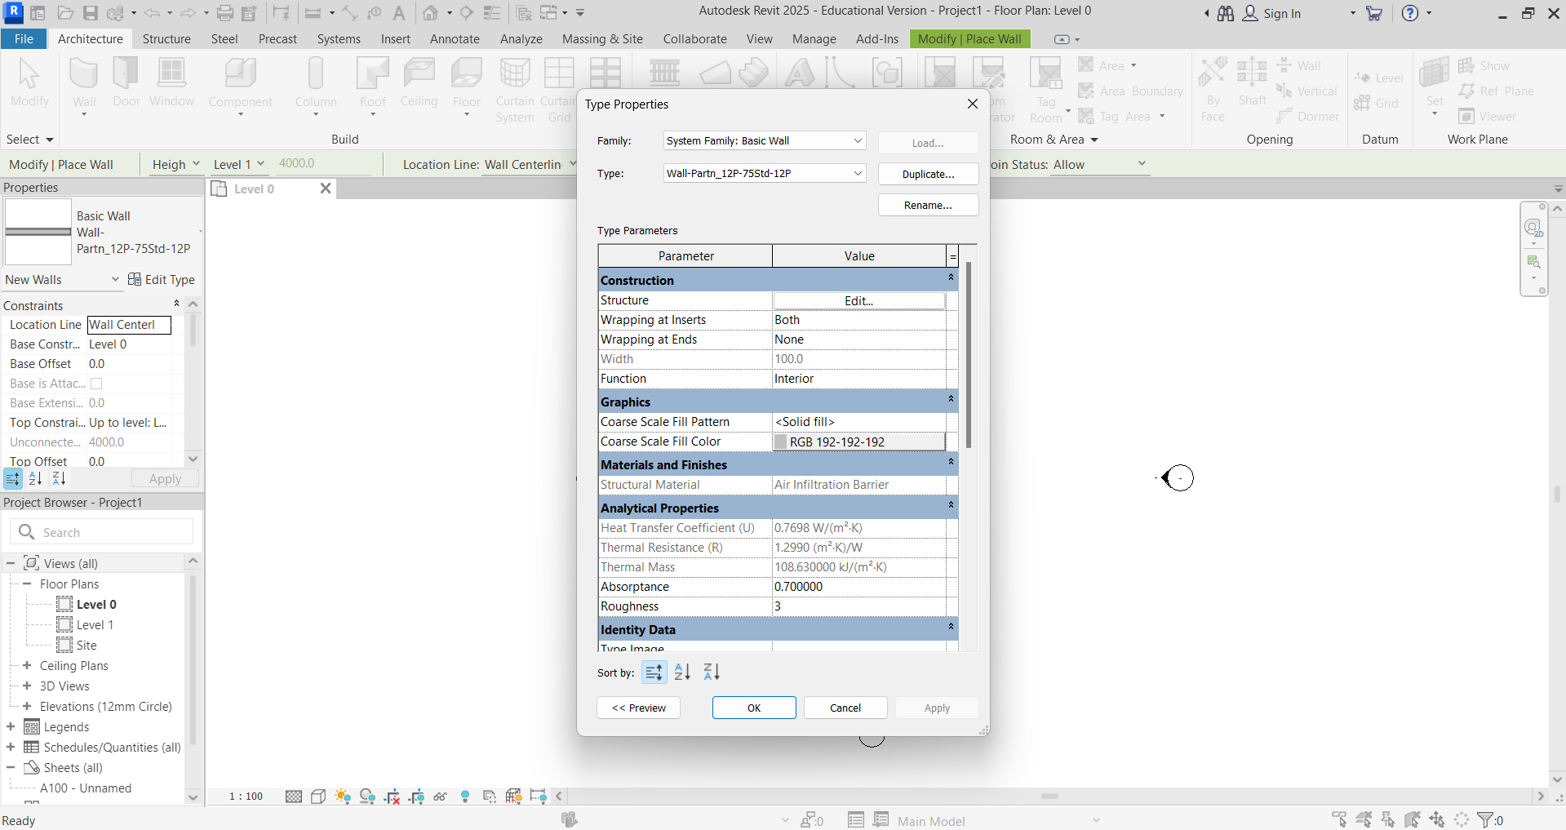

Create a new wall type and give it a name.
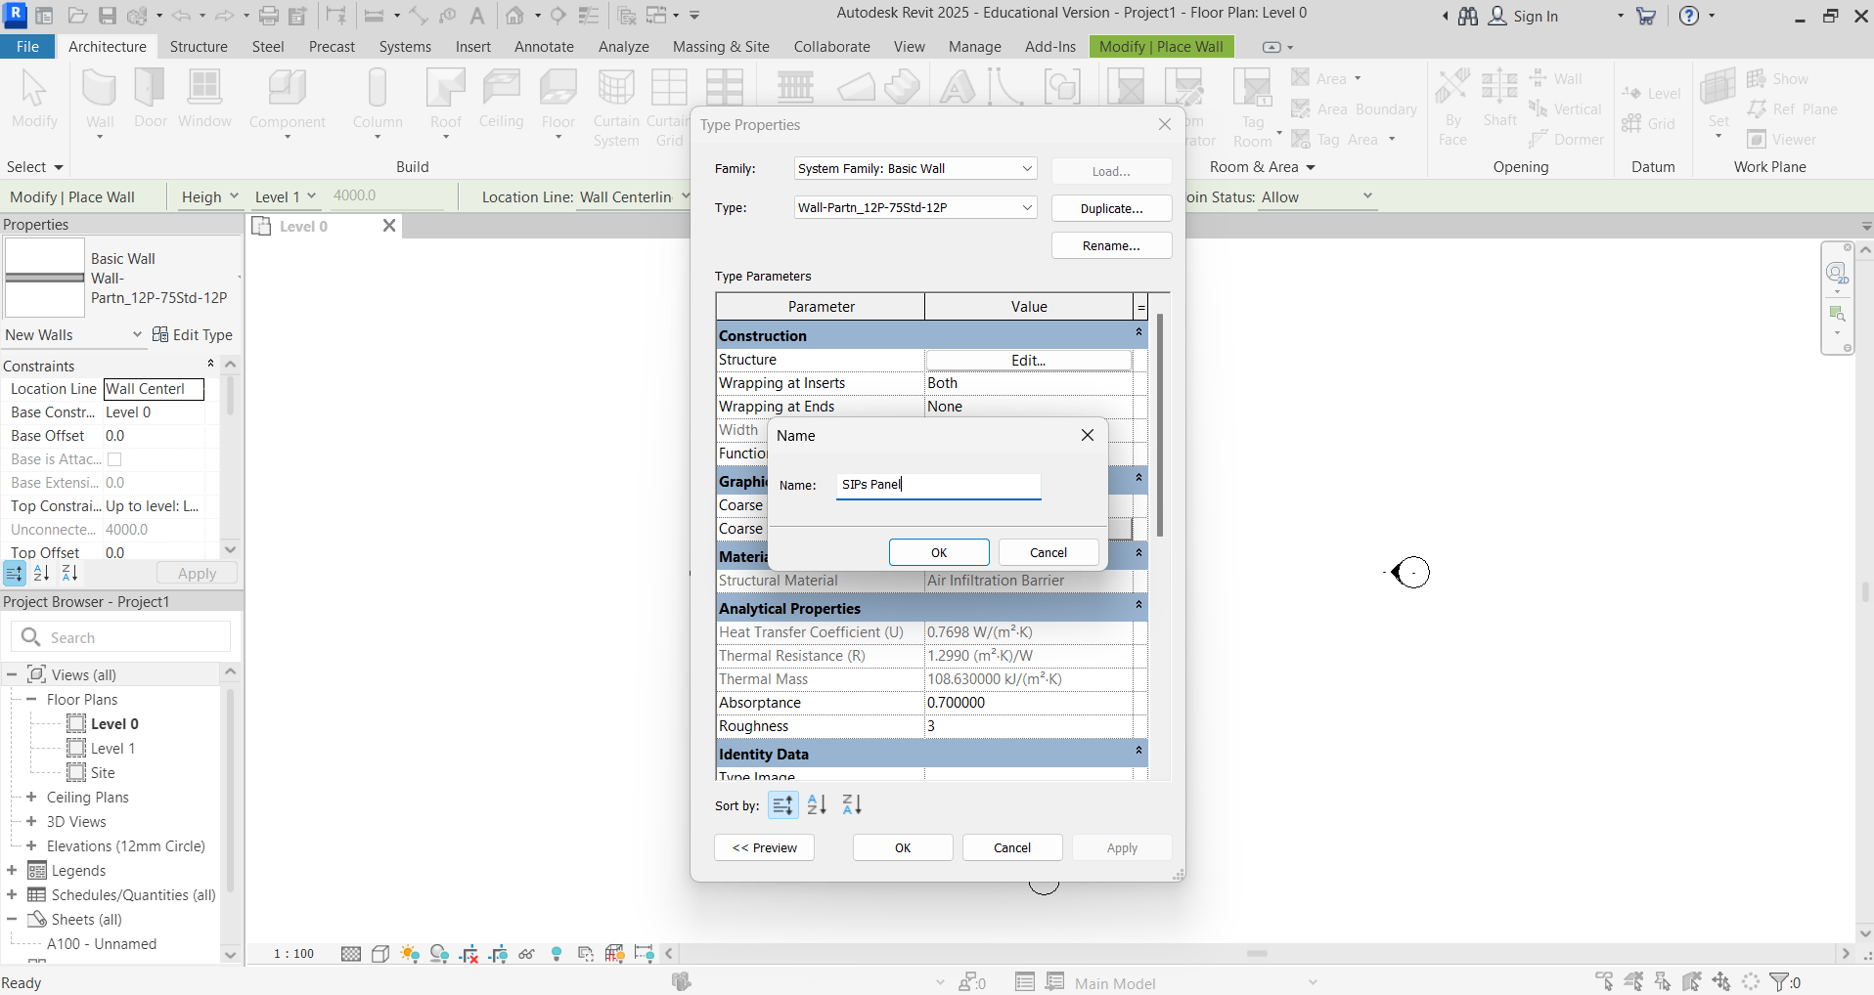
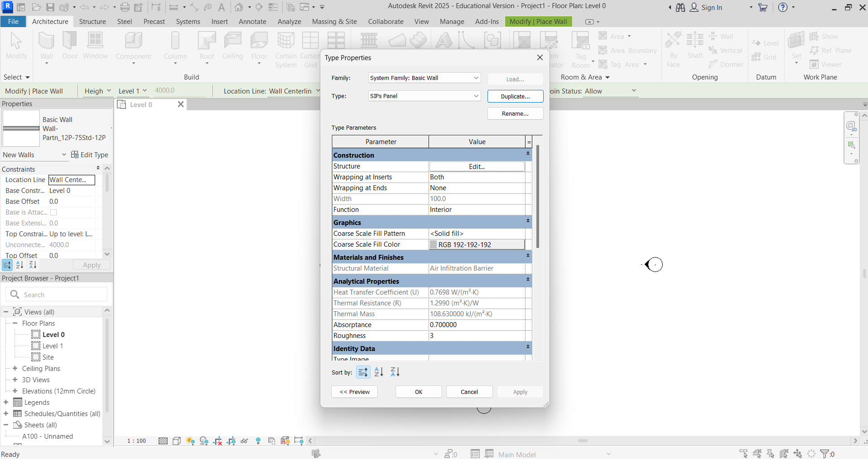
Edit the structure to match the materials and dimensions to the structured insulated panel (SIPs) from your research. Click Edit in the structure row and the Edit Assembly box will appear.
Change materials and dimensions, inserting new layers as required.
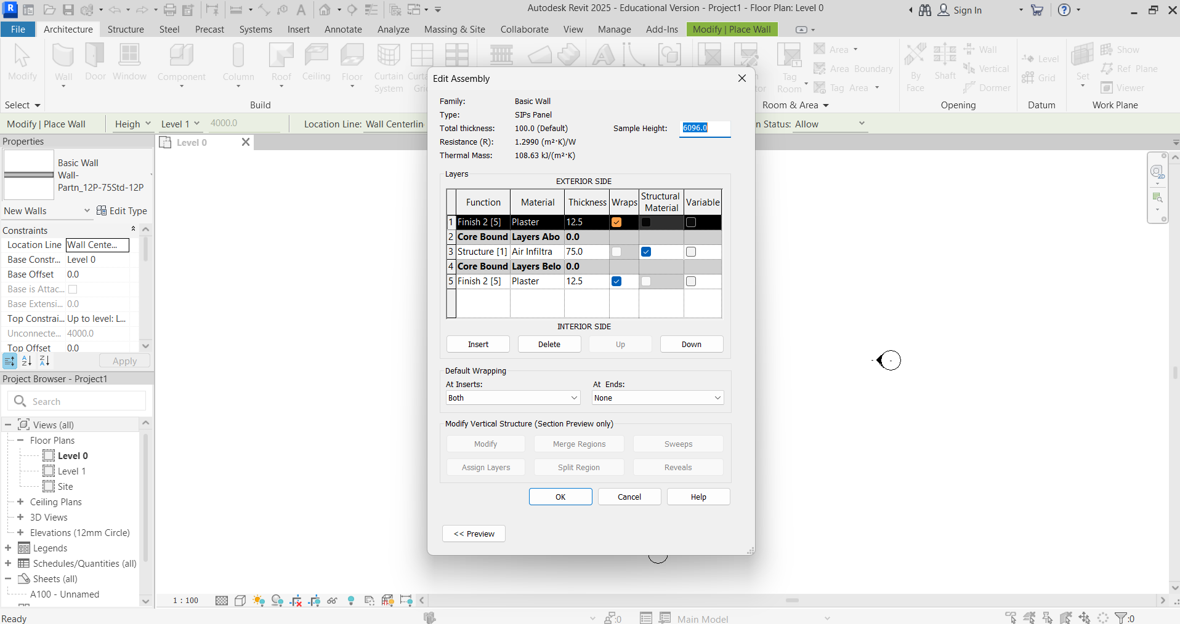

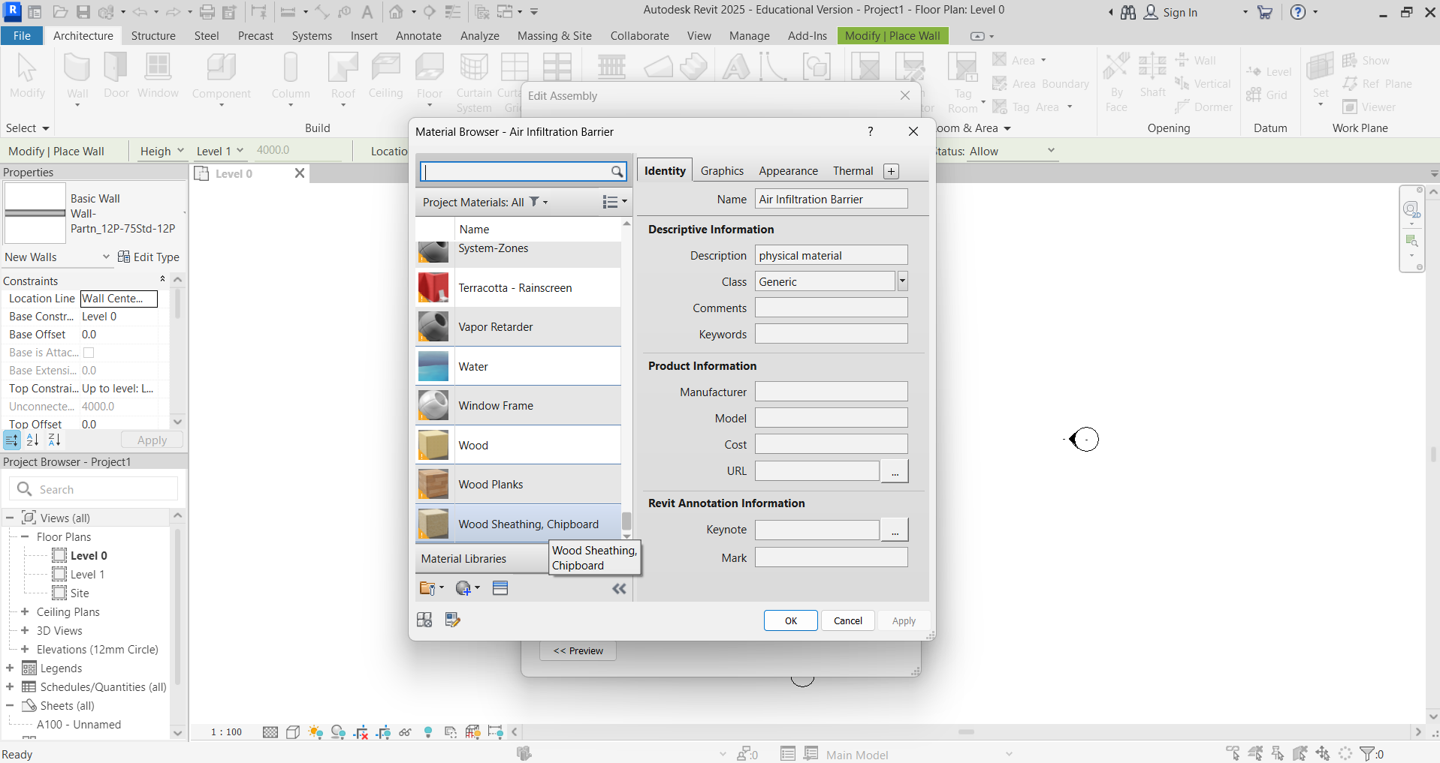
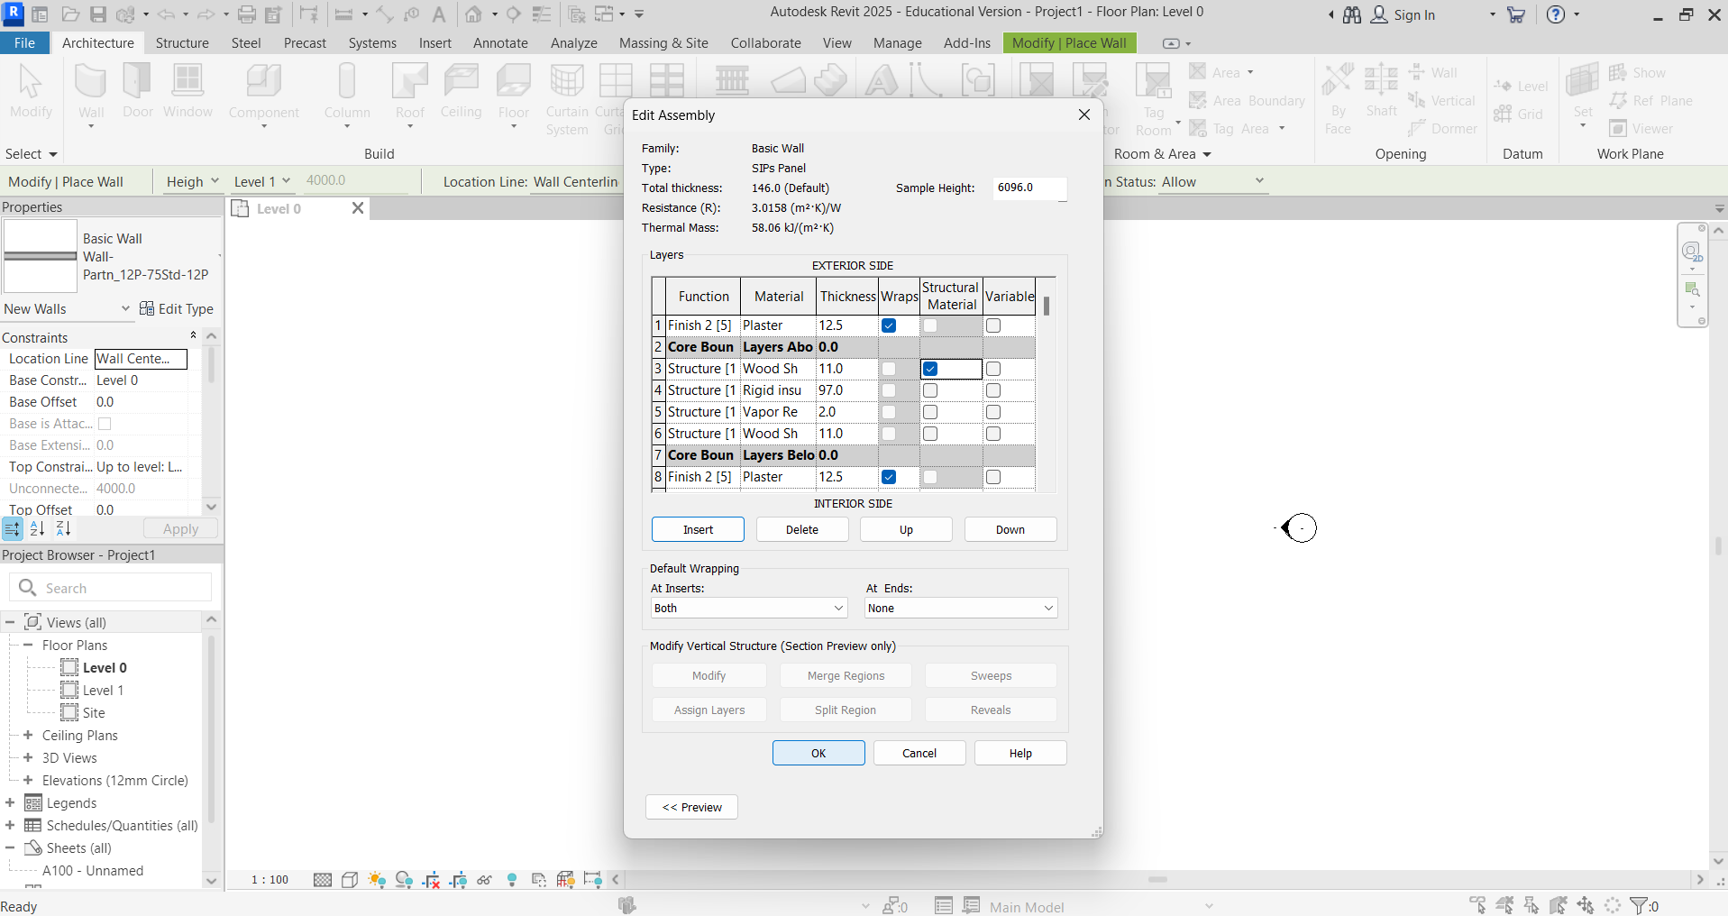
Using the wall type you have created, draw the plan of a building module to suitable dimensions from your module research. Change the Location Line to Finish Face: Exterior to ensure that the external dimensions are correct.
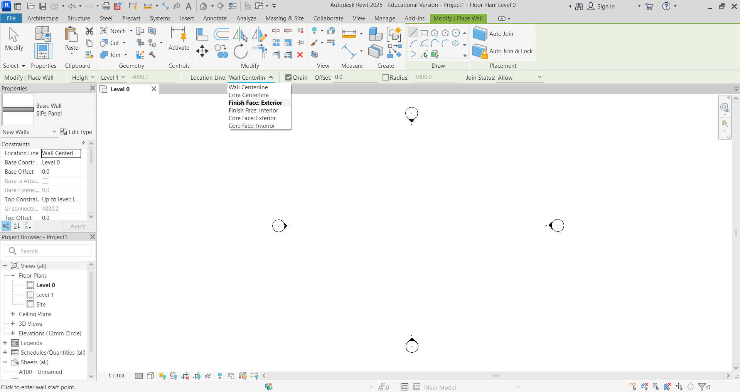

Draw the four walls using the following dimensions – 6 m x 3 m.
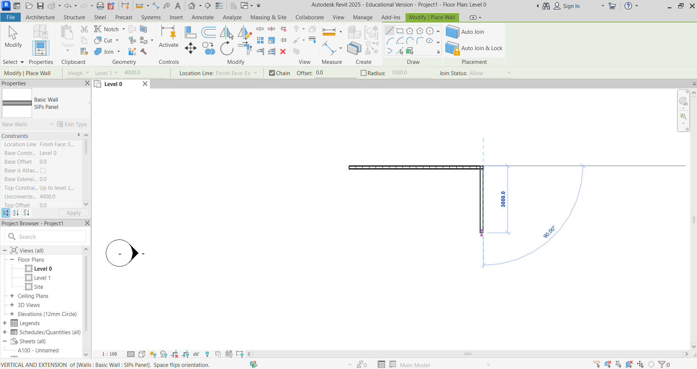
Next, using the Elevation view from the Project Browser, adjust the level to the module height from your research. Select Elevations, then East.
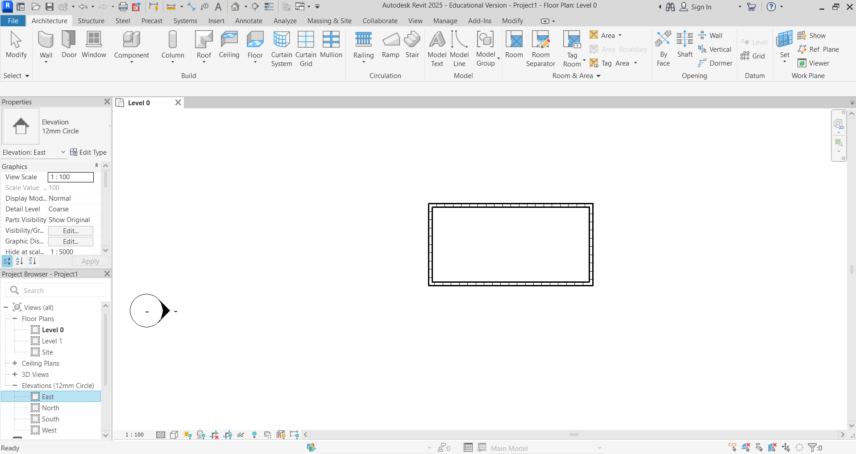

Activate Level 1 by clicking on 4000.
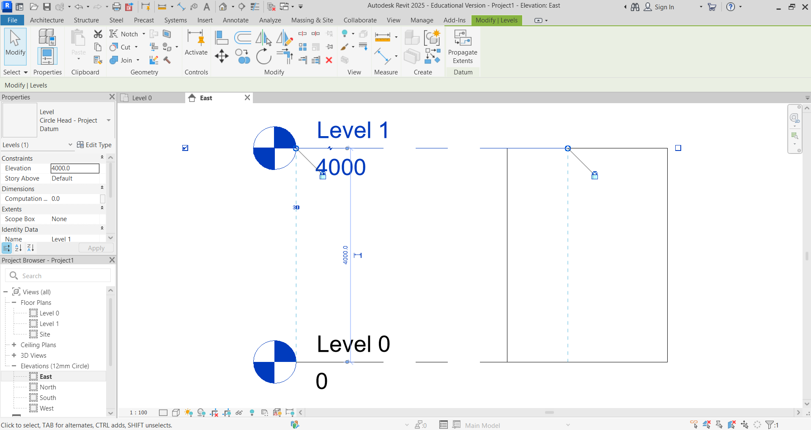

Change 4000 height to 2800, as per research.
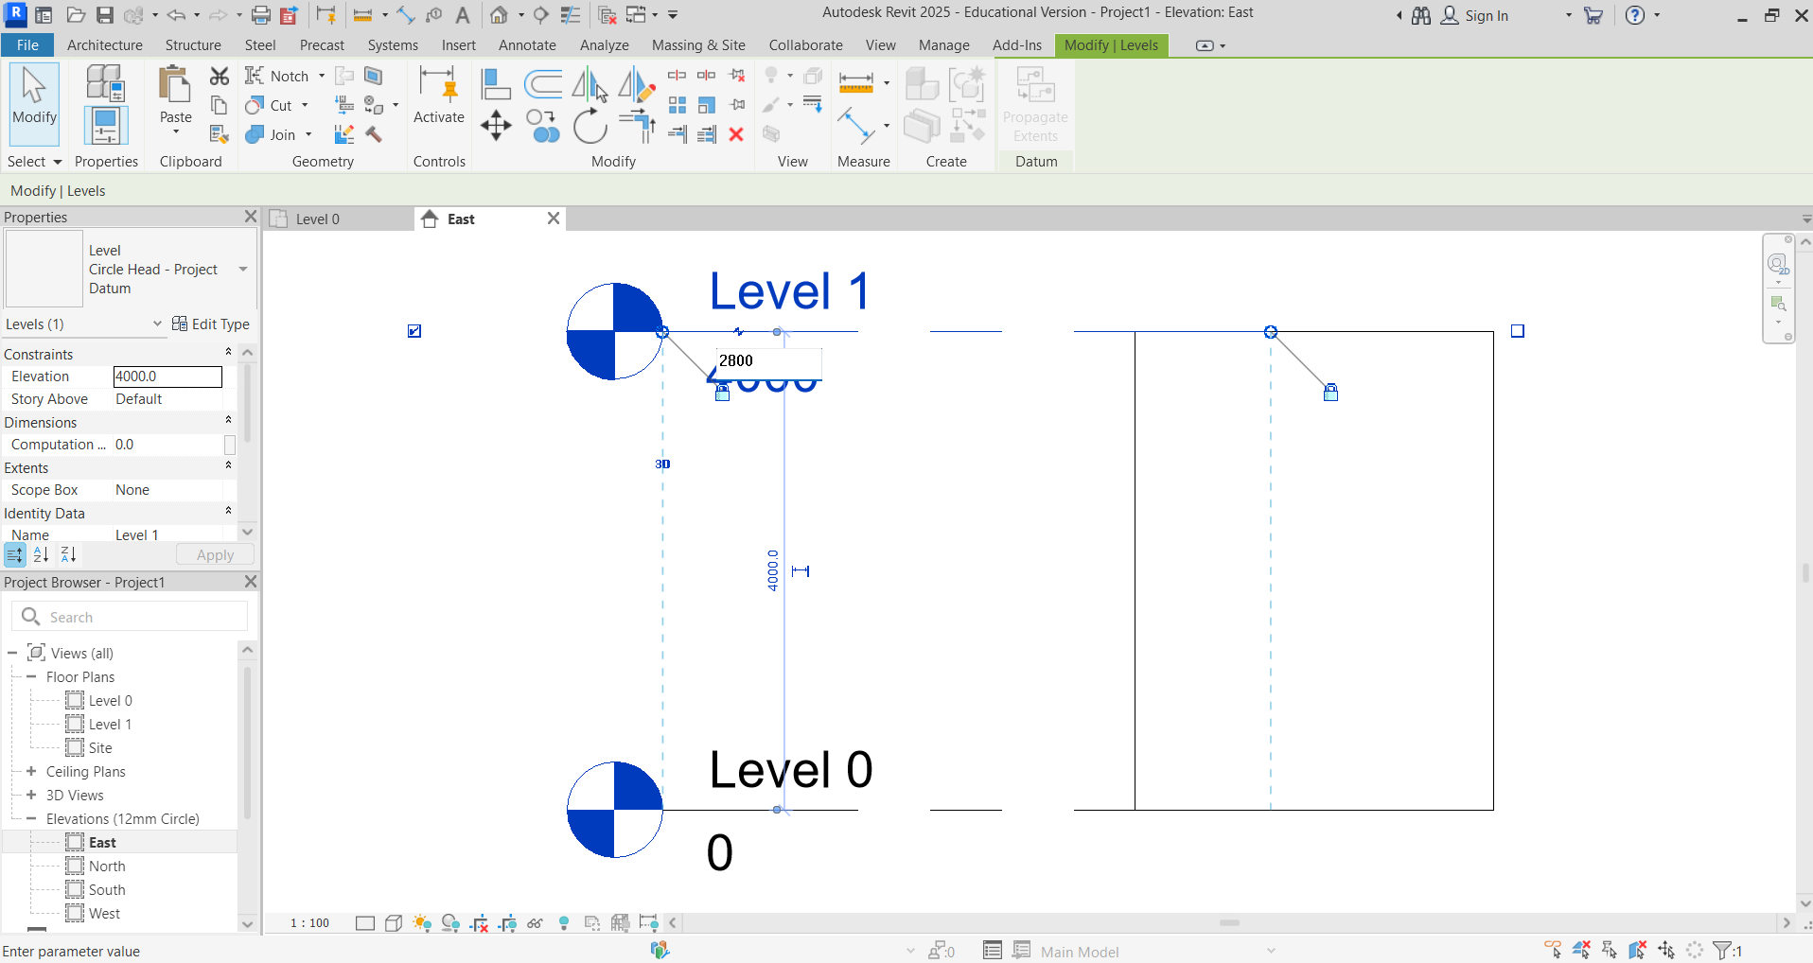
You can have a look in 3D to check the appearance of your module. Double click 3D Views, then 3D. You can rotate the view by holding Shift and pressing the mouse wheel button down while moving the mouse.
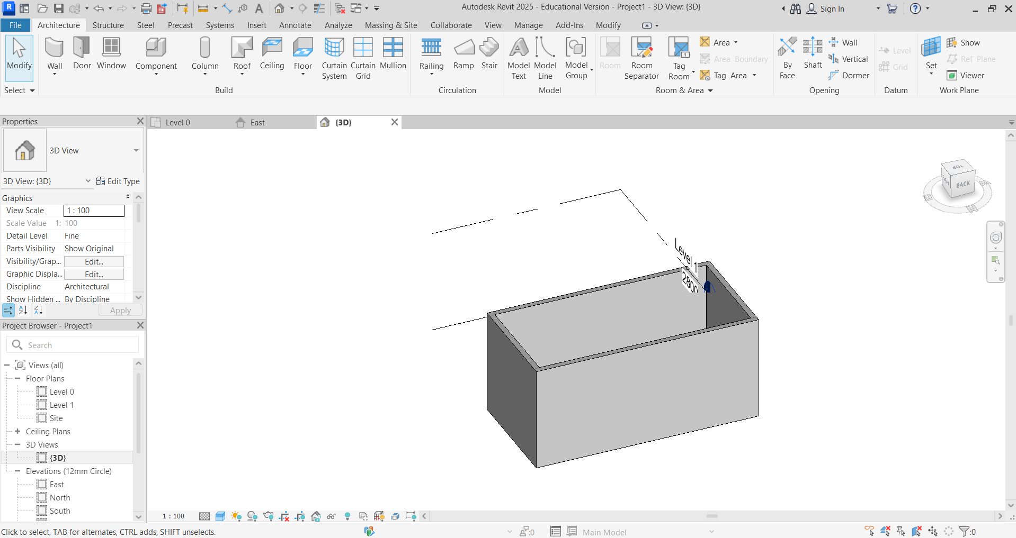

You can now “copy” your module on plan (Level 0) to create your house shape. (You will need to delete repeated walls.)
Highlight the module in Plan View. Then select Copy.
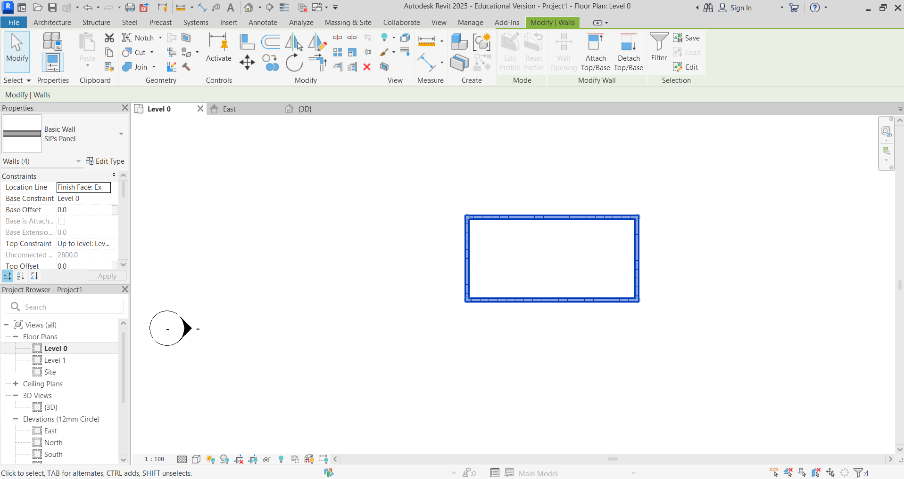

The error shown in orange means that there are two walls in the same position. Click on the wall and delete one to remove the error. An alternative method you can try is to use the Mirror Tool.
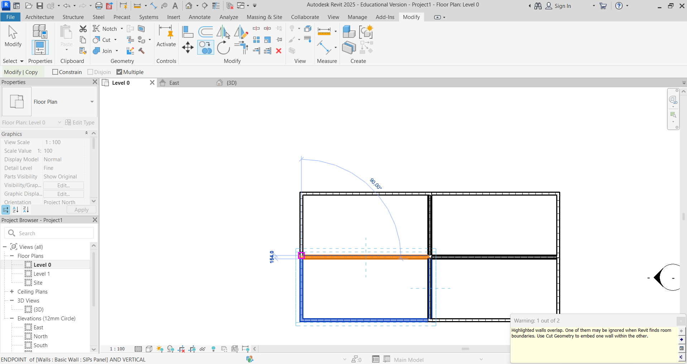

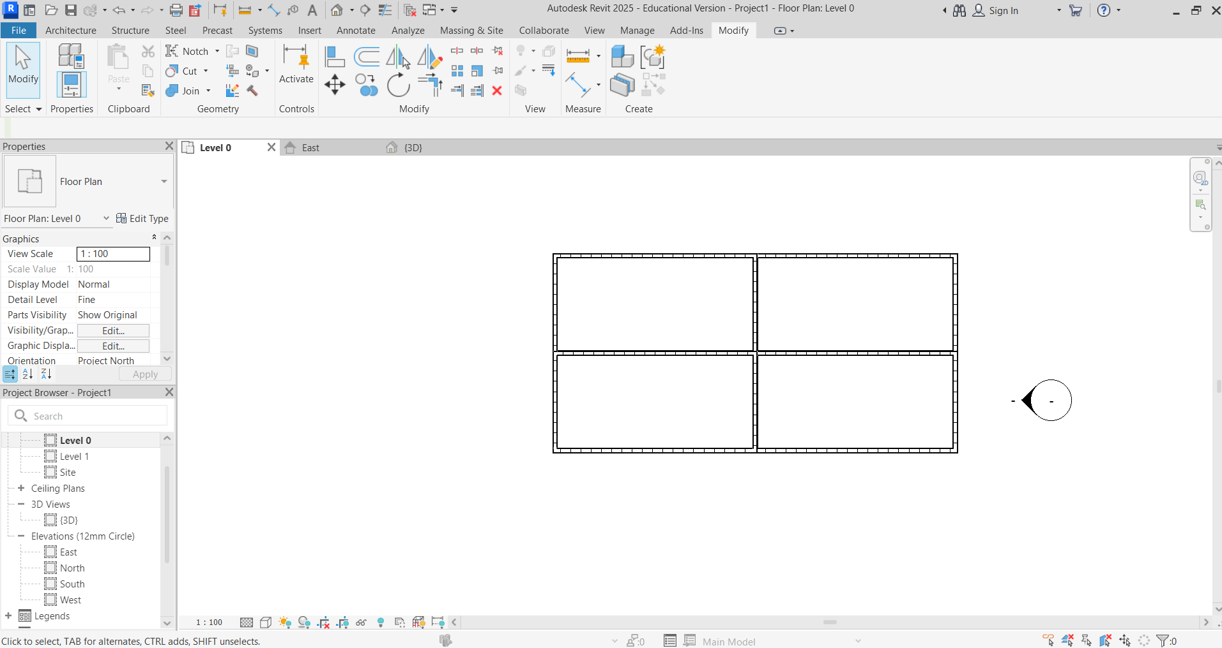
You can also copy vertically using an Elevation View. Select any Elevation View, and in the same way highlight and then “copy” vertically.
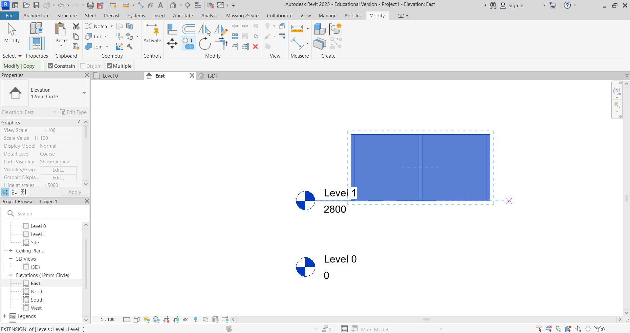

Check the overall look in 3D View.
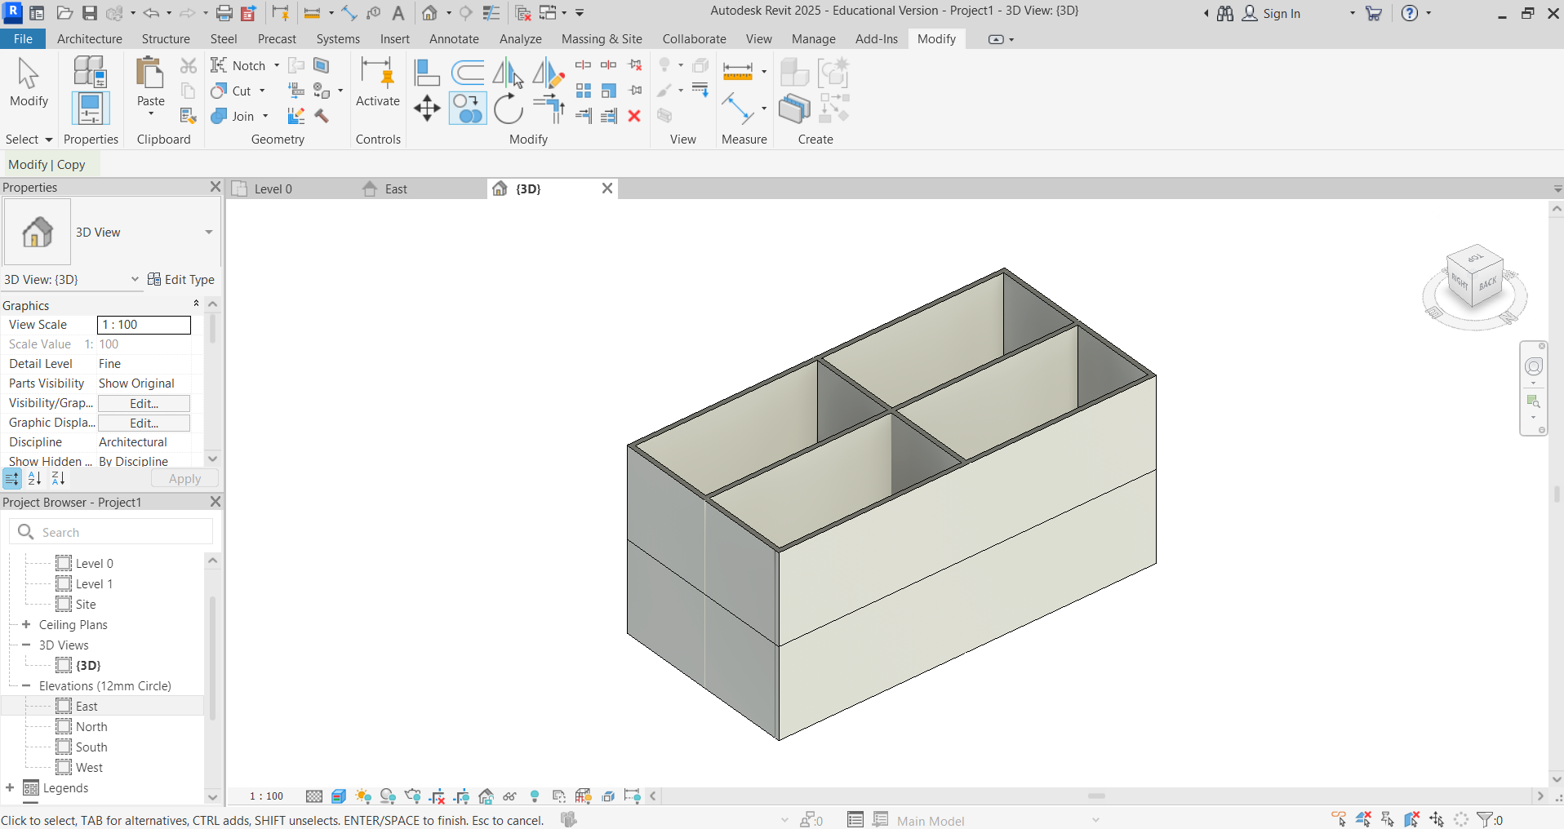

Activity 3: Making your modular house a home
The following instructions correspond to Activity 3 with instructions shown on Slide 7 of the Lesson 6, 7 & 8 slide deck.
Add floors, doors, windows, stairs, and furnishings. In Level 0 plan view, select Floor – Floor: Architectural.
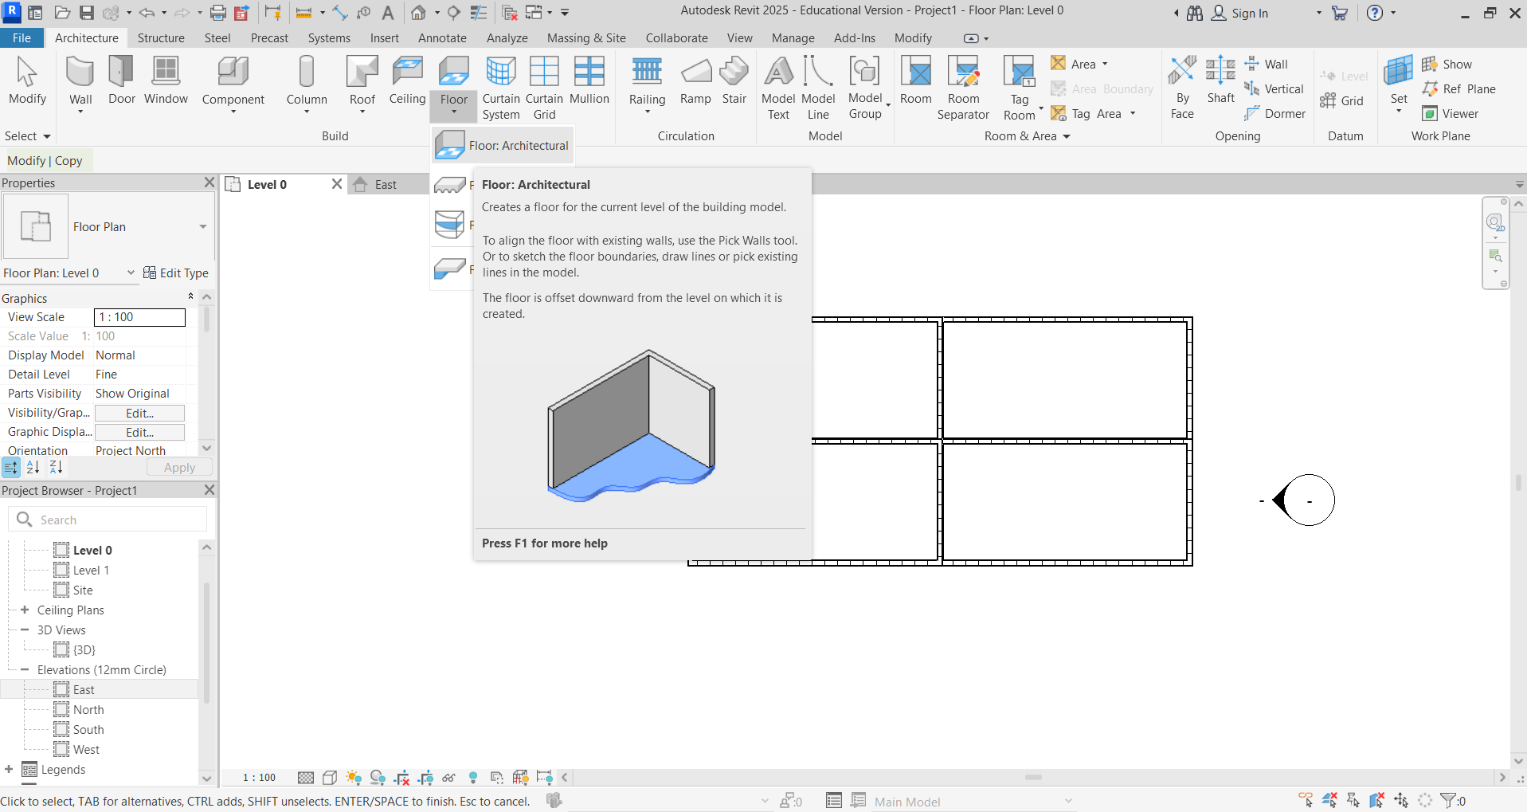

Add floors. Select Line to draw along inside wall lines to create the floor boundary. You are now in Modify/Create Floor Boundary.
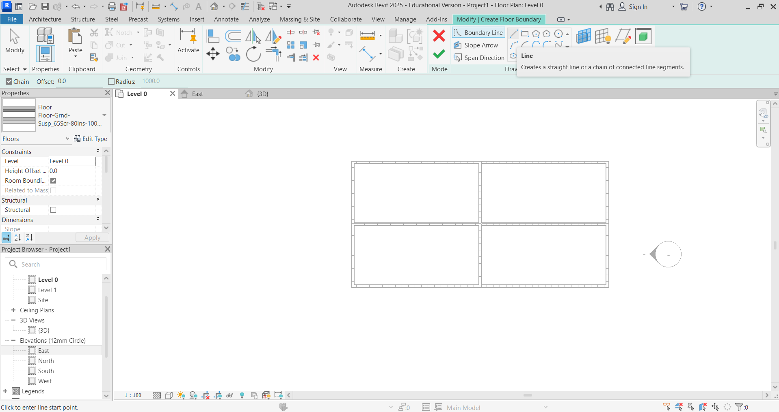

Select each wall line to create the floor boundary. (The first you select is the way the joists run.) Click the green tick when you have finished.
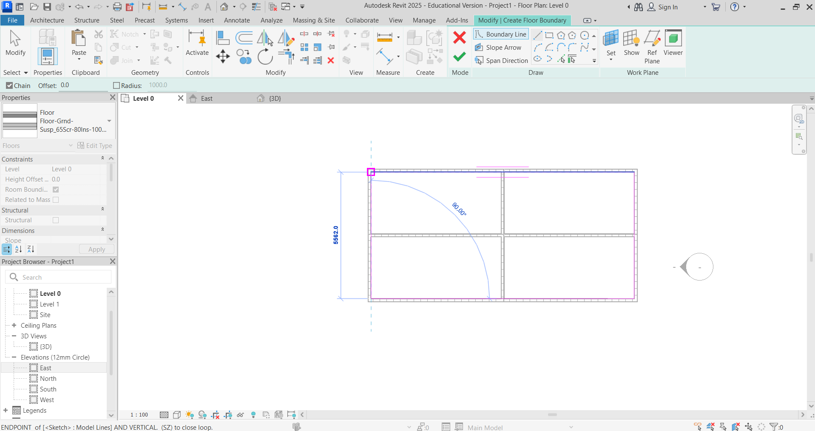

Add doors, windows, stairs, and furnishings. Doors, windows and other components are added by selecting in the Architecture tab.
Then, select the type from the Properties dropdown menu.
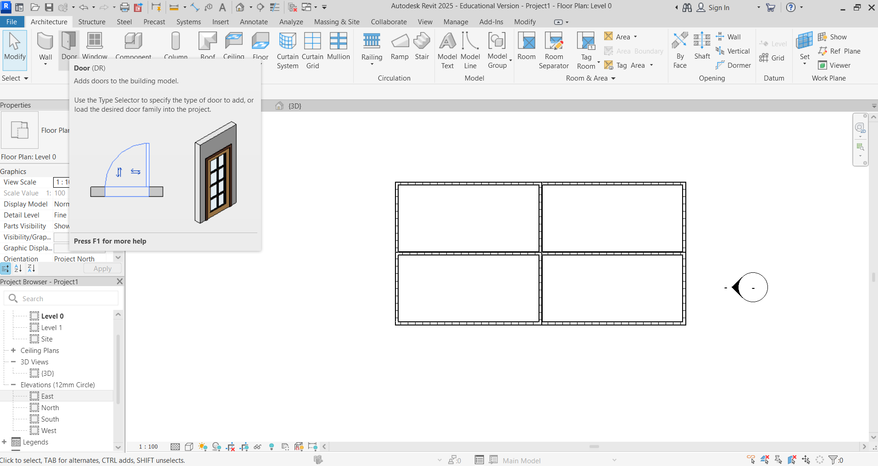

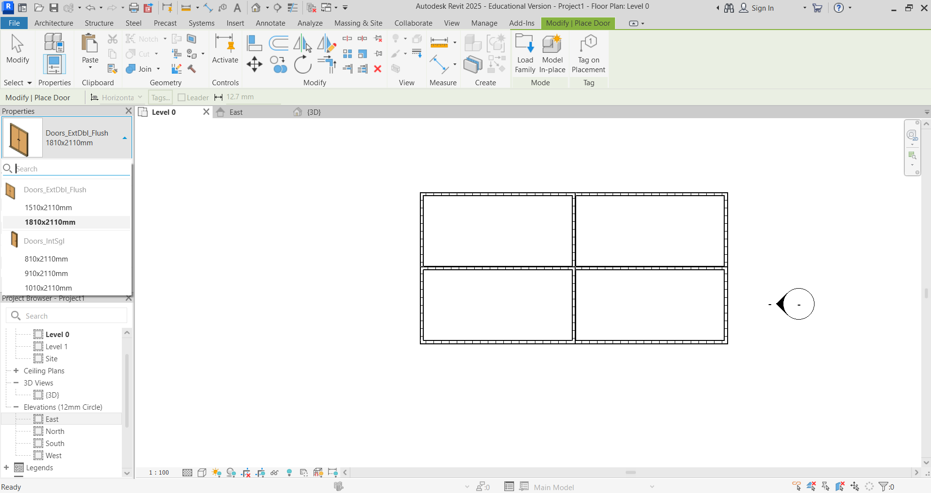

If the door or component you need is not in the dropdown menu, you can find more of a selection by selecting Edit Type and then Load.
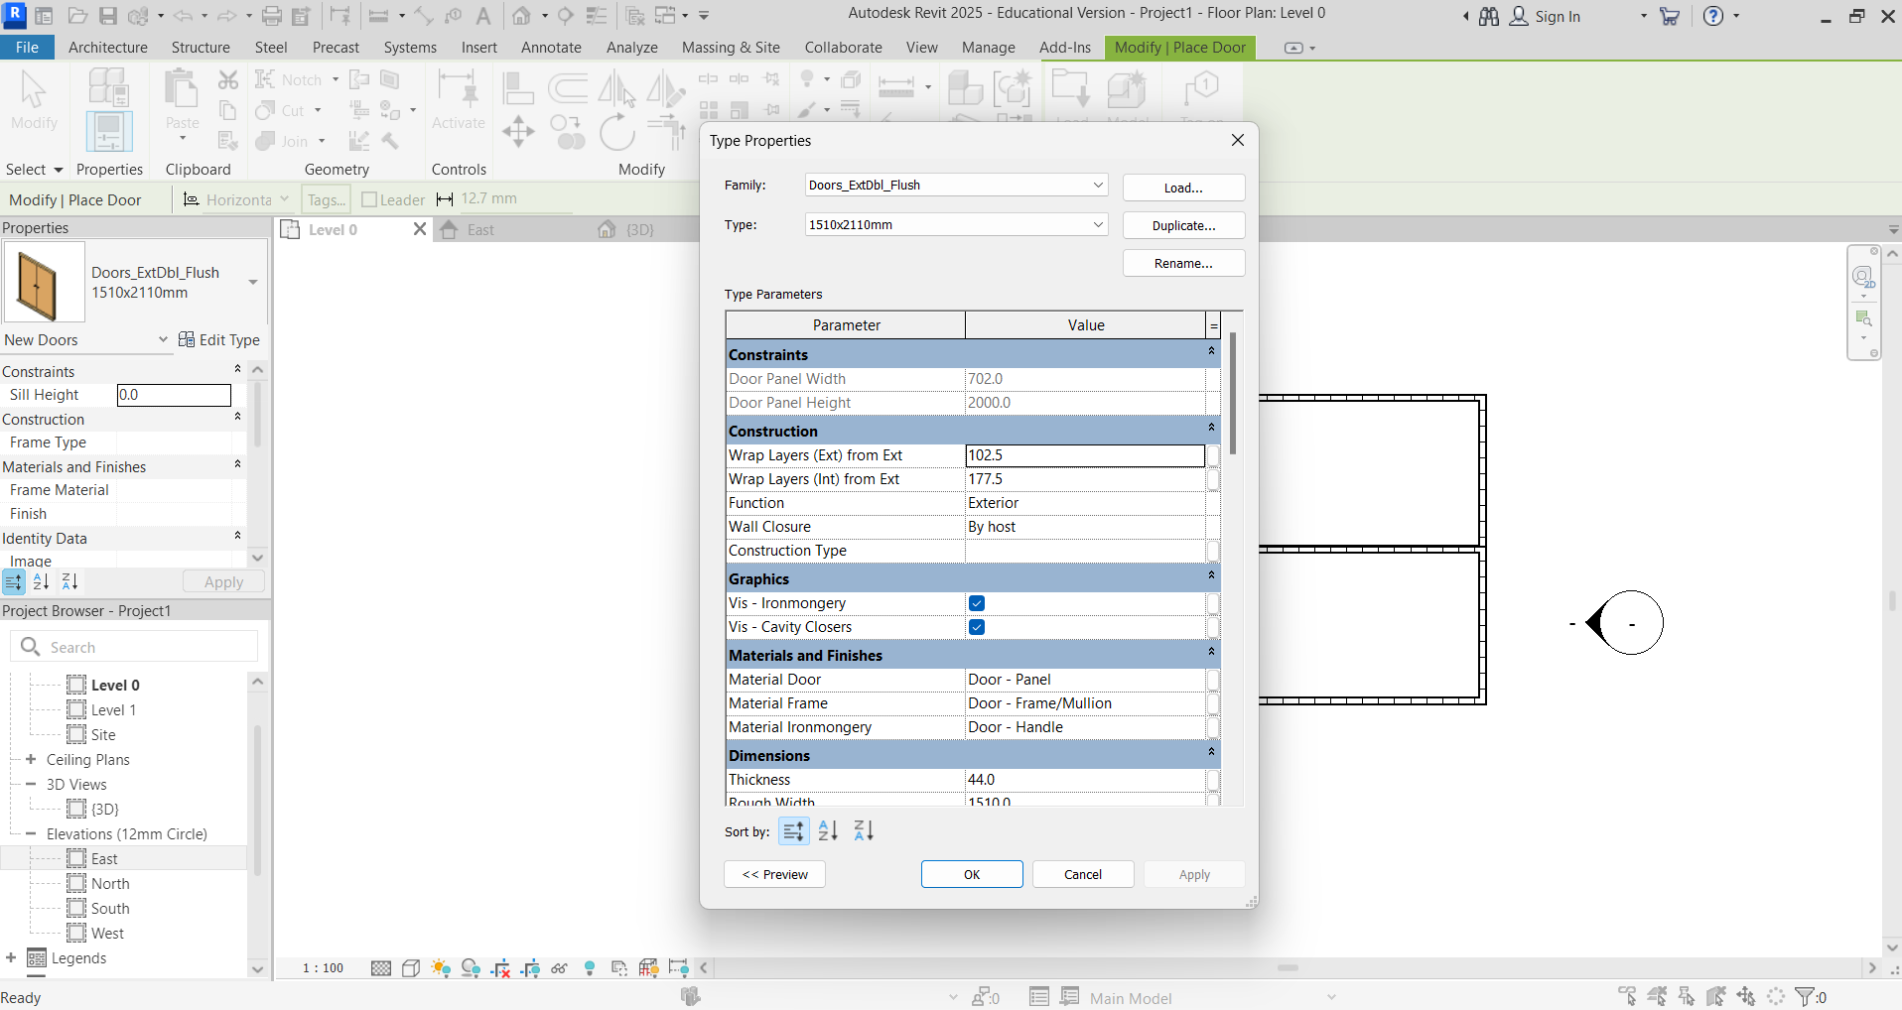

Select UK and a list of component groups appears. Follow the headings to select the component you need.
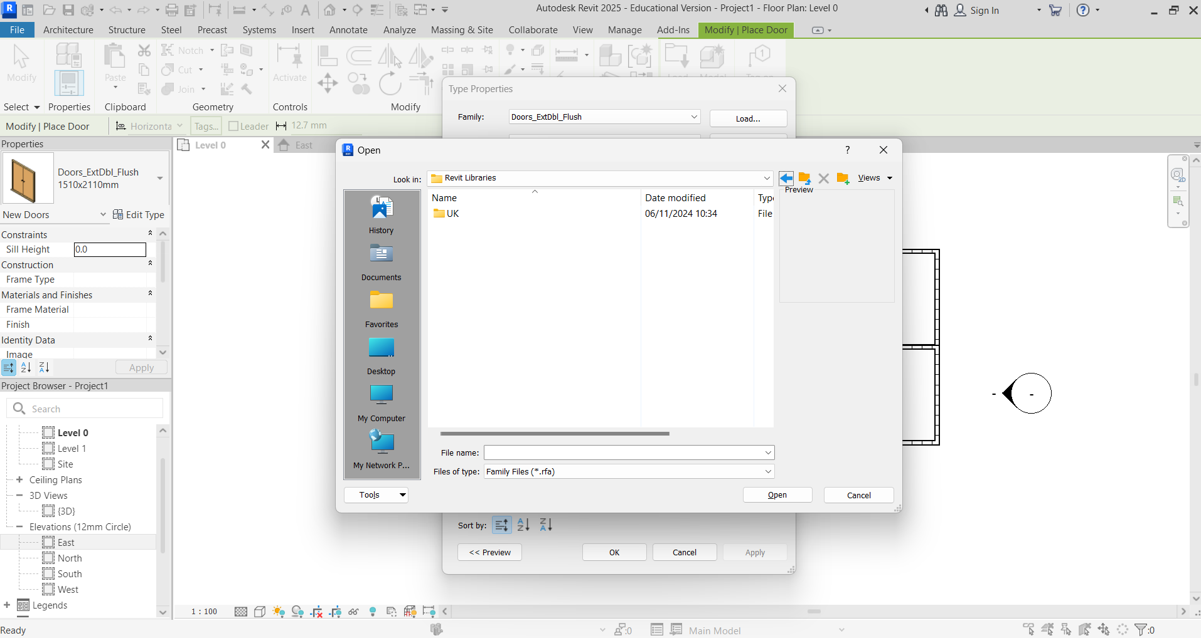
In this case, the route is UK – Doors – External Doors – Doors_ExtSgl_8 – Open.
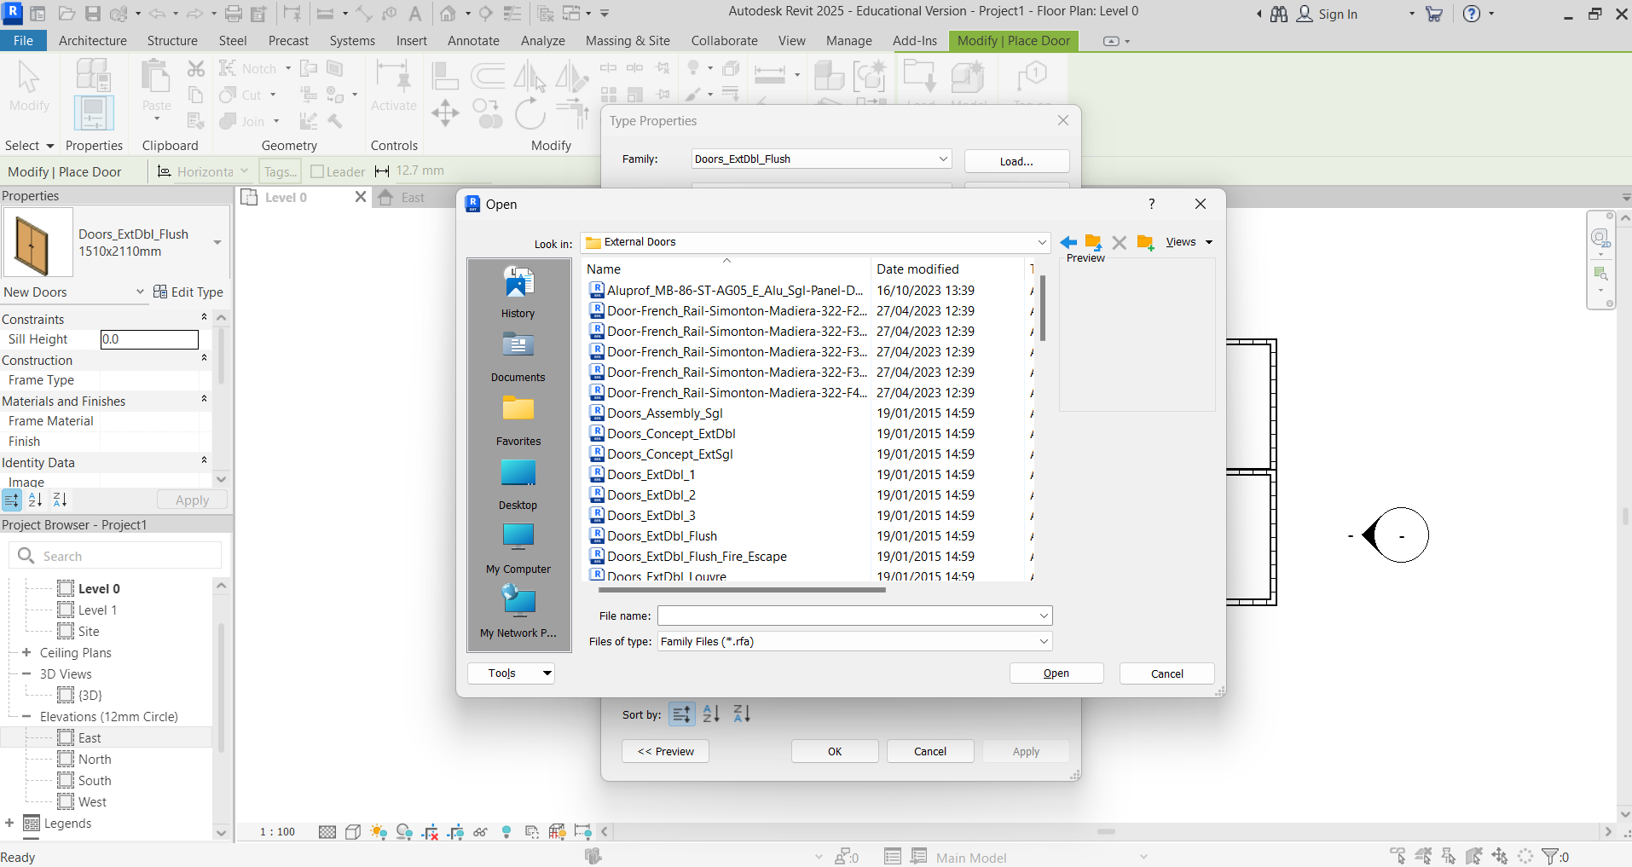
If you need a size of this type of door that did not show, it is possible at this point to duplicate and change the size in Dimensions in Type Properties. Otherwise, click OK.
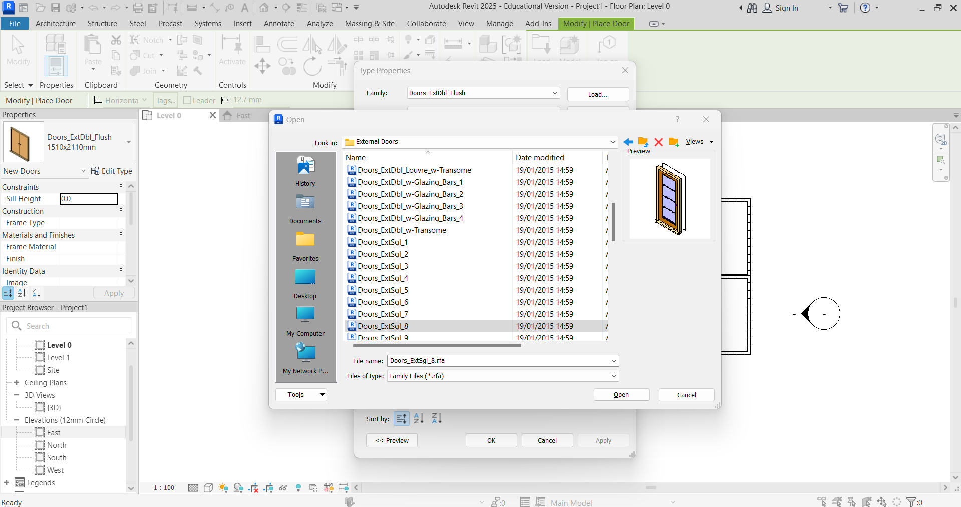

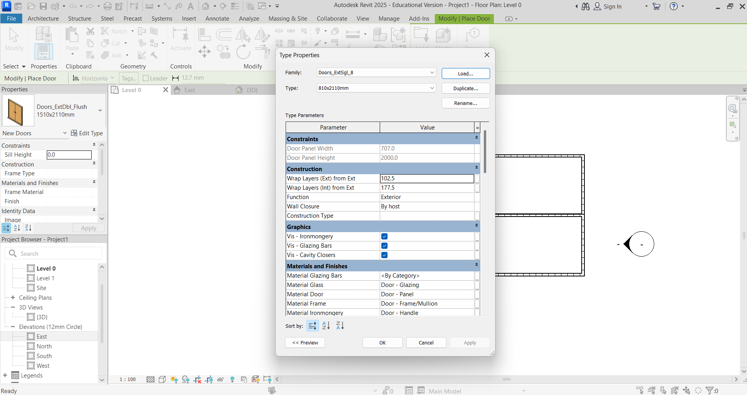
Select the size of door required and hover over the wall. Click to position it, and use the indicator arrows to choose the direction of the opening.
Use the same process to add internal doors, windows and other components.
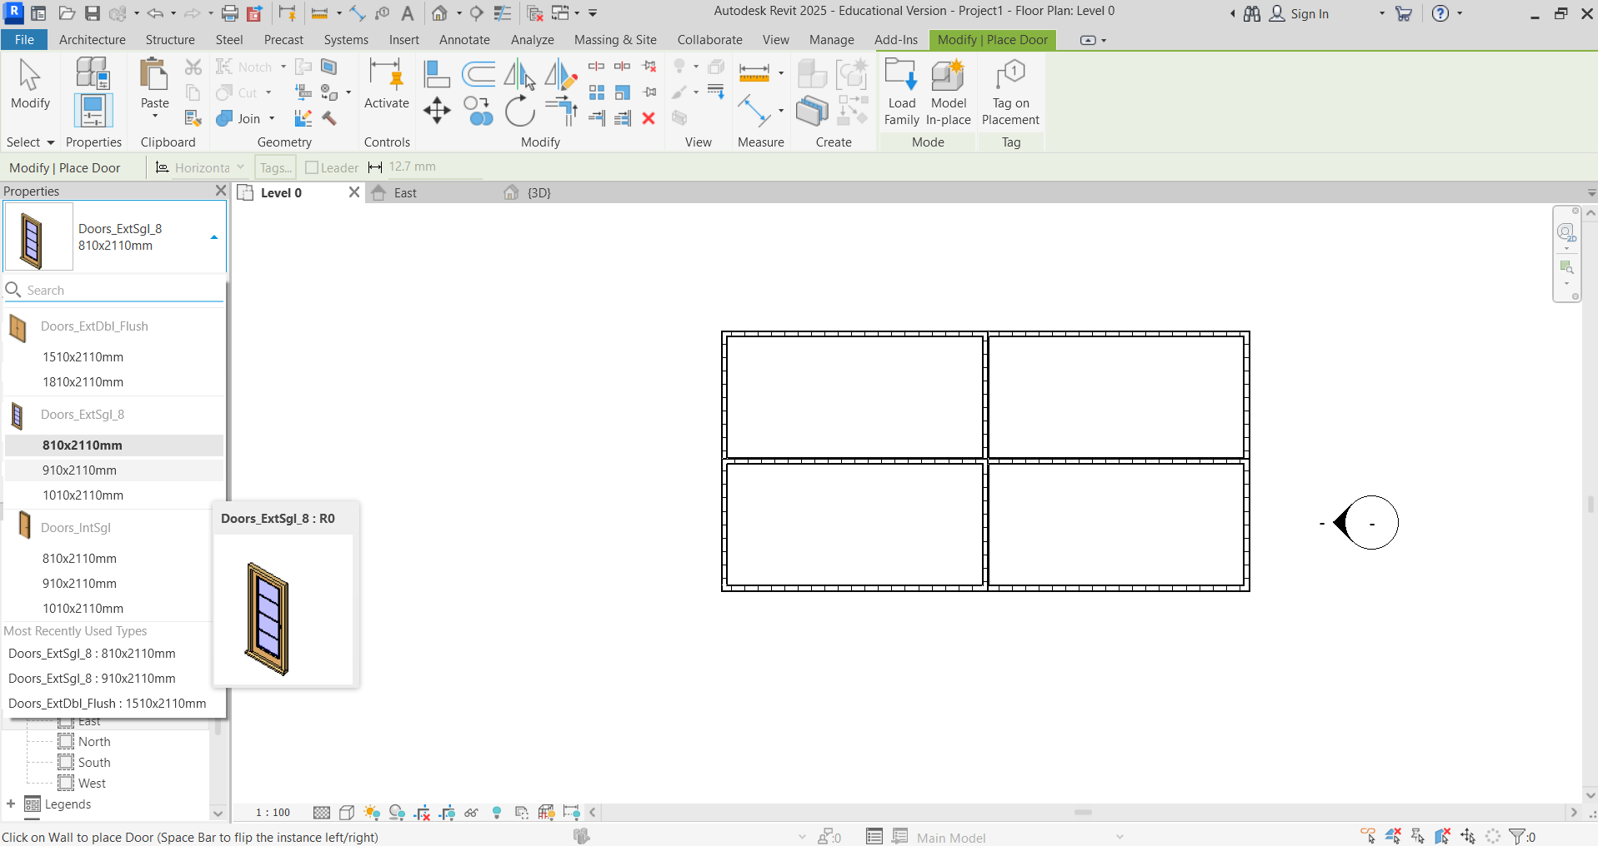

The following components may be found following the routes below:
- Component – Place Component – Load Family (Modify Panel) – UK
- Toilet – Plumbing – Architectural – Fixtures – Water Closets
- Wash Basin – Plumbing – Architectural – Fixtures – Sinks
- Shower (Tray) – Plumbing – Architectural – Fixtures – Showers
- TV/Fridge/Cooker – Speciality Equipment – Domestic
- Beds/Tables/Chairs – Furniture

Add stairs, making sure there is correct access and egress. Select Stairs icon in Architecture tab.
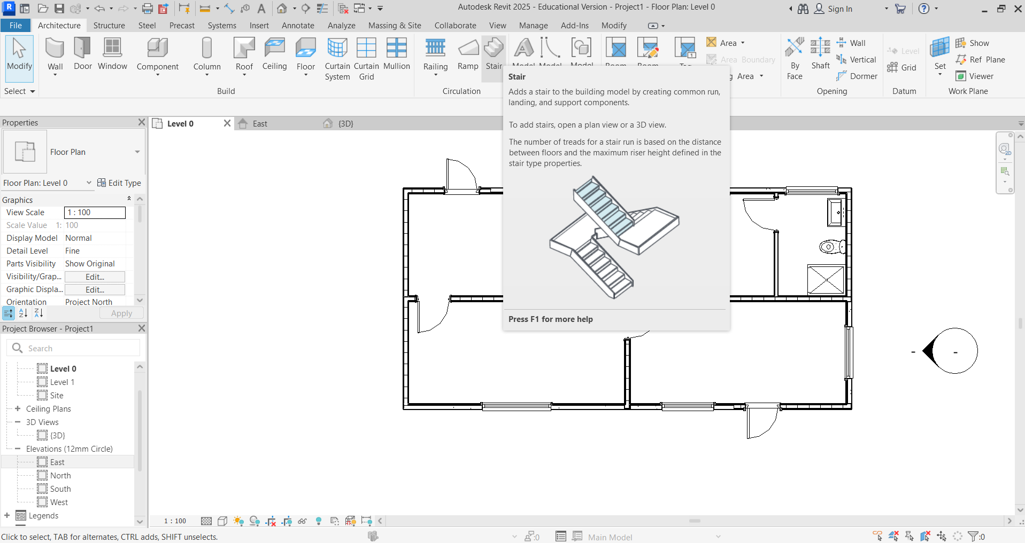

The default setting is Run, which works for straight stairs. Leave a minimum of 800 mm access to the stairs.
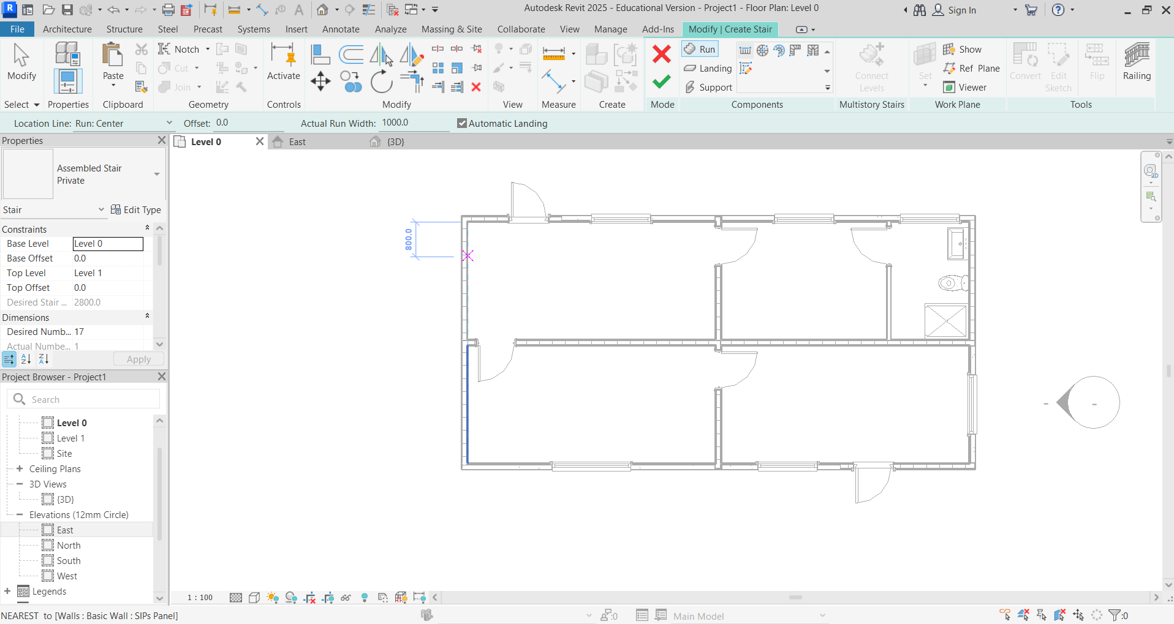

Click to start the stairs on the inside of the wall in the desired position. Use Location Line to Run: Left or Run: Right to suit your design (in this case Run: Right).
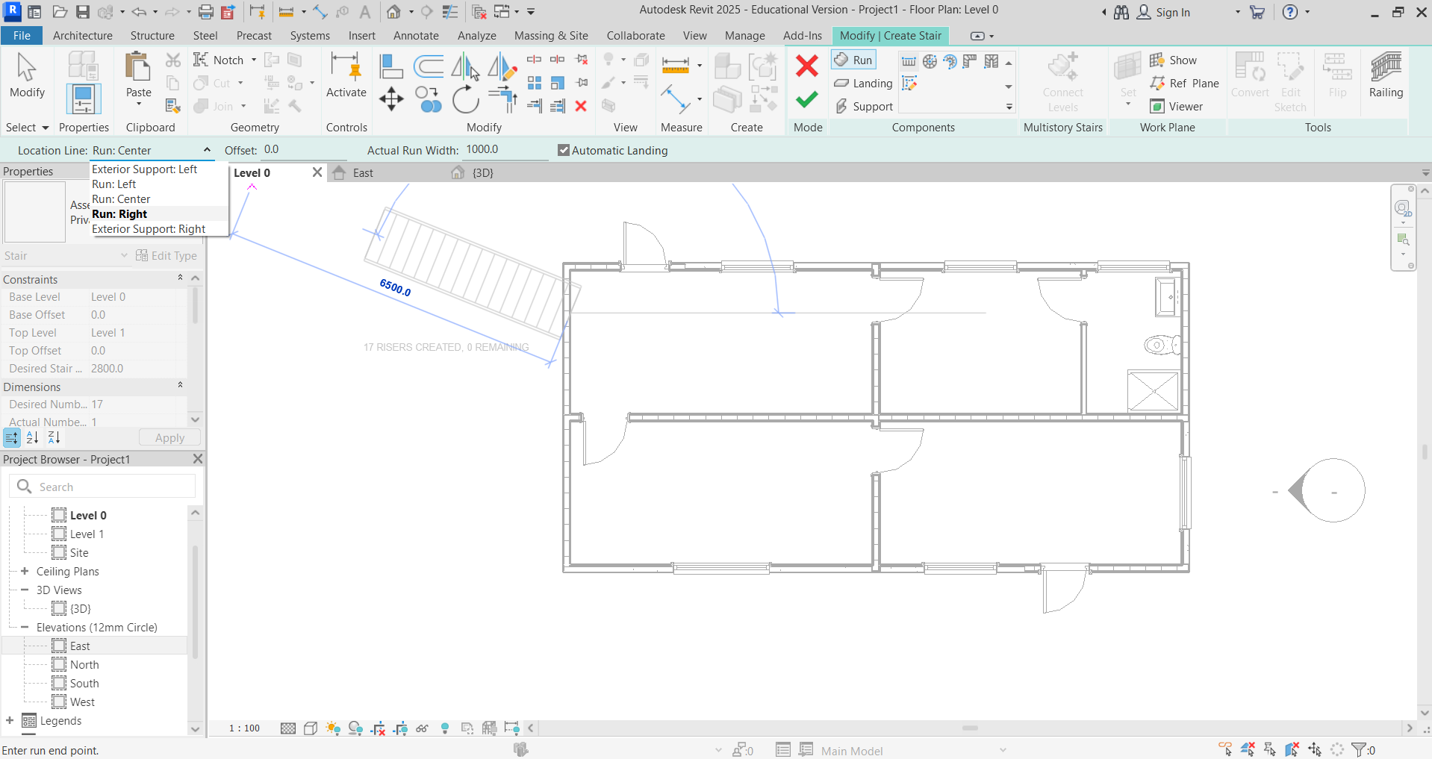

Click at the end of the projected length of the stairs. The software knows the length to reach Level 1, based on the height set when the levels were set. When the stairs are positioned, click the green tick to accept.
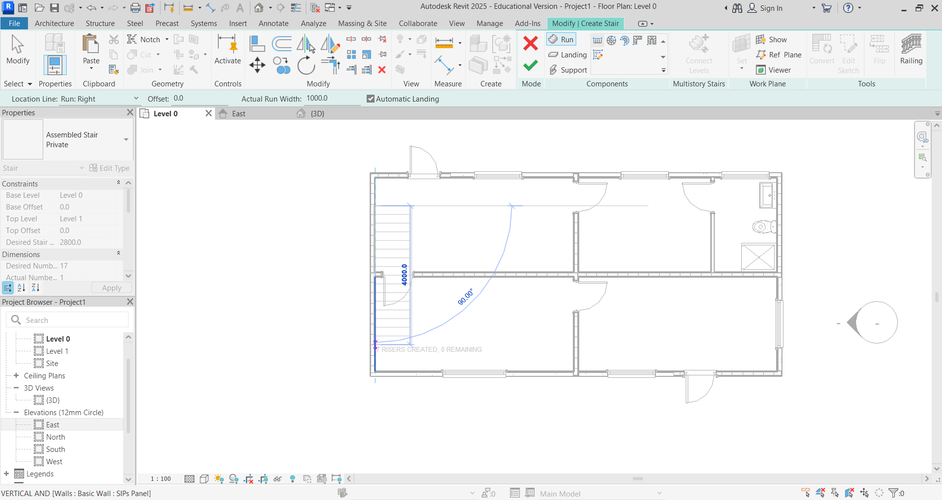

Amend any door/window/component positions after placing the stairs. (In reality, it is unlikely the wall in the example below would be cut here. This wall would more than likely be removed.)
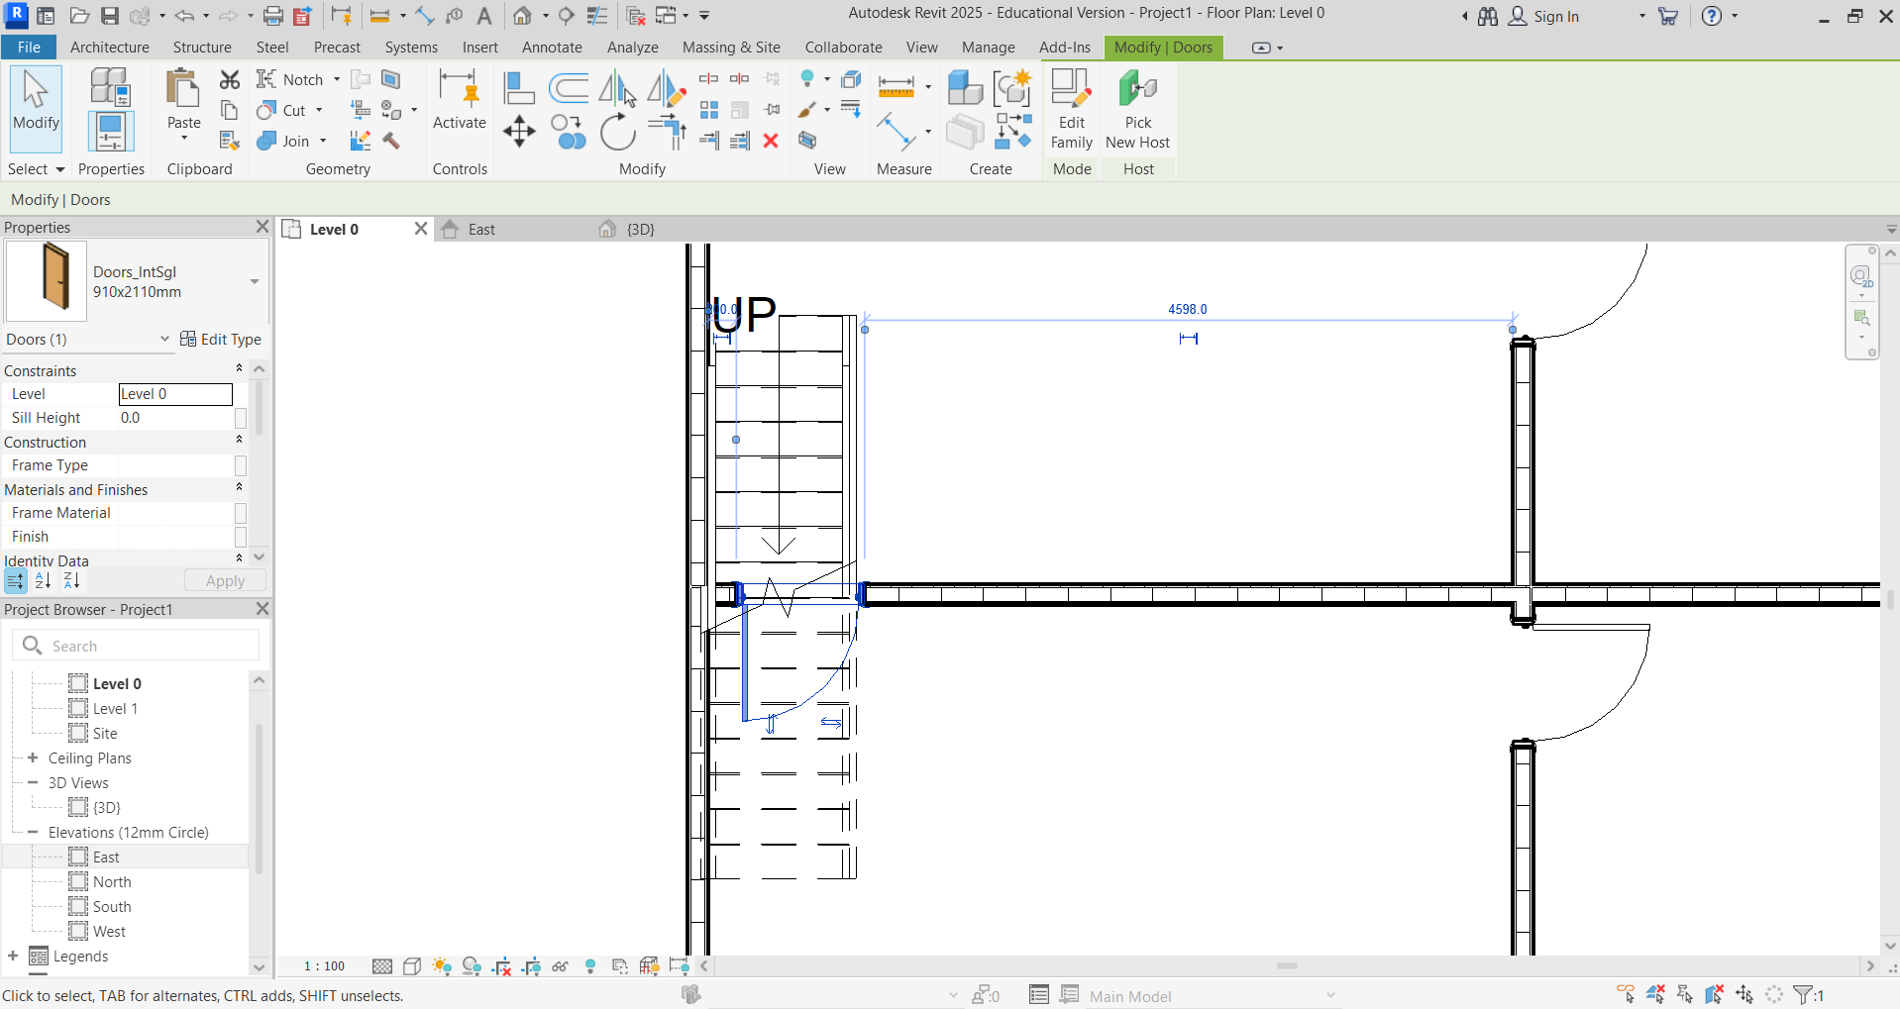

Position the first floor around the stairs. Select Floor – Floor: Architectural.
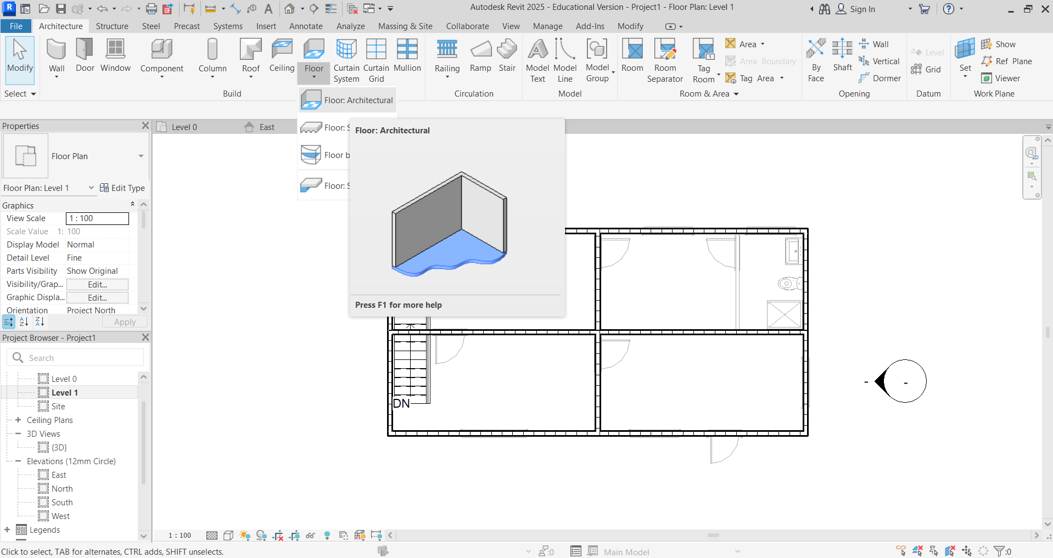

Select Line.
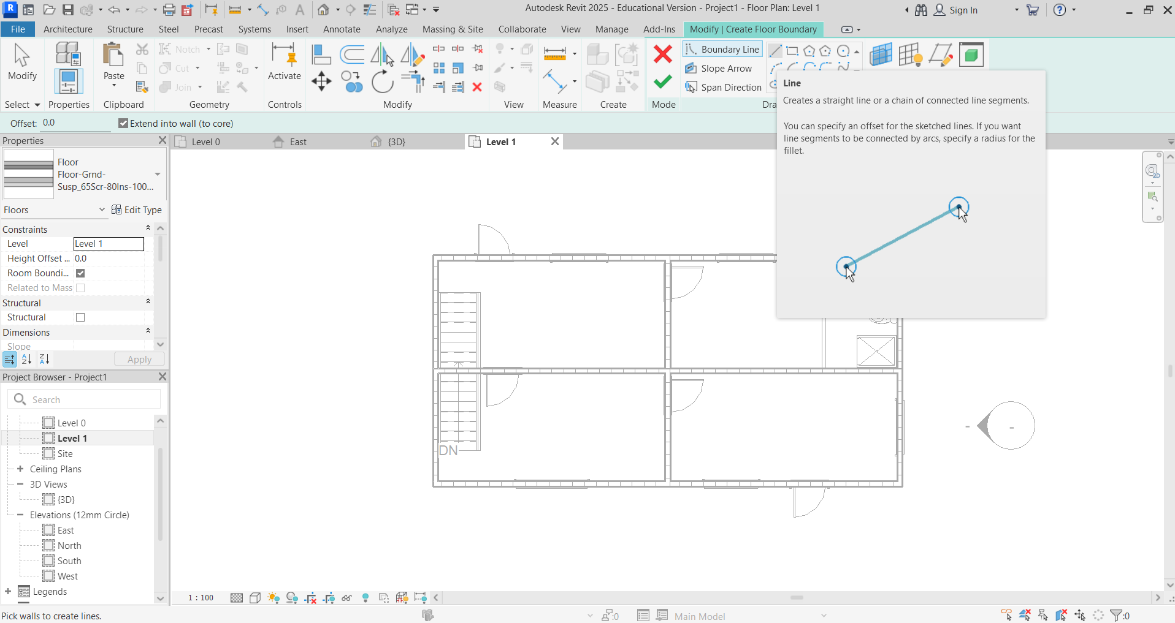

Draw a line around the stair top and the first floor. Click the green arrow to accept, and the floor area will turn blue.
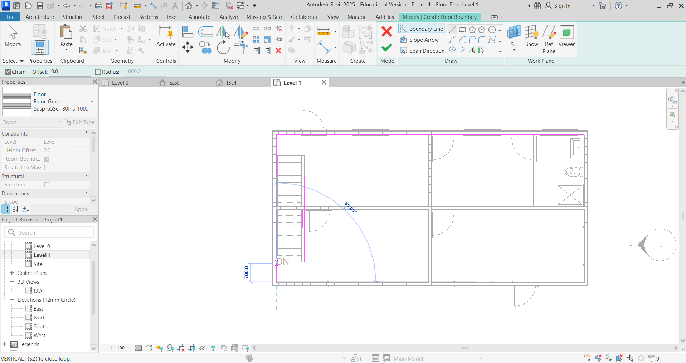

This box will appear when placing the floor on the first floor. Select Don’t attach.
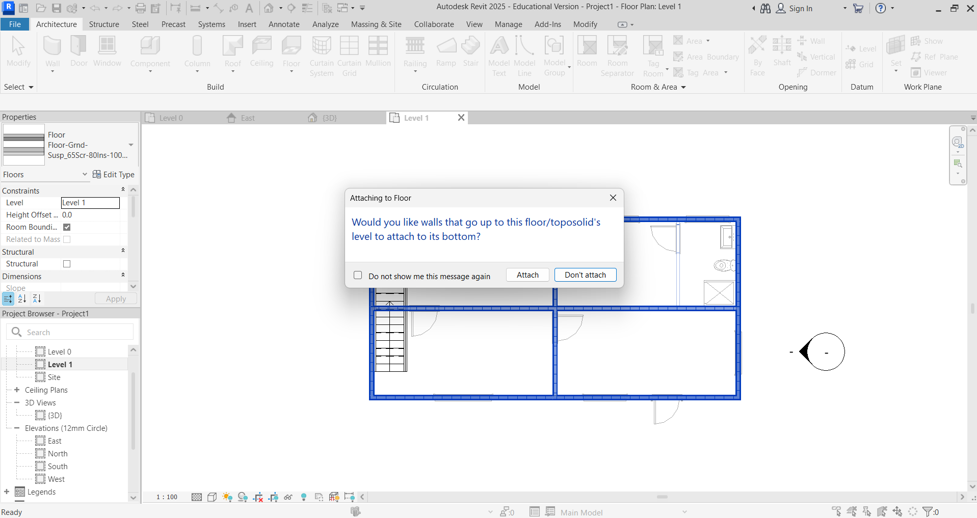
Change the floor type to Floor_Timber_22Cbd -225Joist.
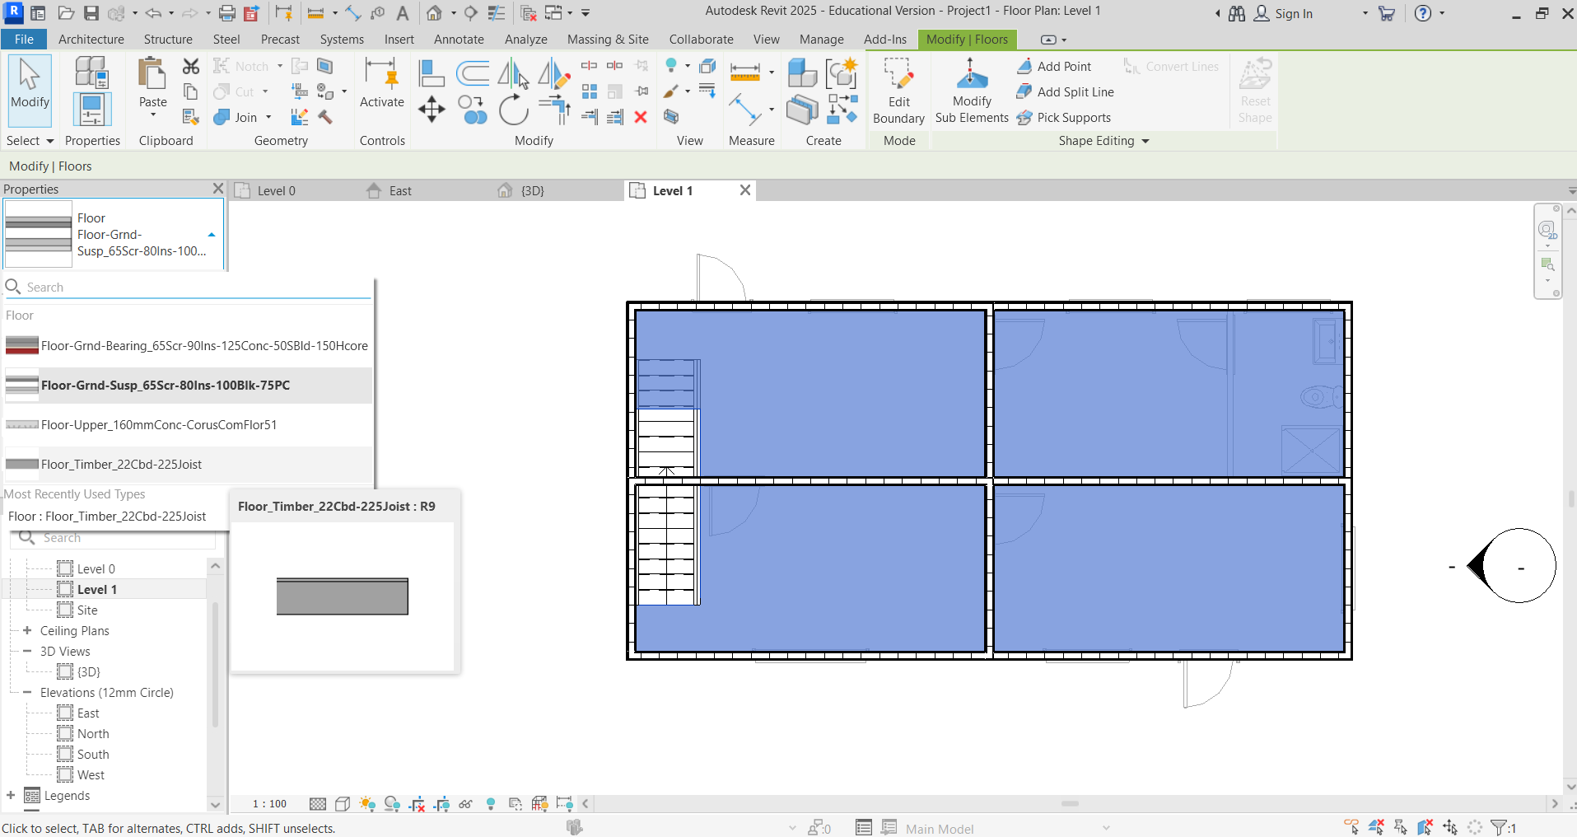

Using the new wall type, add any other partition walls. You will notice that rooms have been labelled on this page. This can be achieved by selecting Annotate, and then Text. Type the corresponding label.
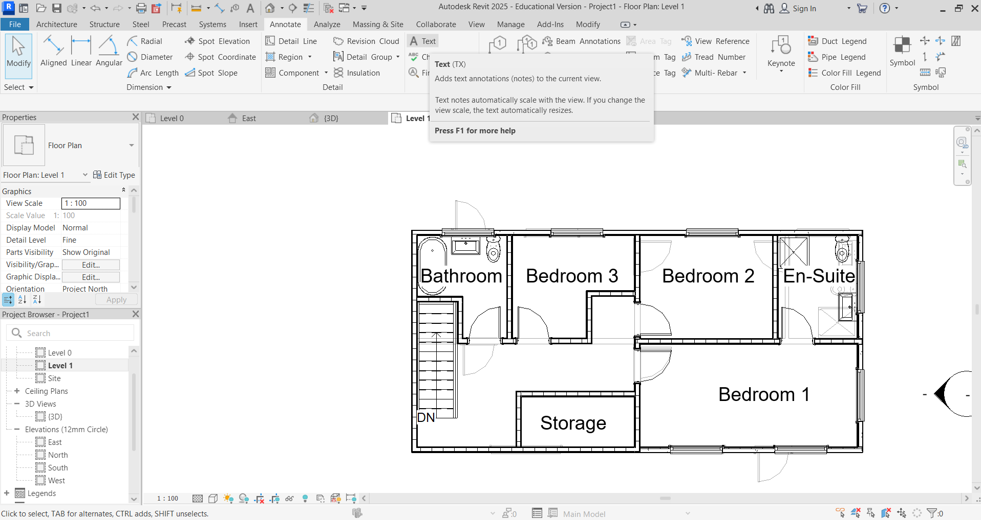

You can change the visible range from Level 1. In doing this, it switches off being able to see Level 0, as shown by the differences in the two images below. To do this, scroll down the Properties menu until you find Underlay. Beneath this is Range: Base Level. On the dropdown, select either Level 1 (in this instance) or the same level you are on or none.
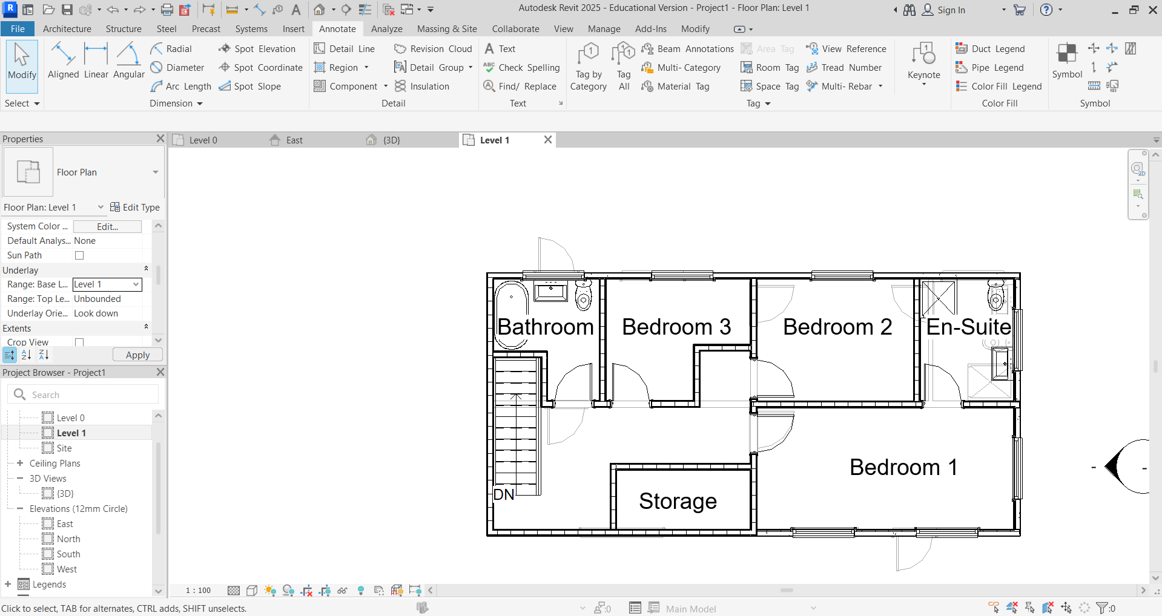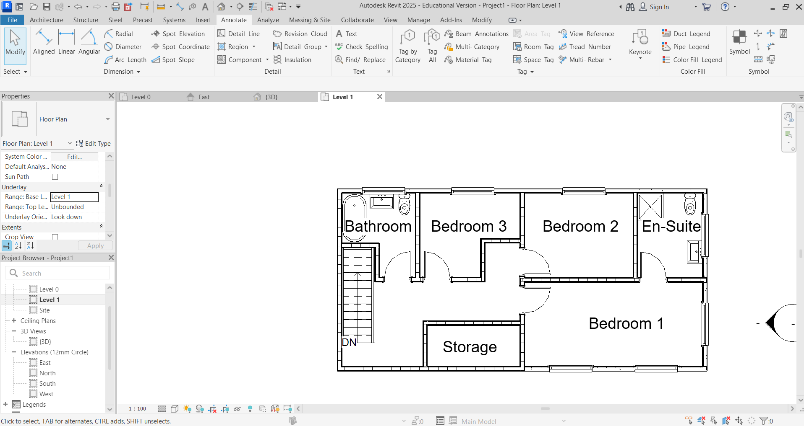

Add a roof (draw on Level 1 but change base level to Level 2). Click Roof – Roof by Footprint in Level 1 Floorplan View.
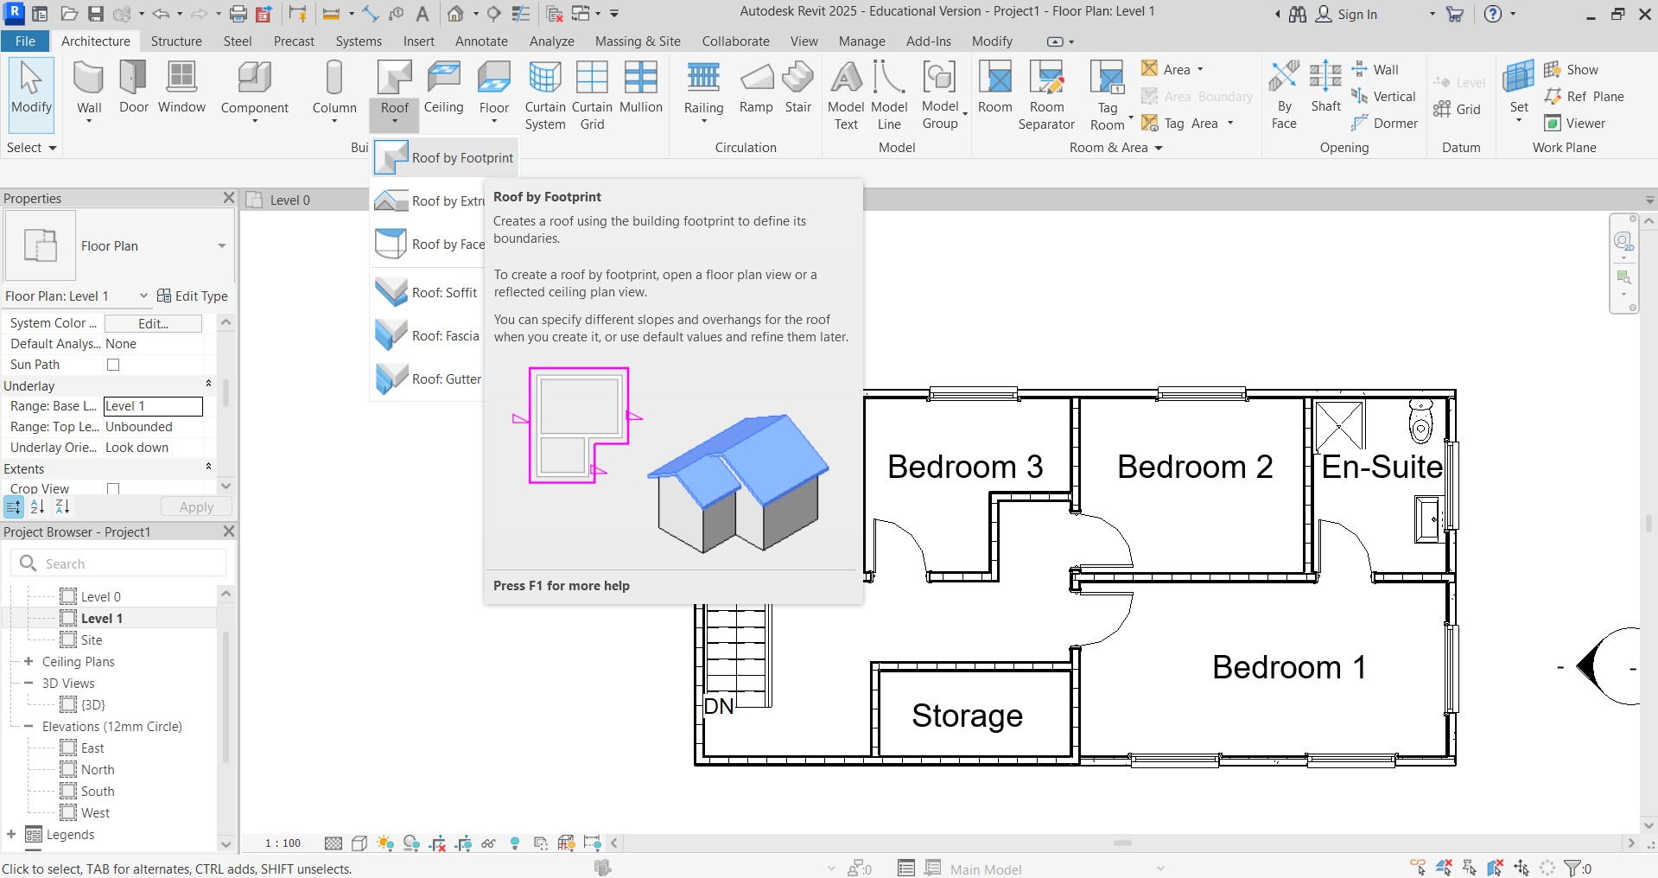

Add a roof outline. Select Pick Lines to use the existing wall boundary line for the roof.
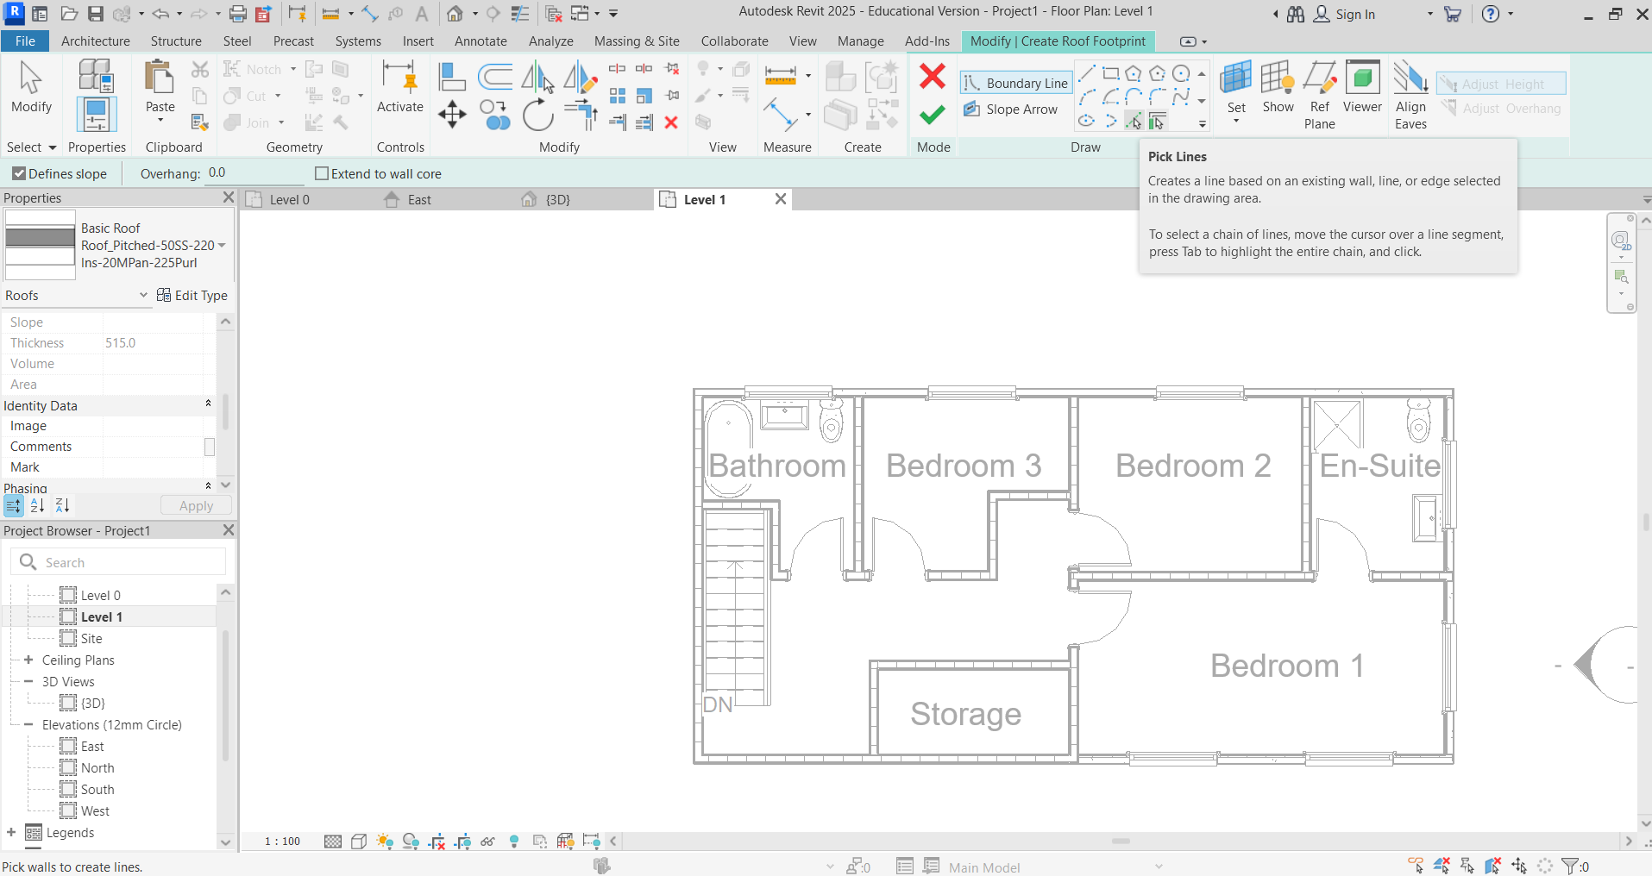

Add a roof offset. Set Offset to 200 to give the roof an overhang.
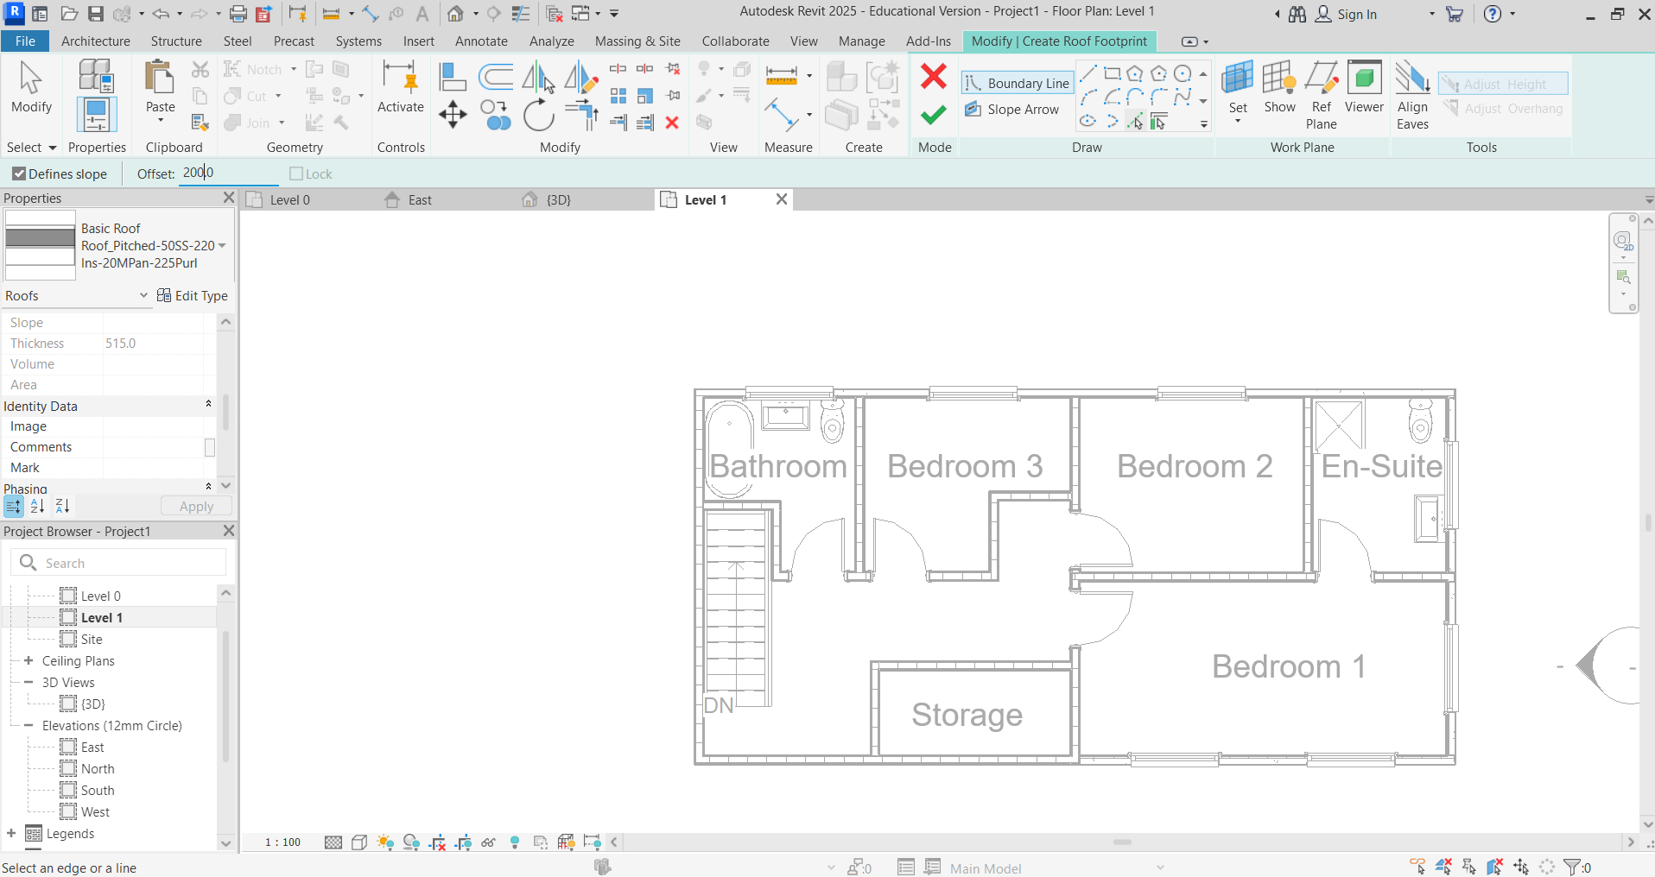

Select walls. Select each line. If there are any gaps in the “closed loop” of the roof, click Escape twice and drag the end of the lines to meet. Do not click more than once on each line.
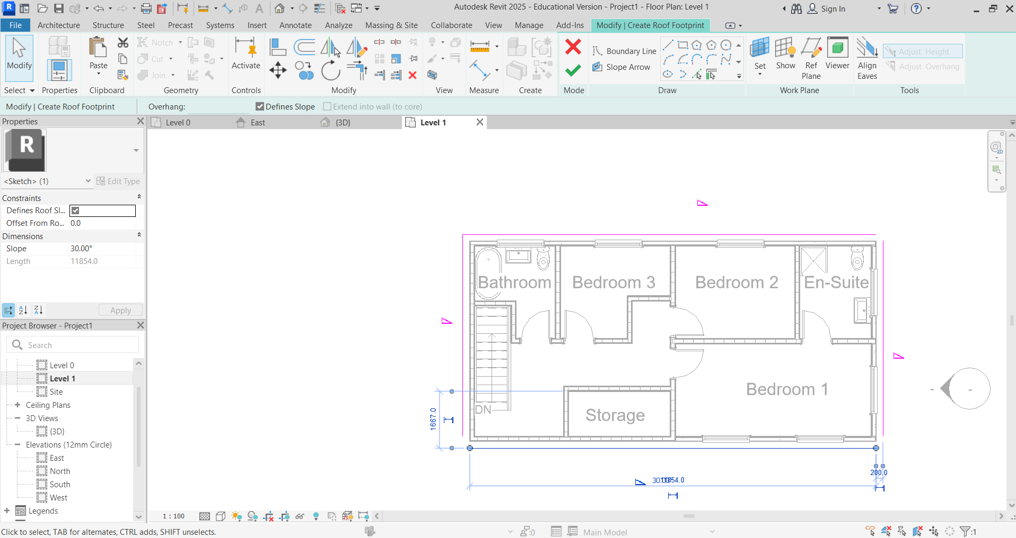
Set the roof shape and level. Change the Base Level of the roof to Level 2. Click the tick to confirm.
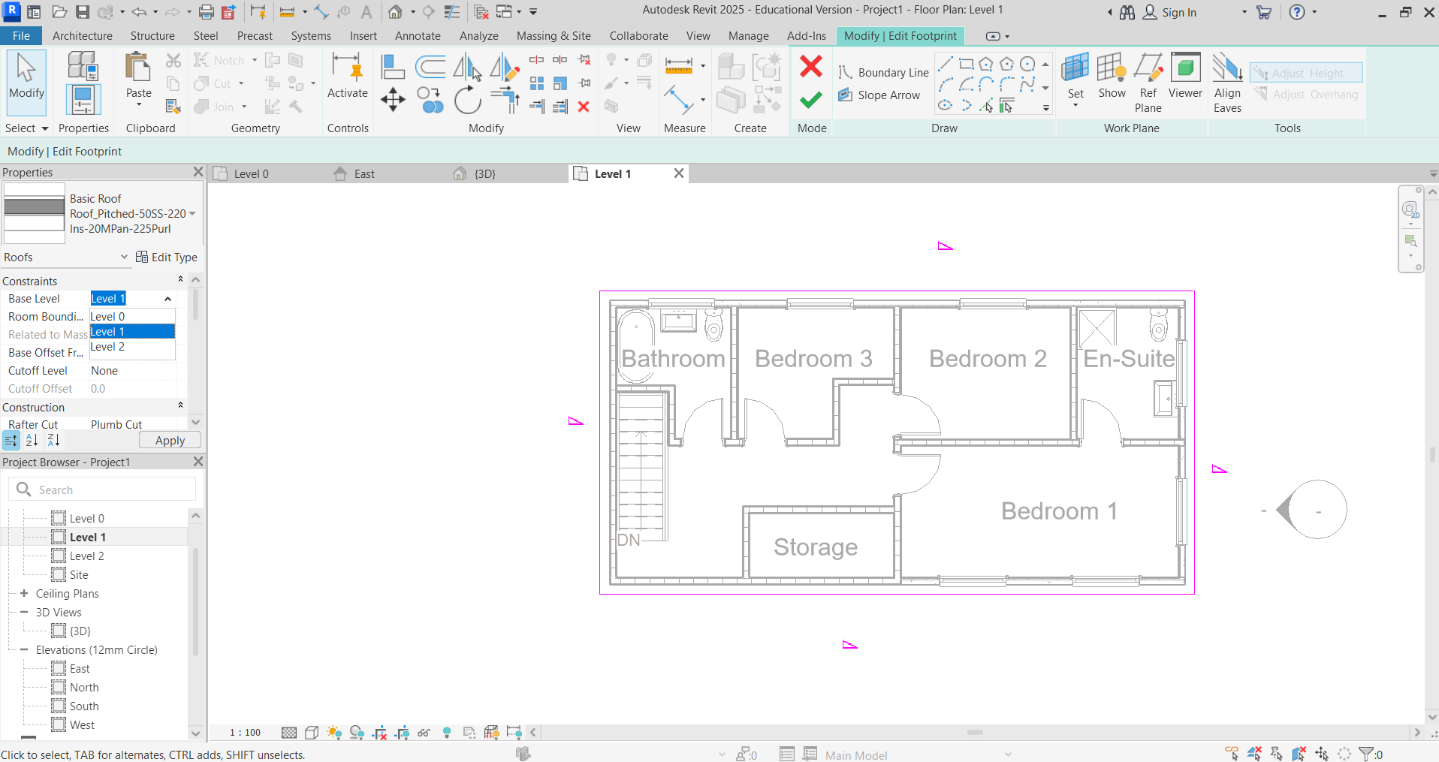

When this box appears, click Don’t attach.
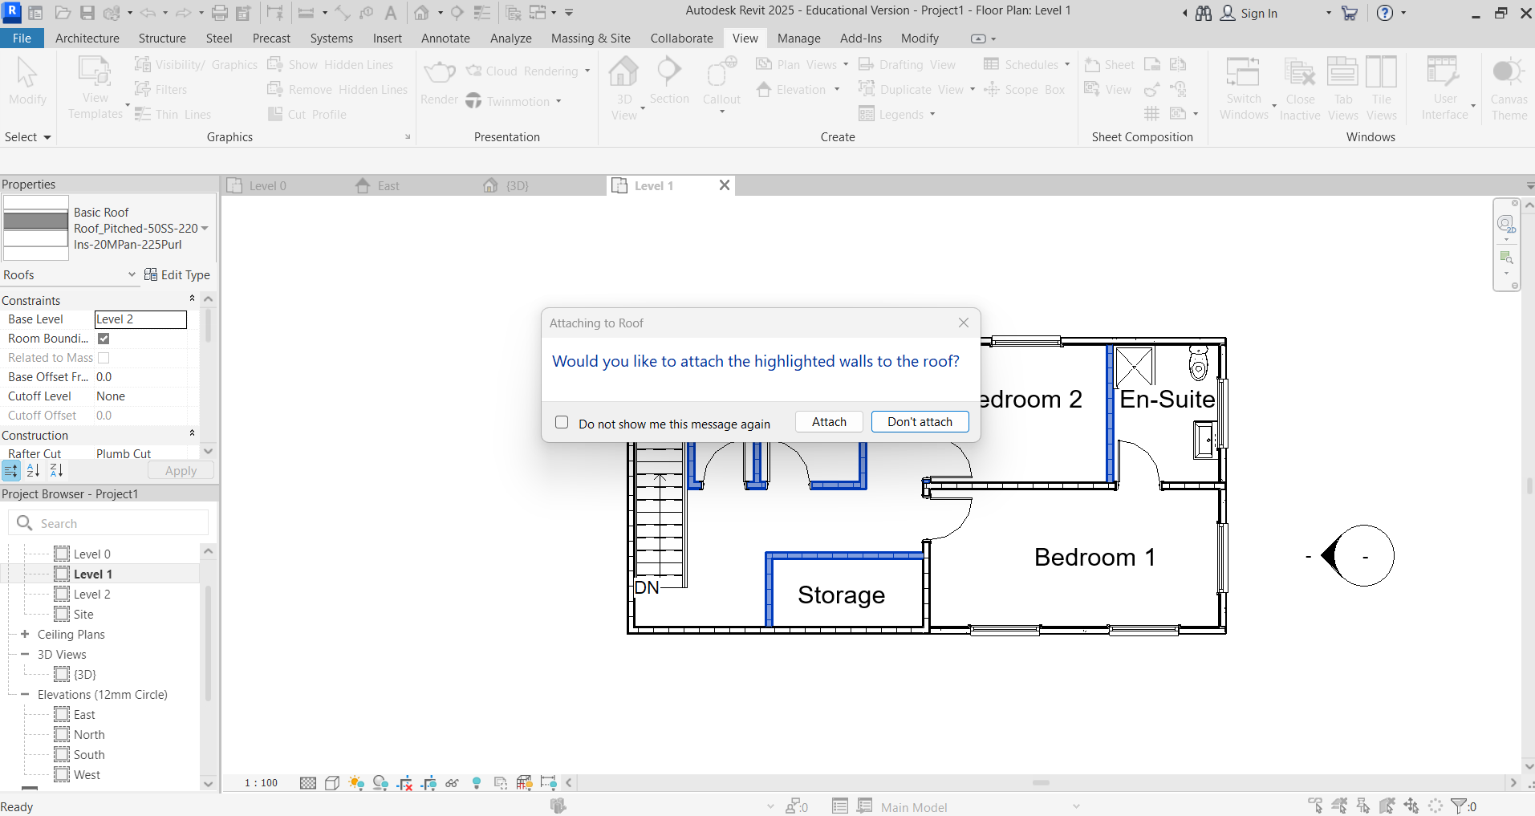

Activity 4: Generating drawings
The following instructions correspond to Activity 4 with instructions shown on Slide 8 of the Lesson 6, 7 & 8 slide deck. Check in 3D that your building is complete.
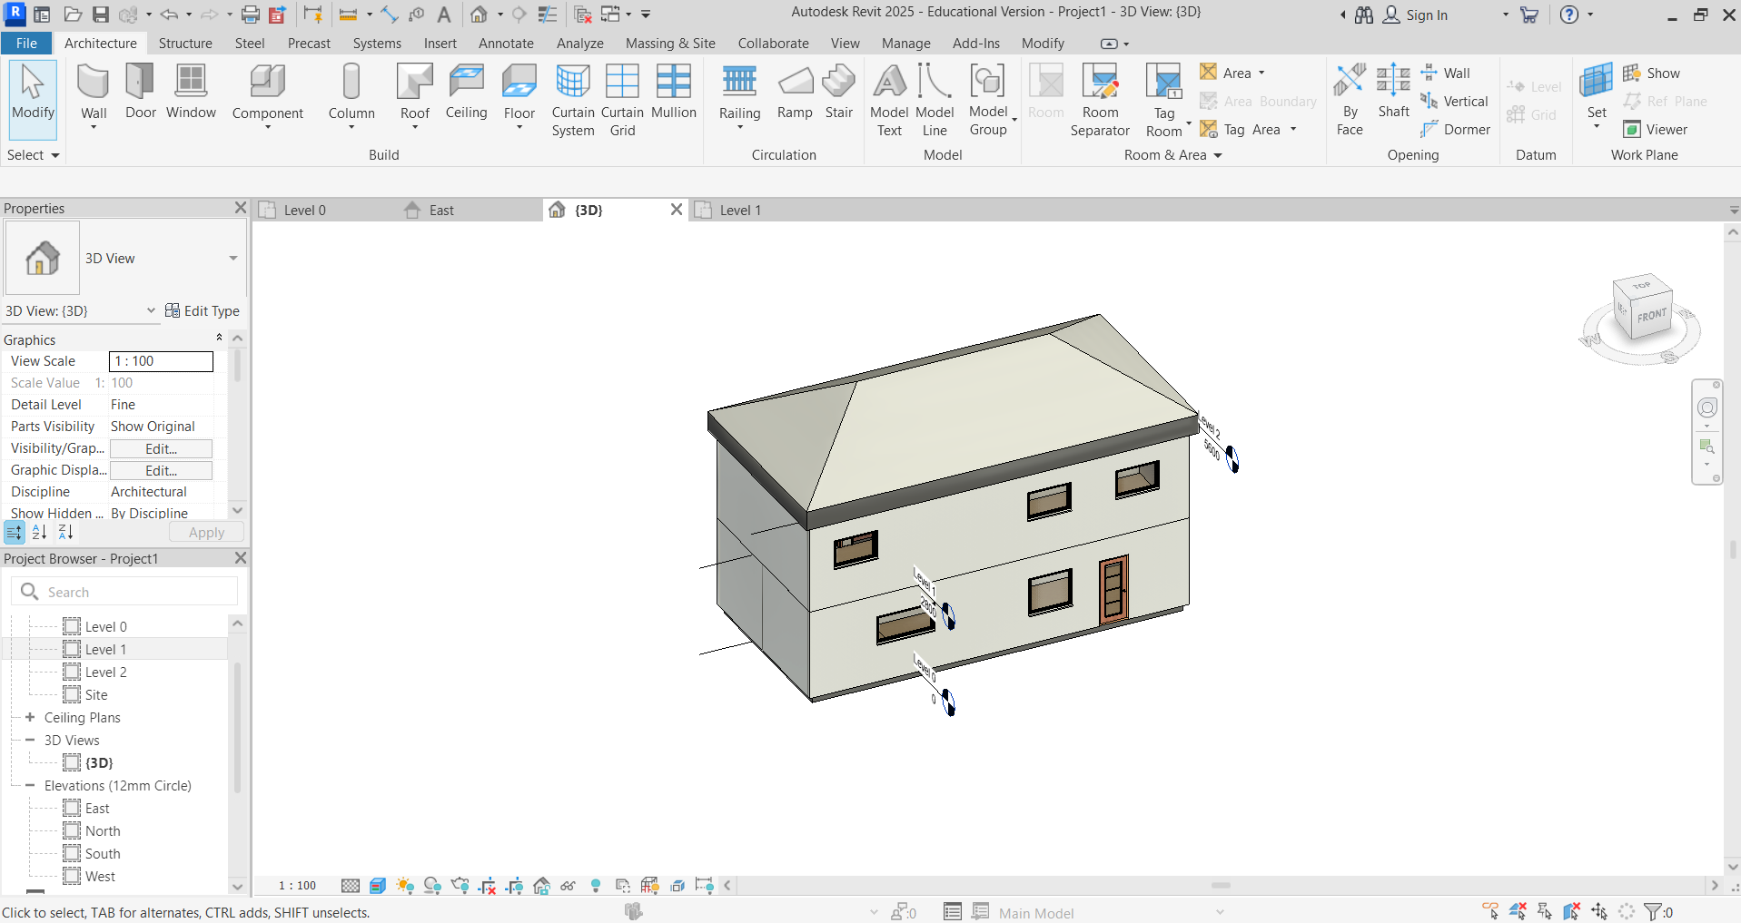
Print the floor plans. In Project Browser right click on Sheets, and then click New Sheet. The New Sheet box will open. Click Load to access more title blocks. As with components click UK – Titleblocks – Title_blocks_A3_Metric. Click Open, and then OK.
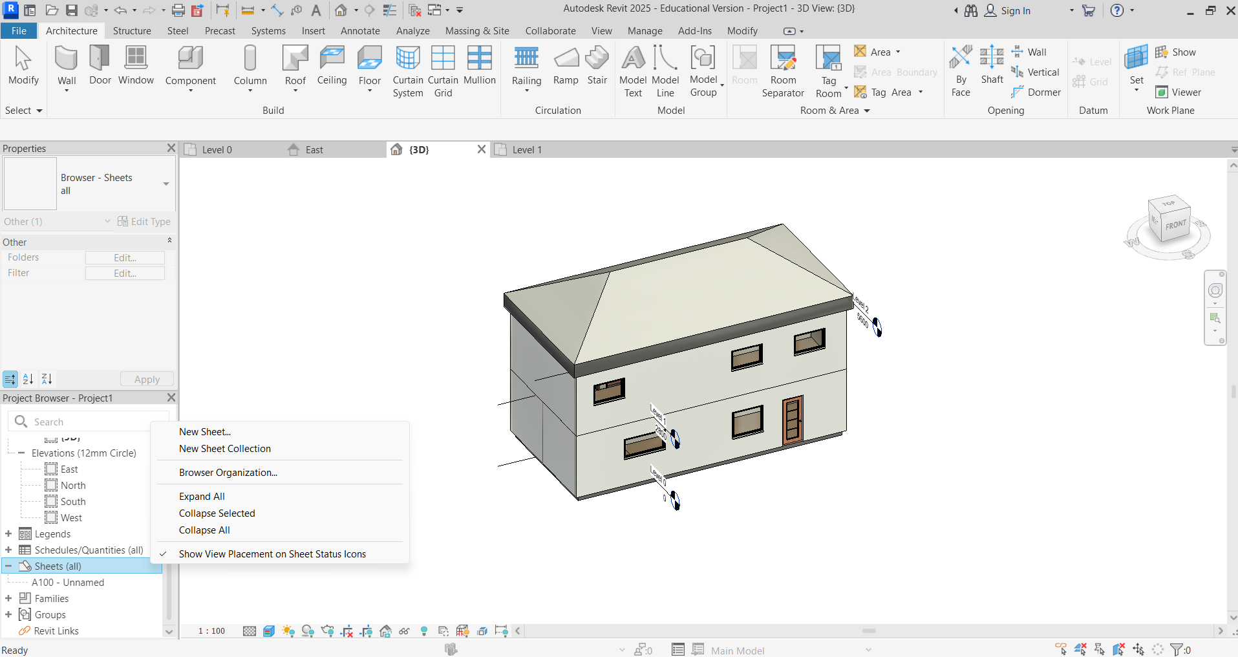

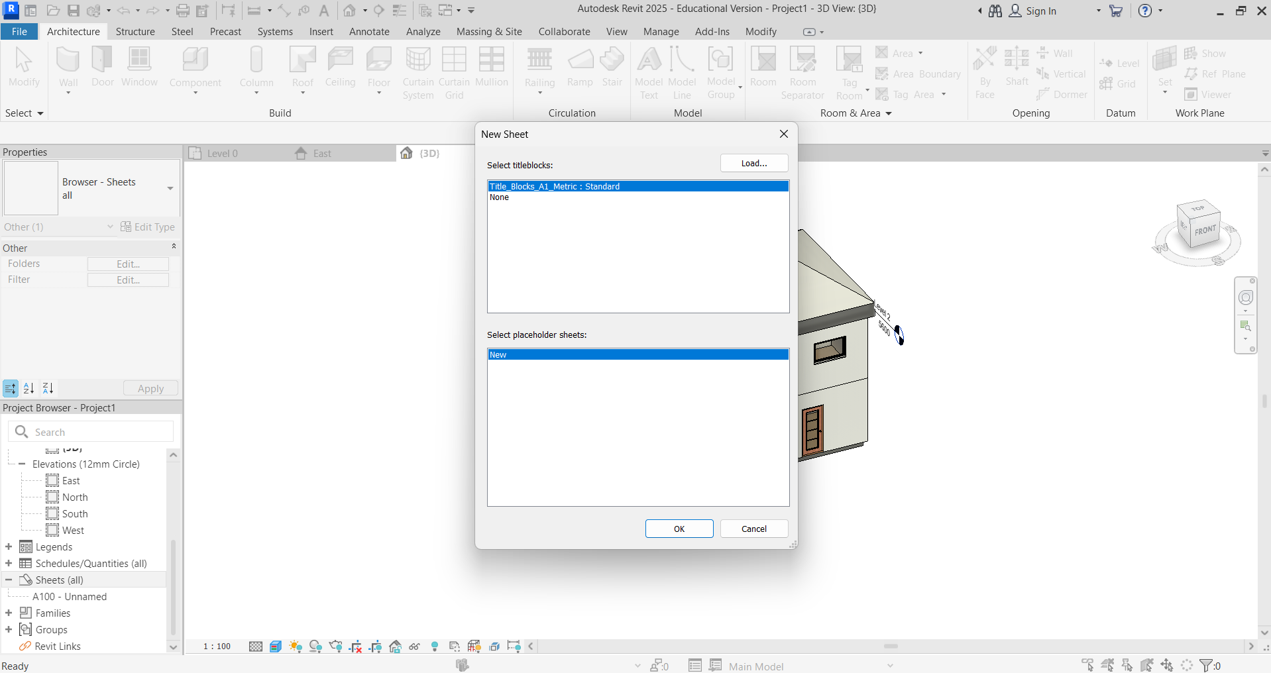

Click to change the drawing sheet information.
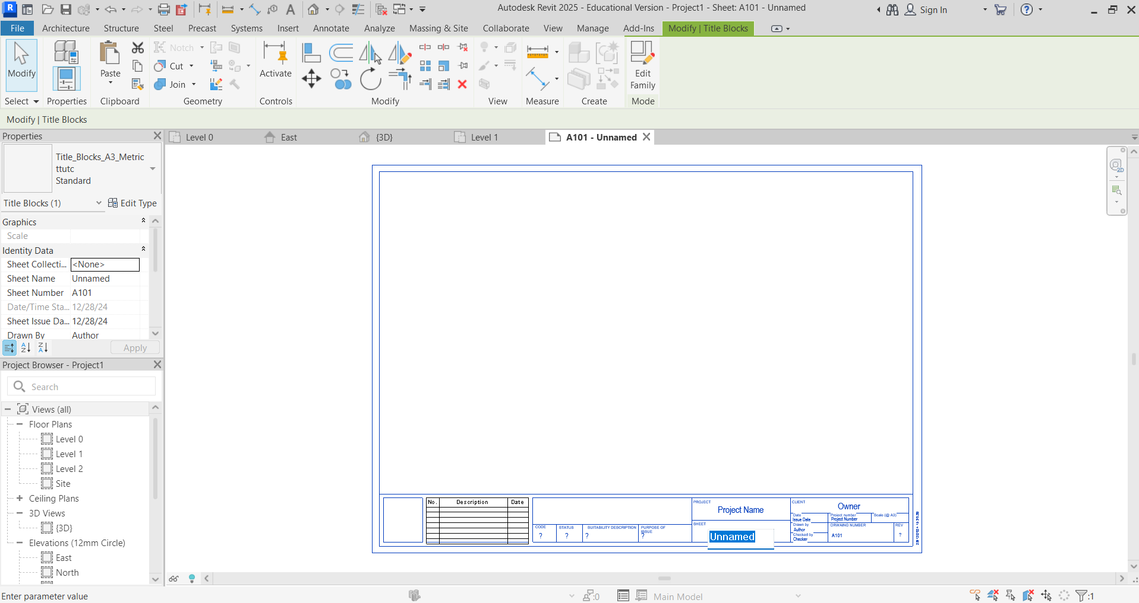

Click on Level 0 in Project Browser, and drag onto the sheet.
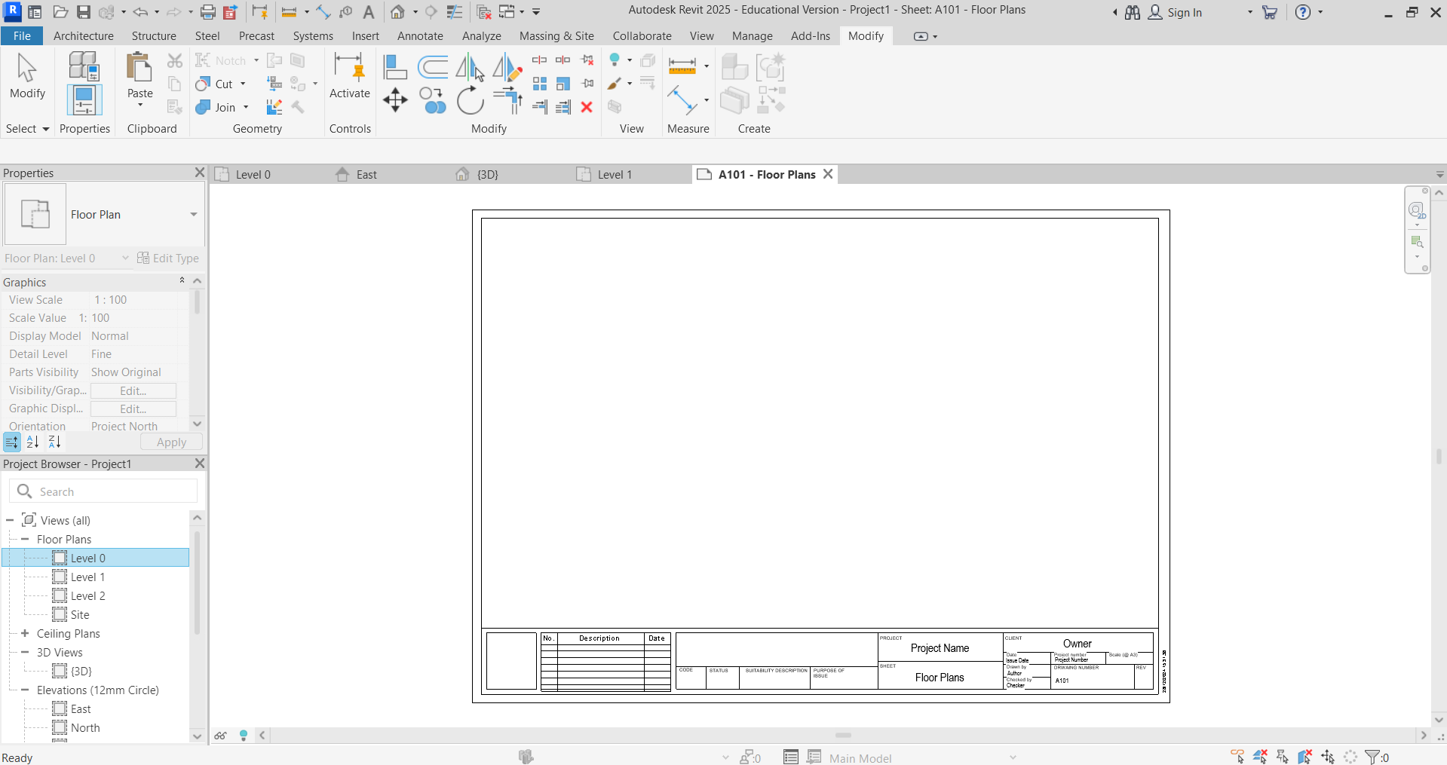
In Properties, at this point, you could change the scale to 1:50. Click Apply. For this example, we are keeping 1:100 scale to fit both plans on one sheet.
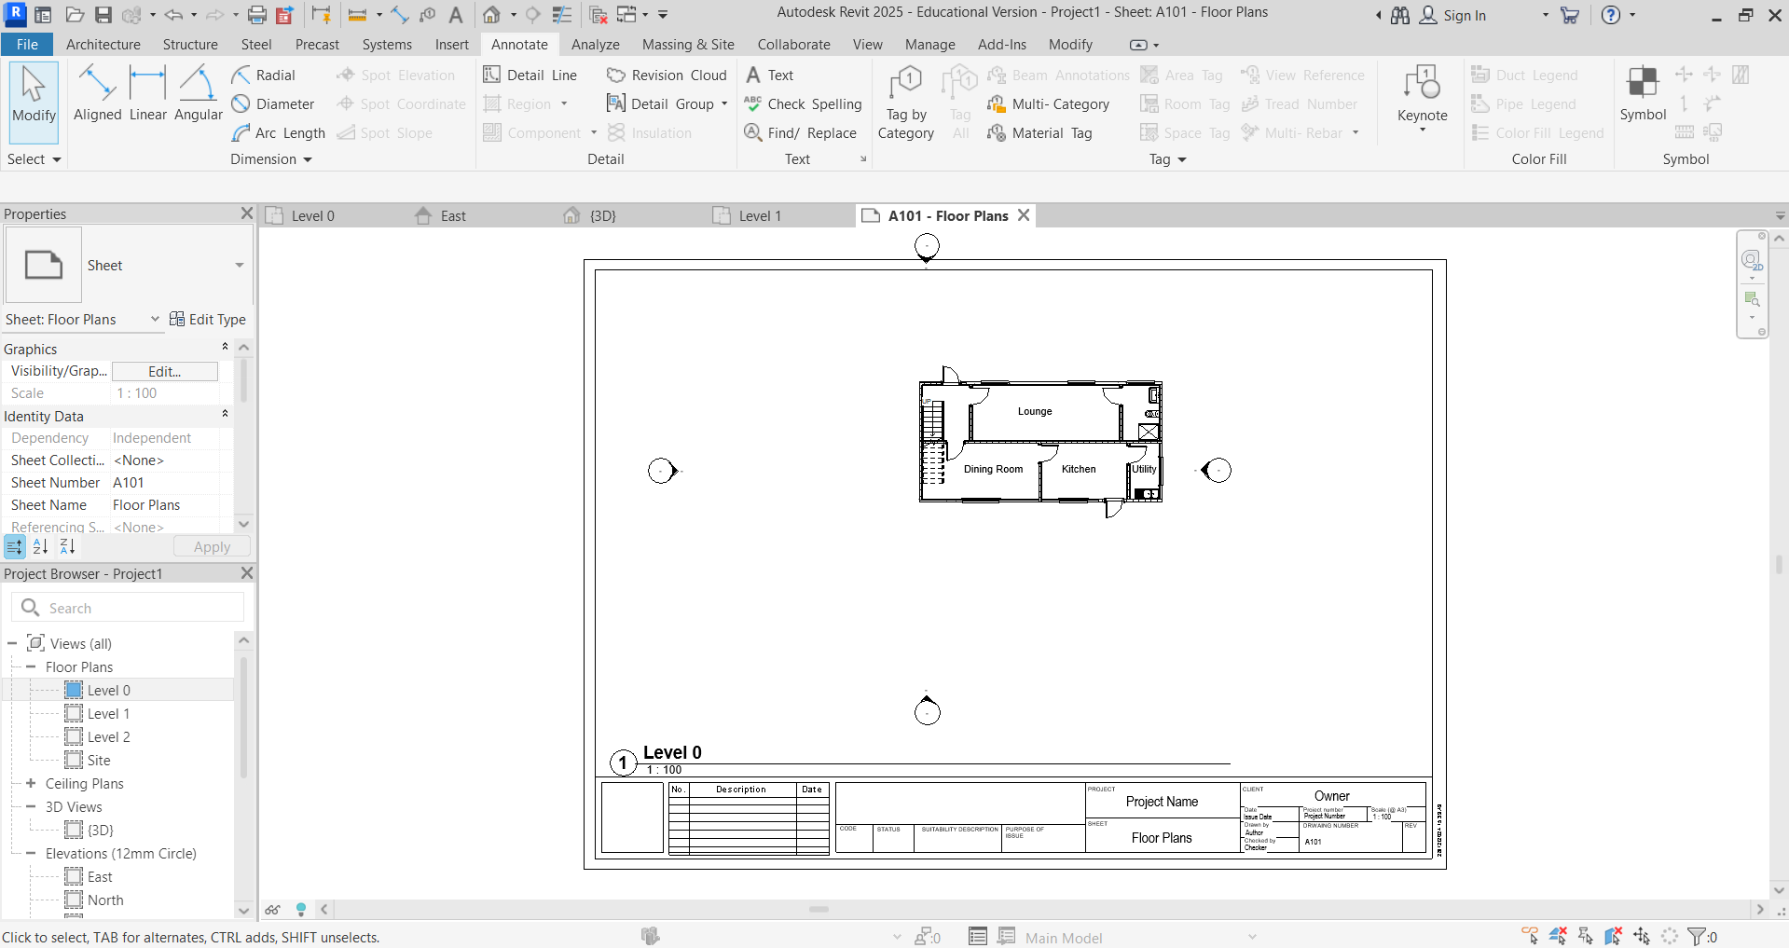
If you would like to clear the Elevation indicators, you can hide them in view.
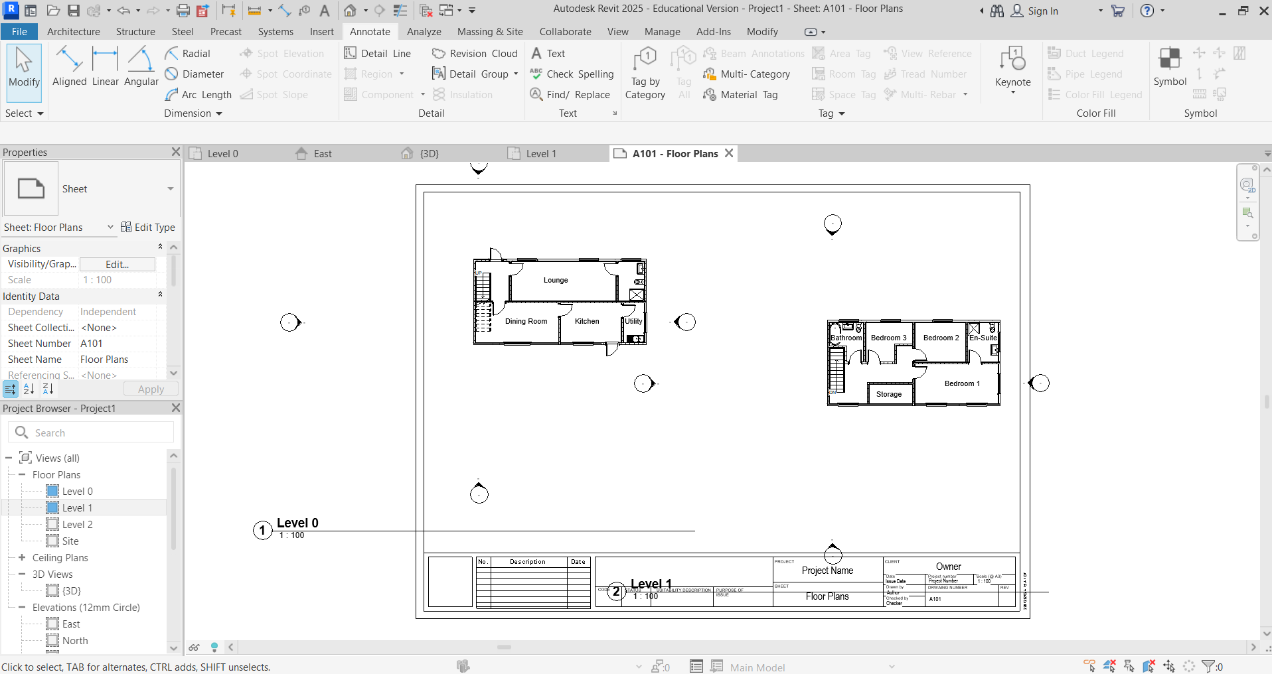

In Project Browser – Floor Plans – Level 0, right click on the indicator. Then, click Hide in View – Elements.
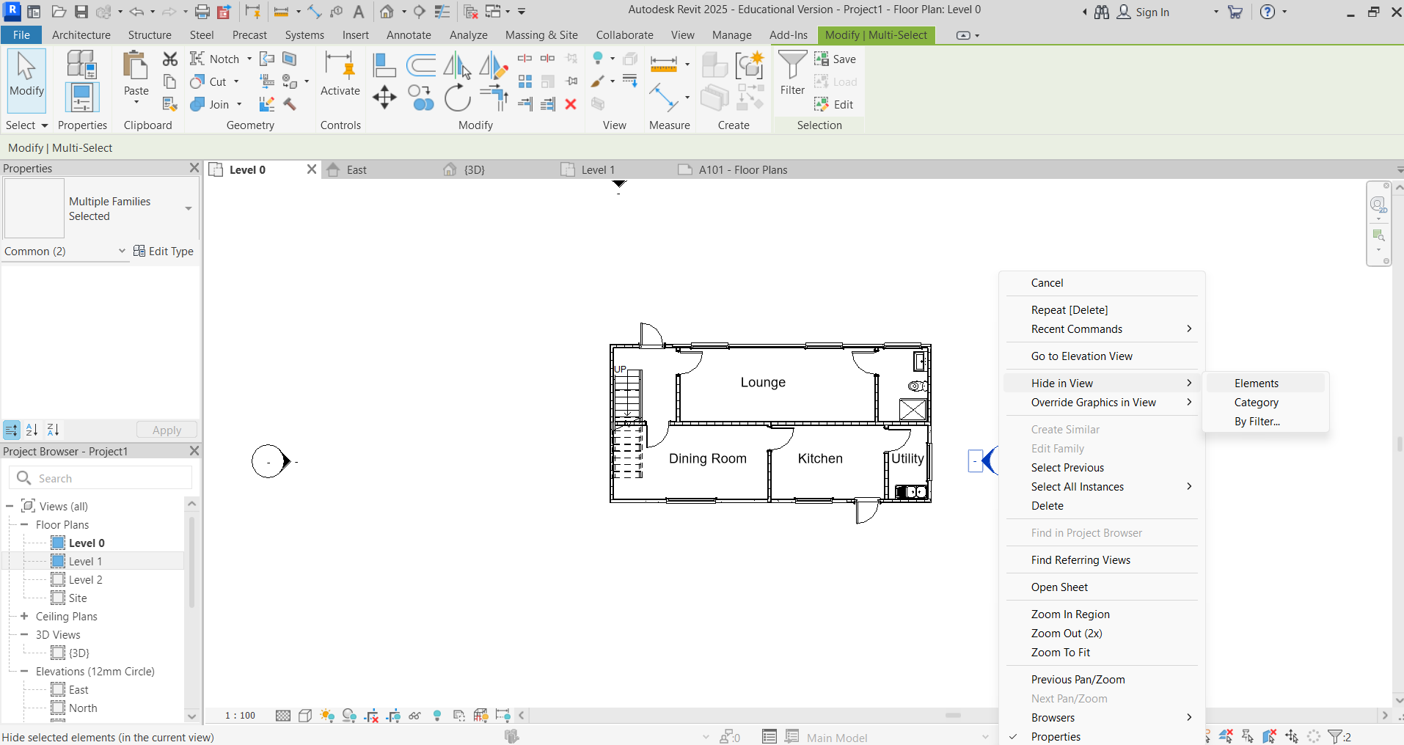
It is possible to do the same process of hiding the viewpoints by category. This removes all of the viewpoints at the same time.
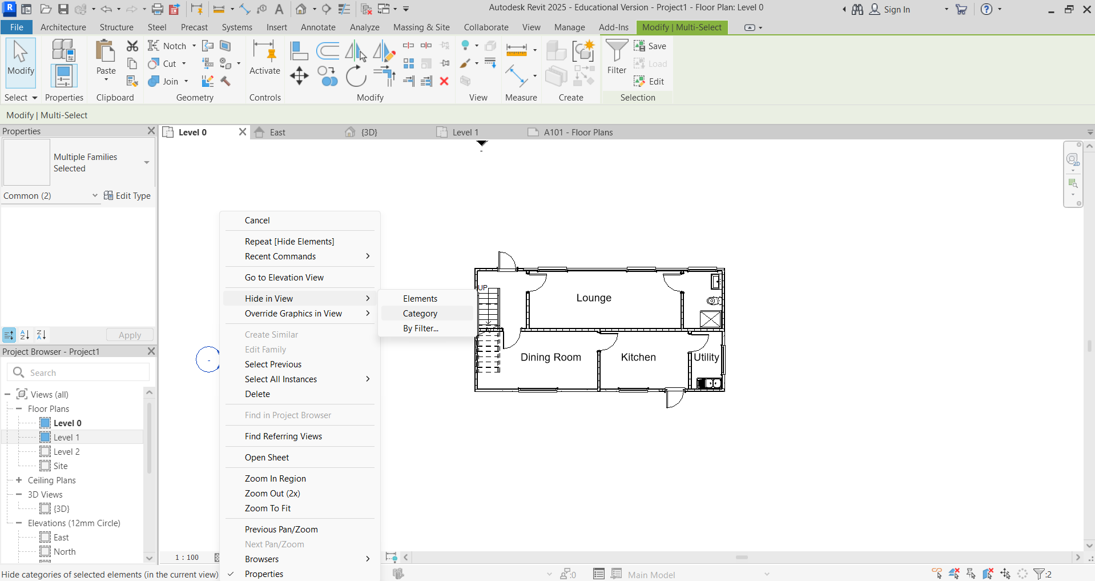
This image shows the floor plans with the tags nearer to the floor plans.
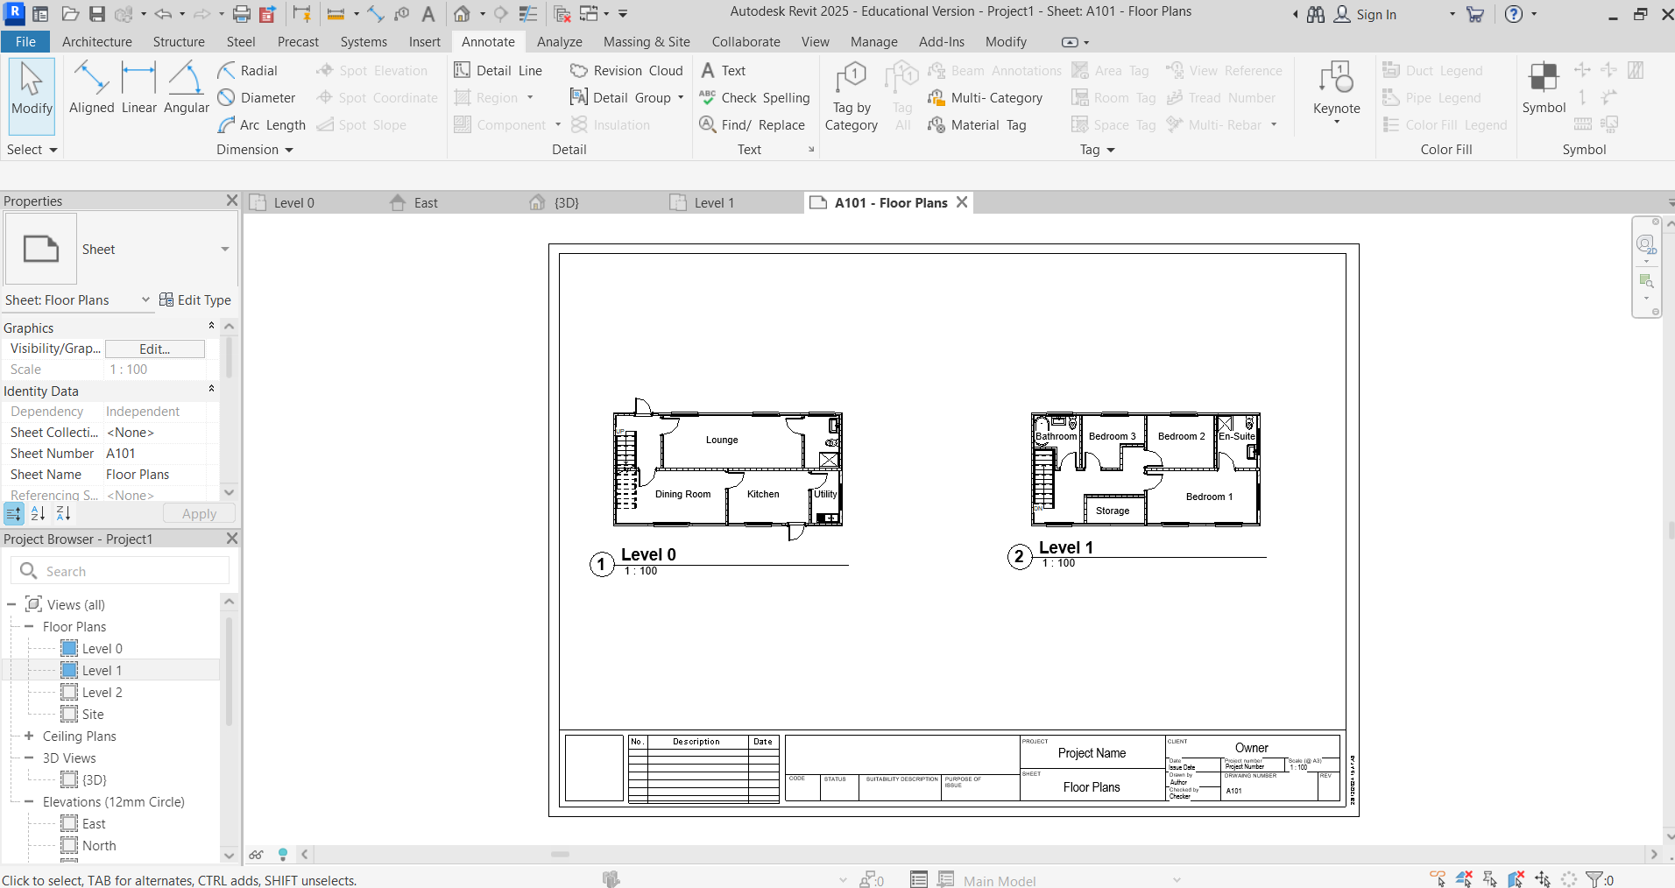
Select Print from the File menu, then Print.
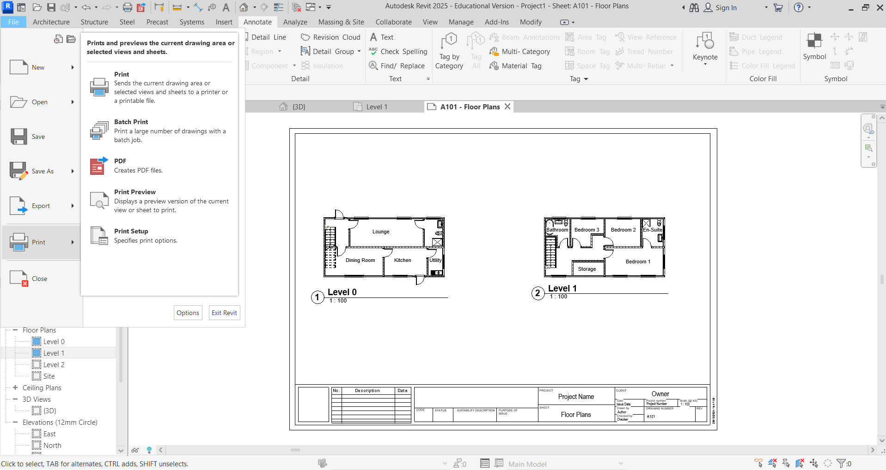
Select your printer in Properties. Choose A3. Click Select View Sheets – Select. Click Sheet: A101 – Floor Plans. Click Select and OK.
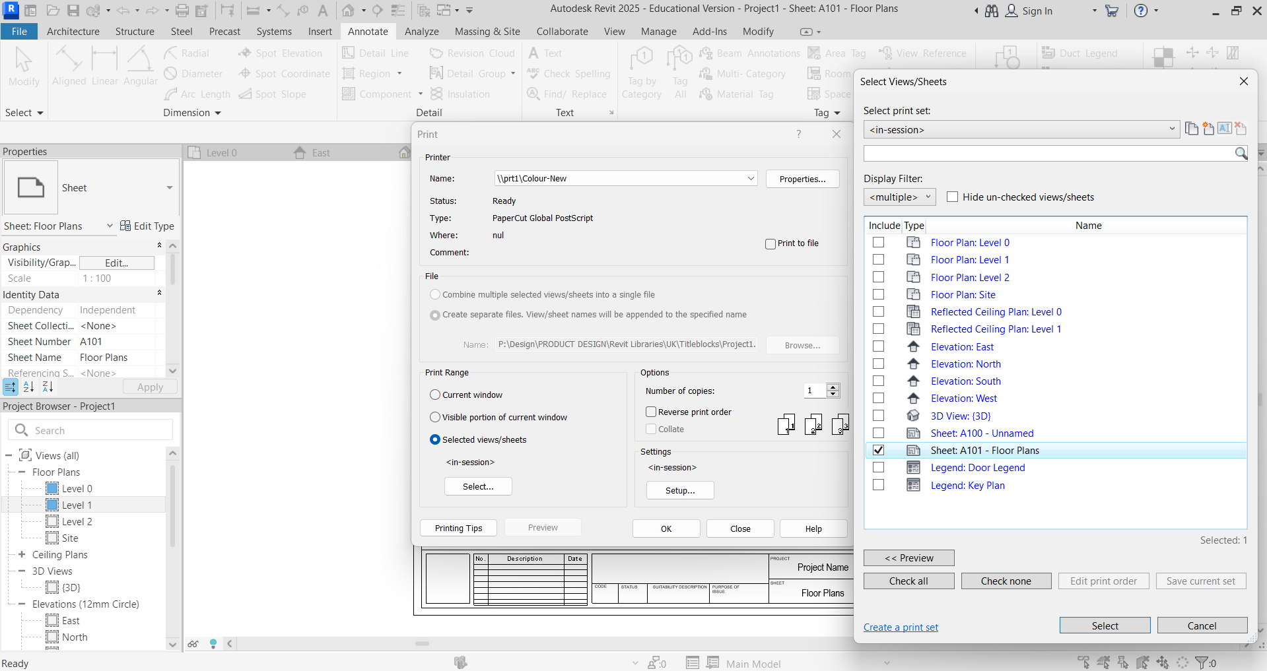
Print 3D Front and Side, and 3D Back and Side. Create another two New Sheets using the same process.
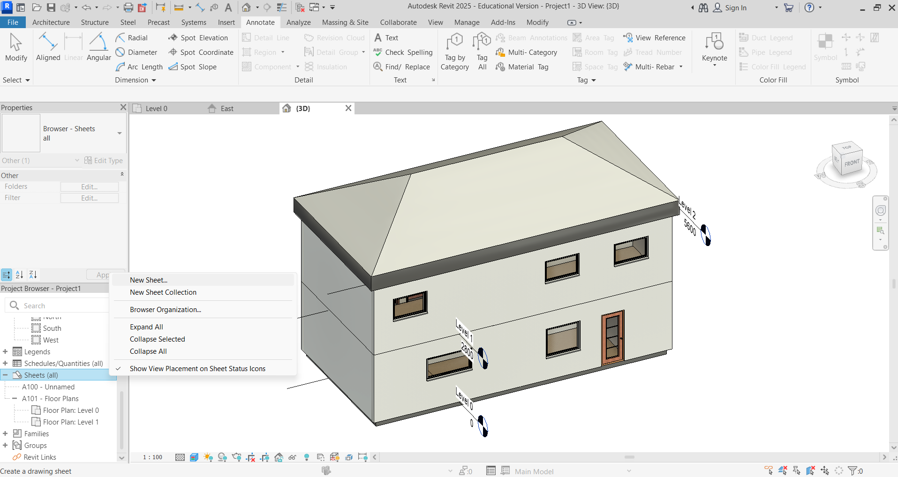
In Project Browser – 3D – 3D Views, hold Shift and the mouse wheel button down to rotate the model to a Front and Side view.
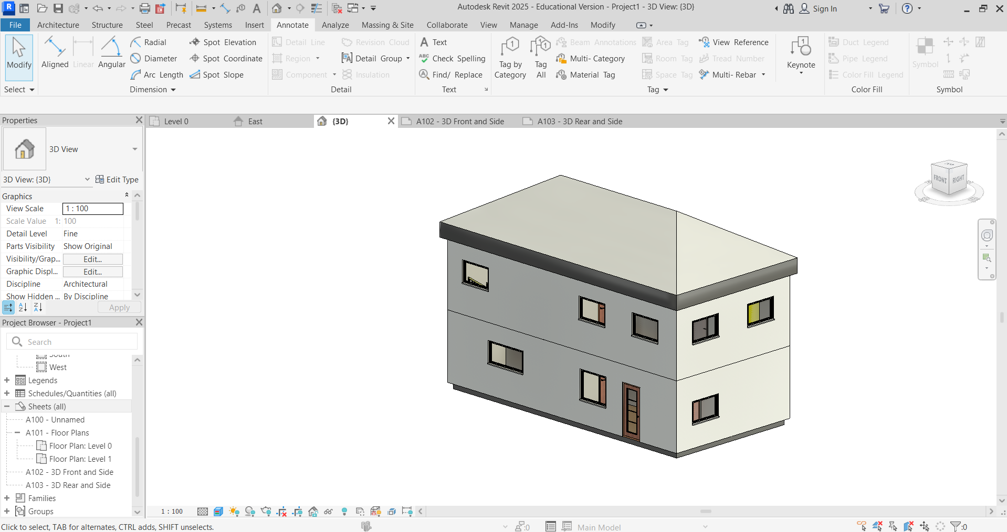
Right click on 3D View, and click Duplicate to duplicate the view.
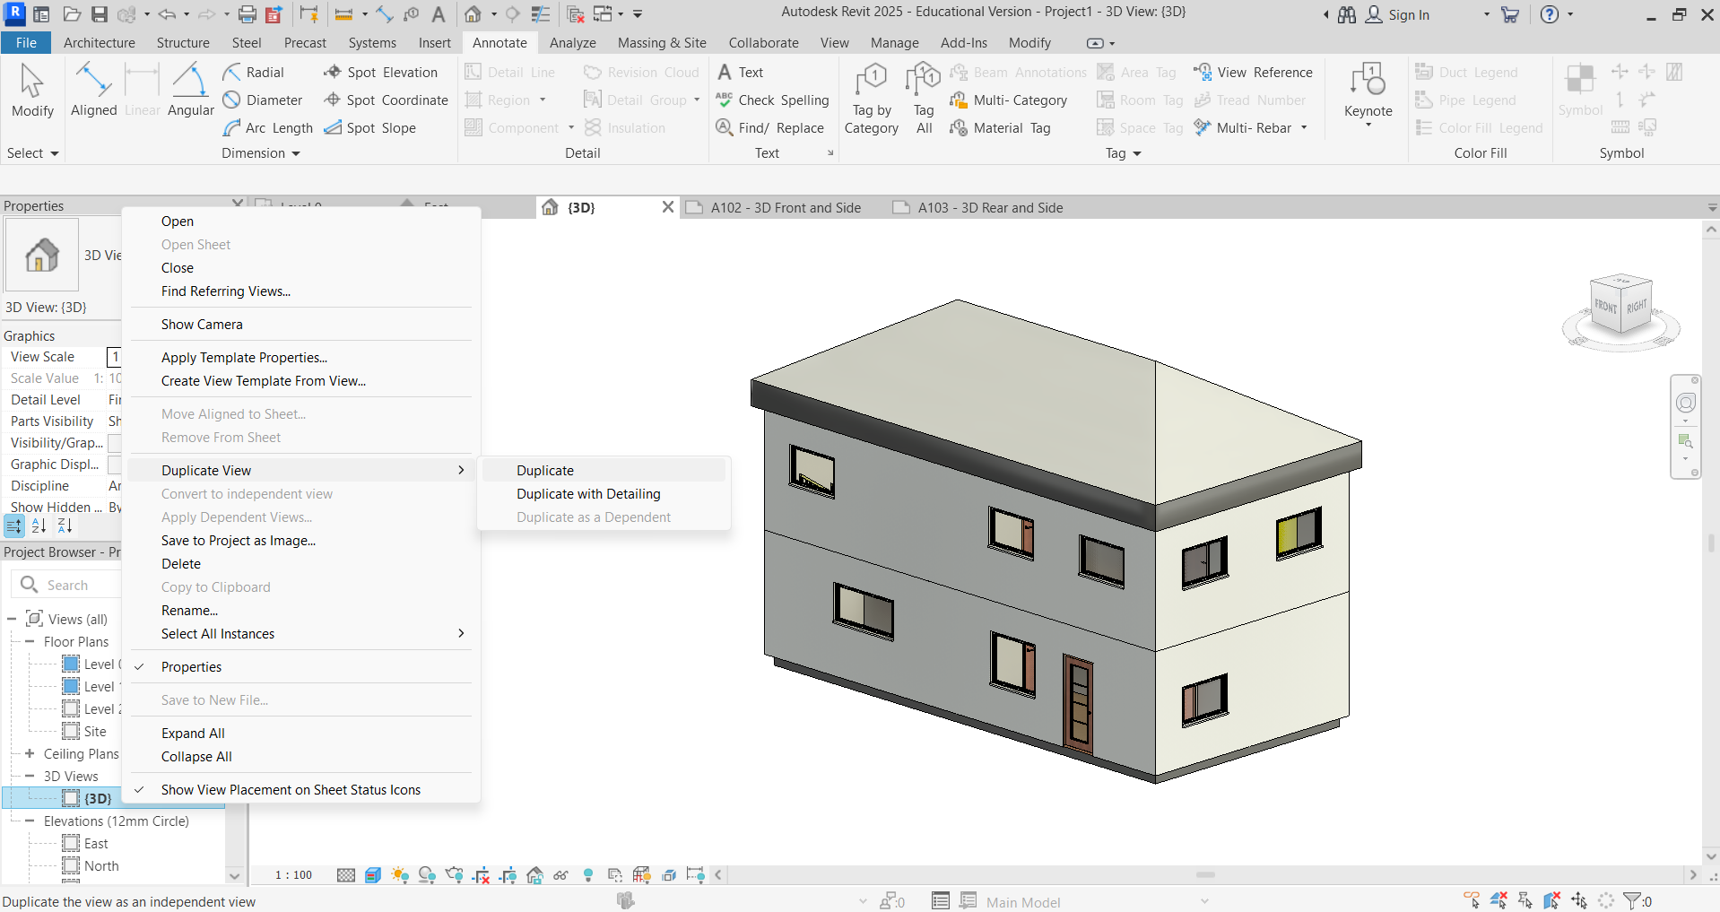
Rename the views by right clicking on them – Front and Side, and Rear and Side.
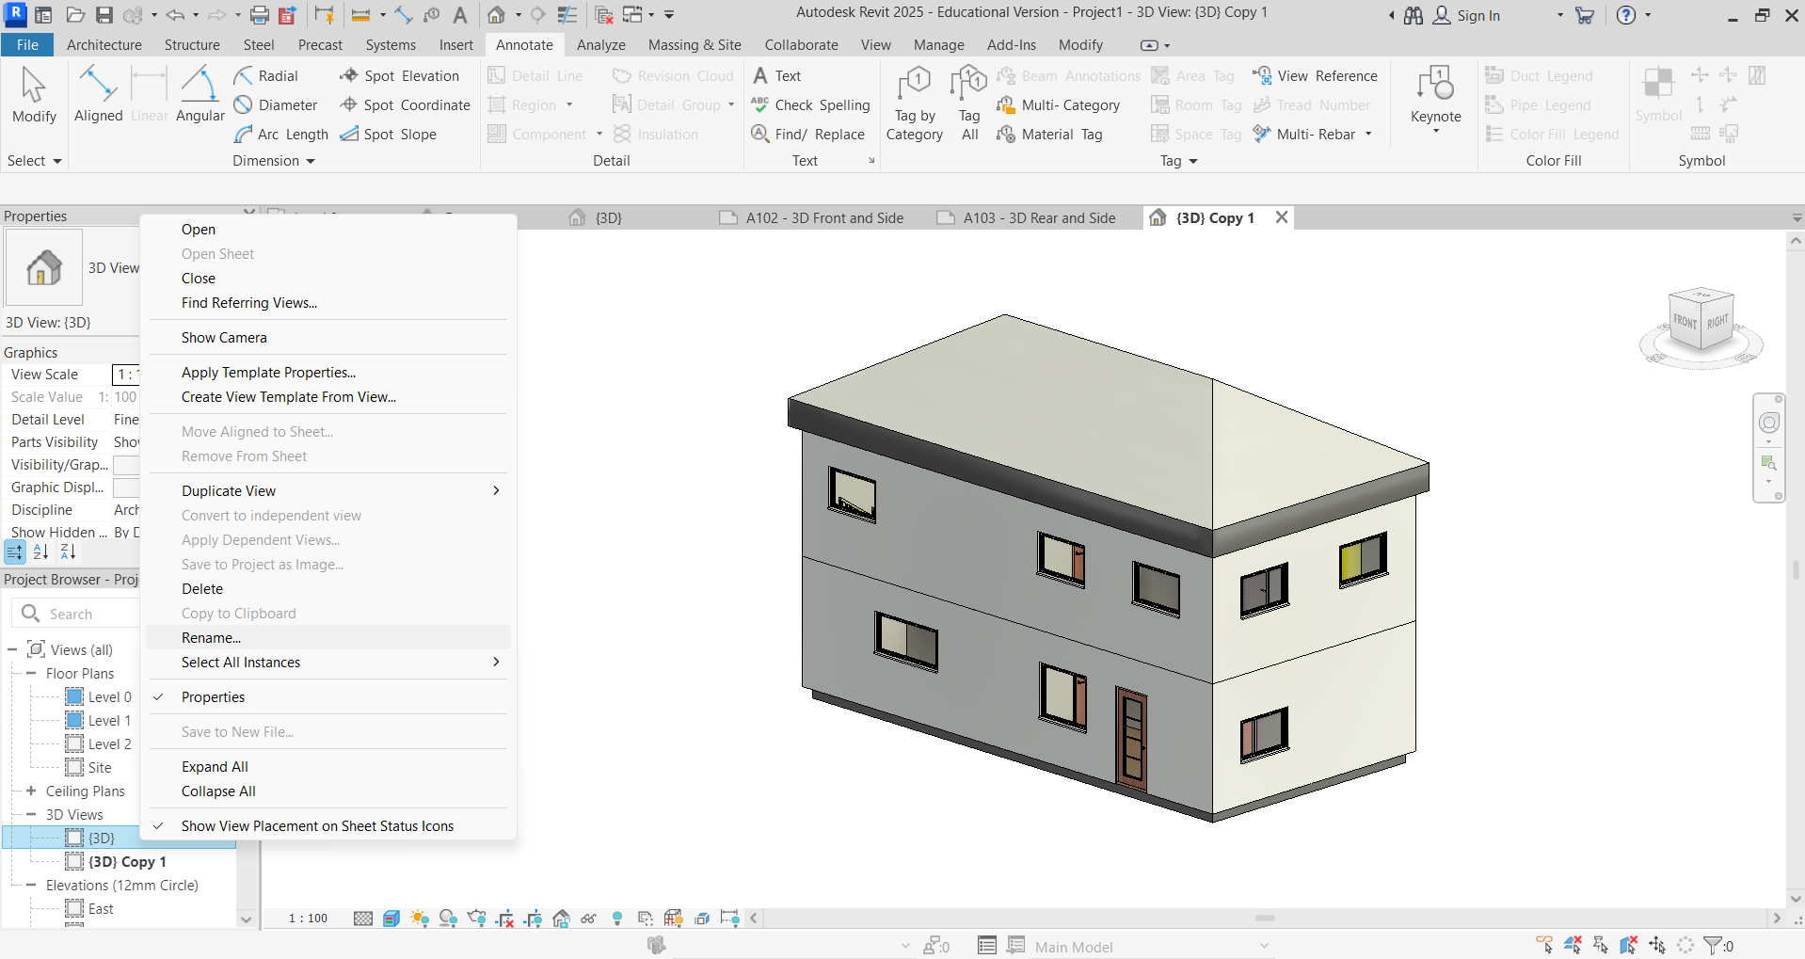
Holding the mouse wheel down, rotate the view to Rear and Side.
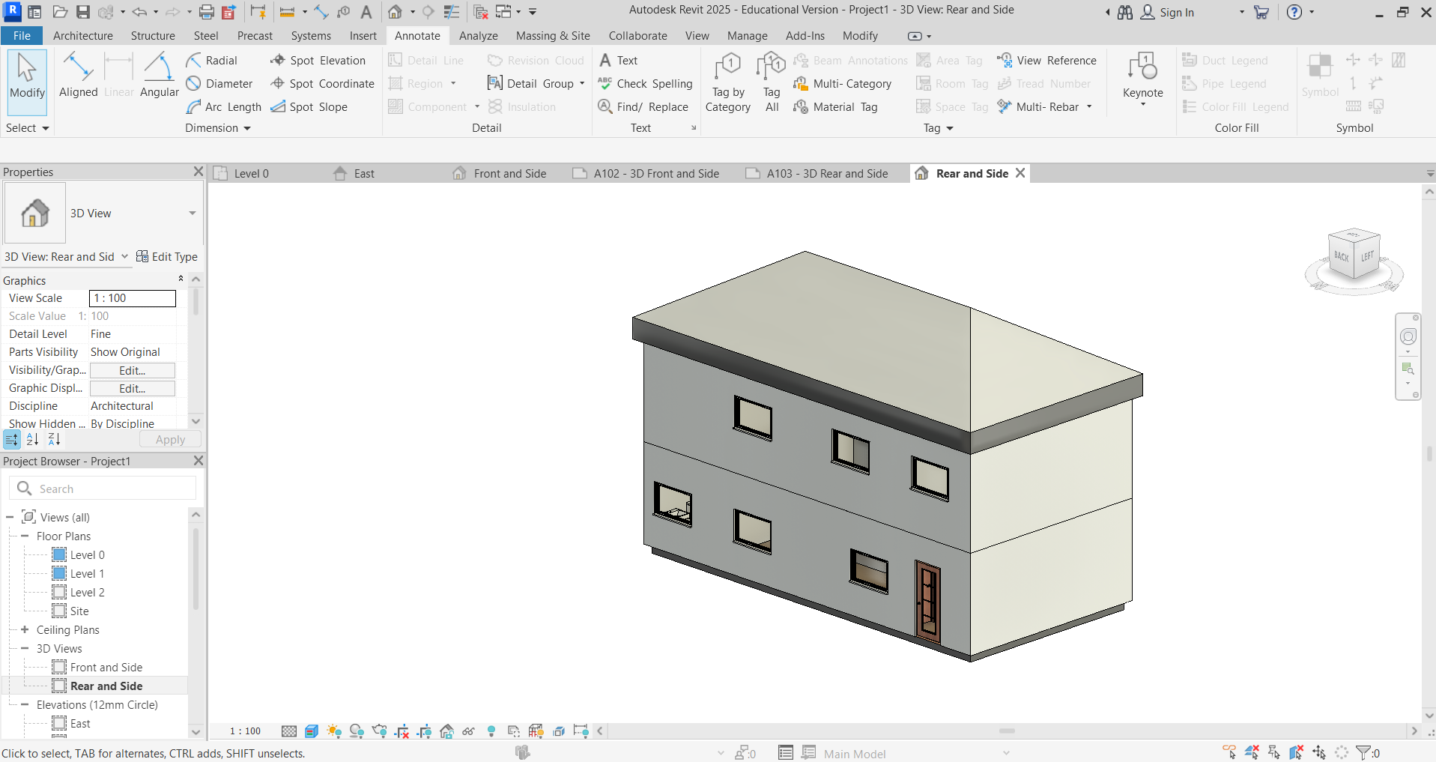
As before, drag and drop the view onto the corresponding sheet. You can change to scale 1:50 to help make the image bigger.
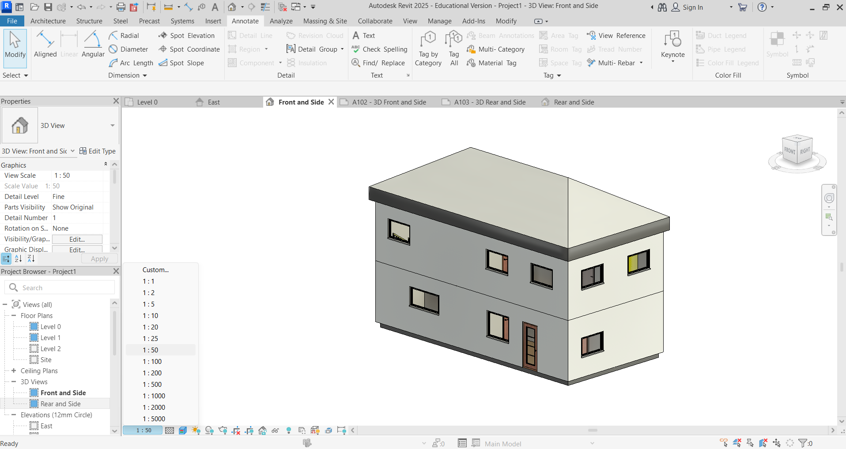
Print in the same way, by selecting the New Sheets A102 and A103.
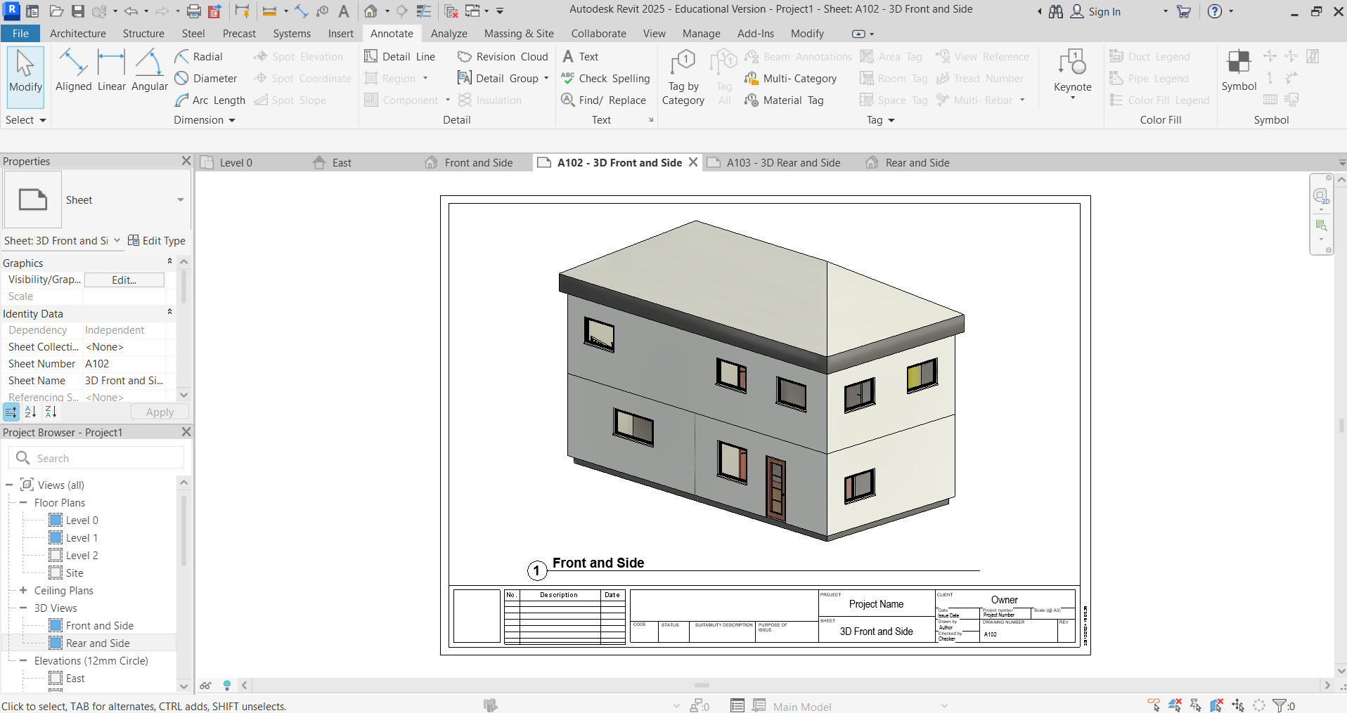
Now, you need to render the model. From the 3D view, rotate to the required view by holding down Shift and the mouse wheel button and move the mouse. Next click the Teapot icon to render at the bottom left of the screen. Make sure the model fills the screen and is shown completely.
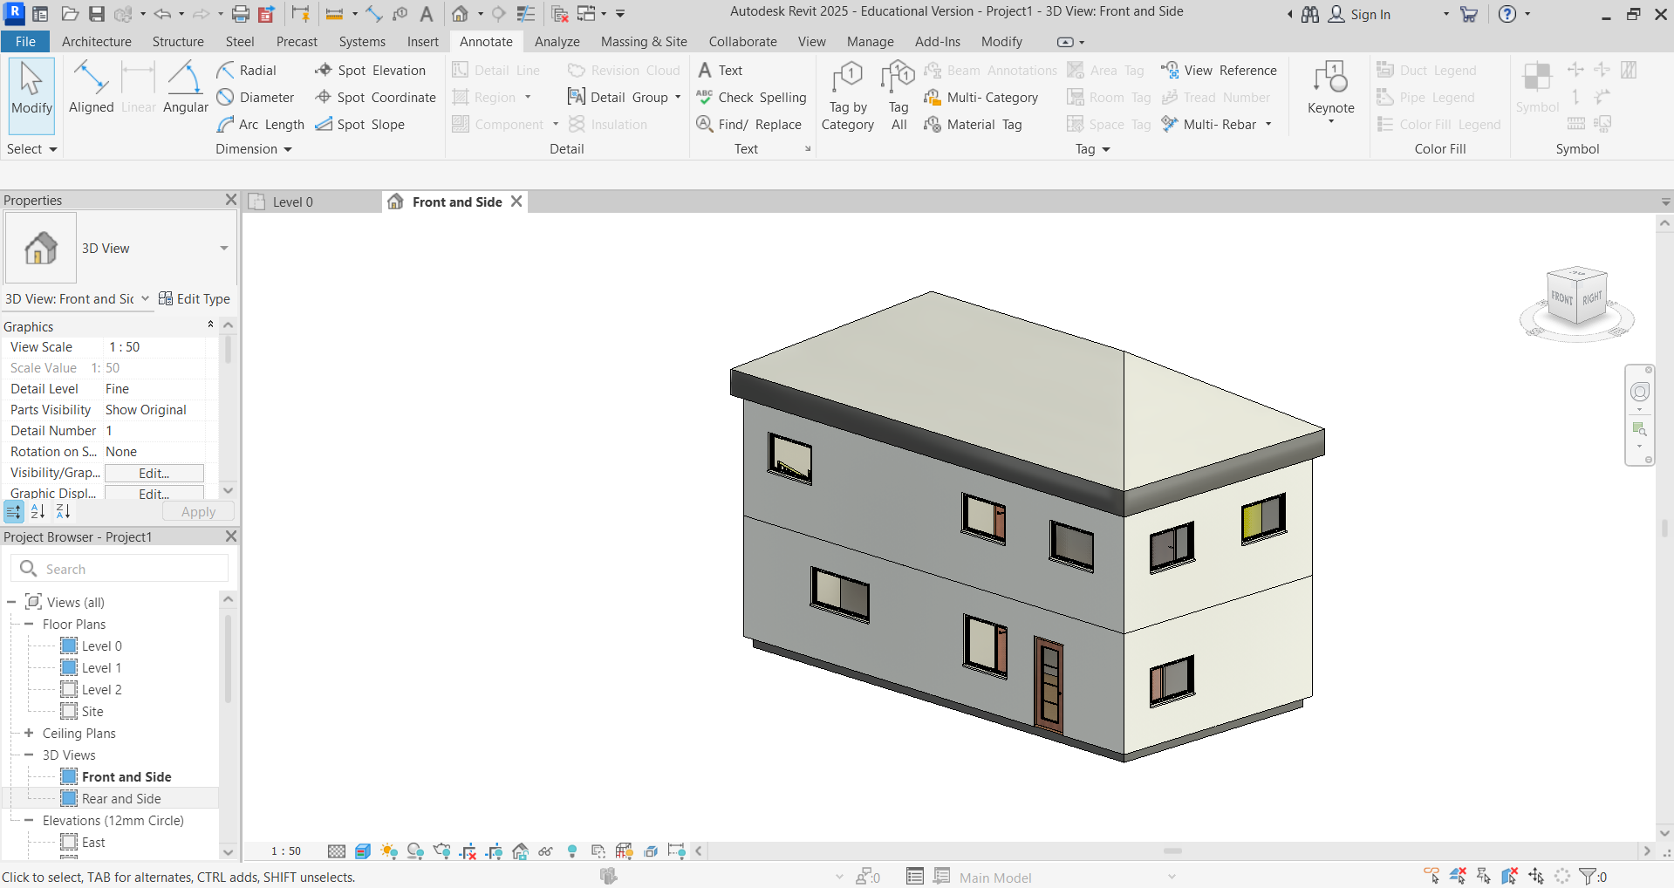

Select the Medium setting and click Render.
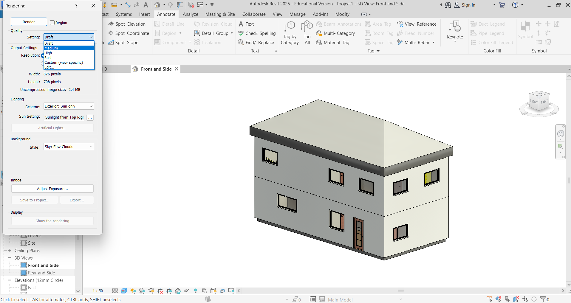
Click to Save to Project and the rendered view will be saved. If you also click Export, the rendering will be saved as a JPEG file and it can be used outside the Autodesk® Revit application.
