**Teacher support: Reflux demonstration**

Follow the method to perform a demonstration to oxidise ethanol to ethanoic acid using a reflux. Discuss the theory of reflux and oxidation during the demonstration, use the teaching guide for support and for suggested discussion points.

There are several options for equipment and setup, depending on equipment availability or personal preference.

A magnetic stirrer bar and magnetic hotplate stirrer/heating mantle can be used to keep the reaction agitated. If they are not available, a heating mantle and anti-bumping granules can be used instead.

A lab jack provides a safe option for heat removal, without the need to touch hot equipment. However, if it isn’t available, a heating mantle can be placed on a heatproof mat on the desk. If this is used, the clamped flask and condenser will need to be lifted to allow cooling.

There is also the option to clamp the condenser, especially if a lab jack is used (as the condenser will not need to be moved once it is clamped). However, this can easily cause the join between the flask and condenser to shift and is not necessary if the round-bottom flask (RBF) is clamped well, and there is a good fit between the flask and the condenser.

**Equipment:**

* 50 cm3 round-bottom flask (or 50 cm3 pear-shaped flask)
* Ice water bath
* Anti-bumping granules (if magnetic stirrer not used)
* Hotplate stirrer/heating mantle/hot water bath
* 20 cm3 graduated cylinder
* Ethanol
* Dropping pipette
* Lab jack
* (Liebig) condenser
* Acidified potassium dichromate (VI)

**Safety factors:**

Ensure risk assessments have been conducted and checked by an appropriate practitioner.

Acidified potassium dichromate is an oxidiser, toxic and a health hazard, HC078c

Ethanol is flammable, an irritant and toxic, HC040A

Ethanoic acid > 1.7 M is an irritant, HC038a

**Method:**

* Place 20 cm3 of acidified potassium dichromate solution in a reaction flask (pear-shaped if using a water bath to heat or round-bottom flask (RBF) if using a heating mantle) and cool it in an ice-water bath for at least five minutes. It is important the acidified potassium dichromate is cold before the addition of ethanol, as the addition of ethanol is an exothermic reaction (it gives off heat), and cooling it helps to reduce the rate of the reaction. It keeps the top temperature low and reduces the risk whilst the flammable ethanol is being added.
* Set up the reflux equipment as shown in the diagram.

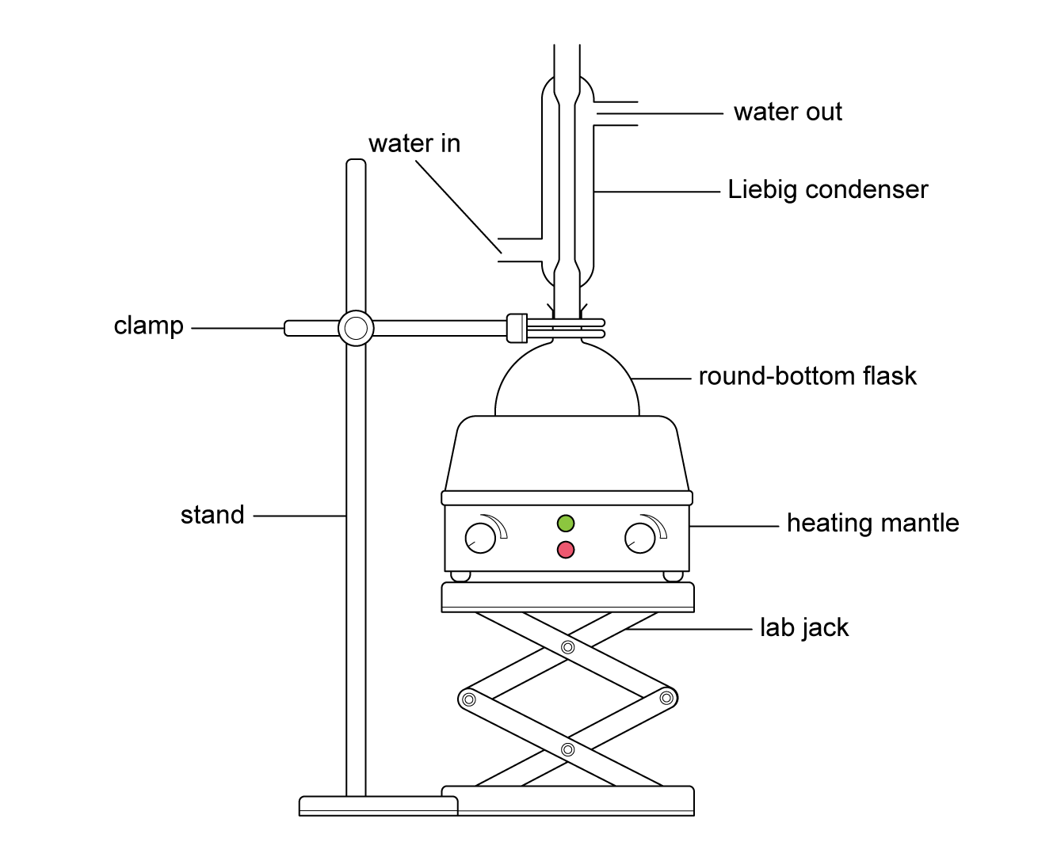

* Place some anti-bumping granules in the reaction flask.
* Add 1 cm3 ethanol dropwise to the reaction flask down the reflux condenser.   
  Ensure the reaction has subsided in between additions.
* Allow the flask to warm to room temperature.
* Heat the reaction flask to boiling temperature and hold it on boil for twenty minutes. Adjust the flow rate on the condenser as necessary to ensure a regular, fast drip rate.
* (OPTIONAL: Distil the product off and run a boiling point analysis to prove the production of ethanoic acid.)