Worksheet
Introduction
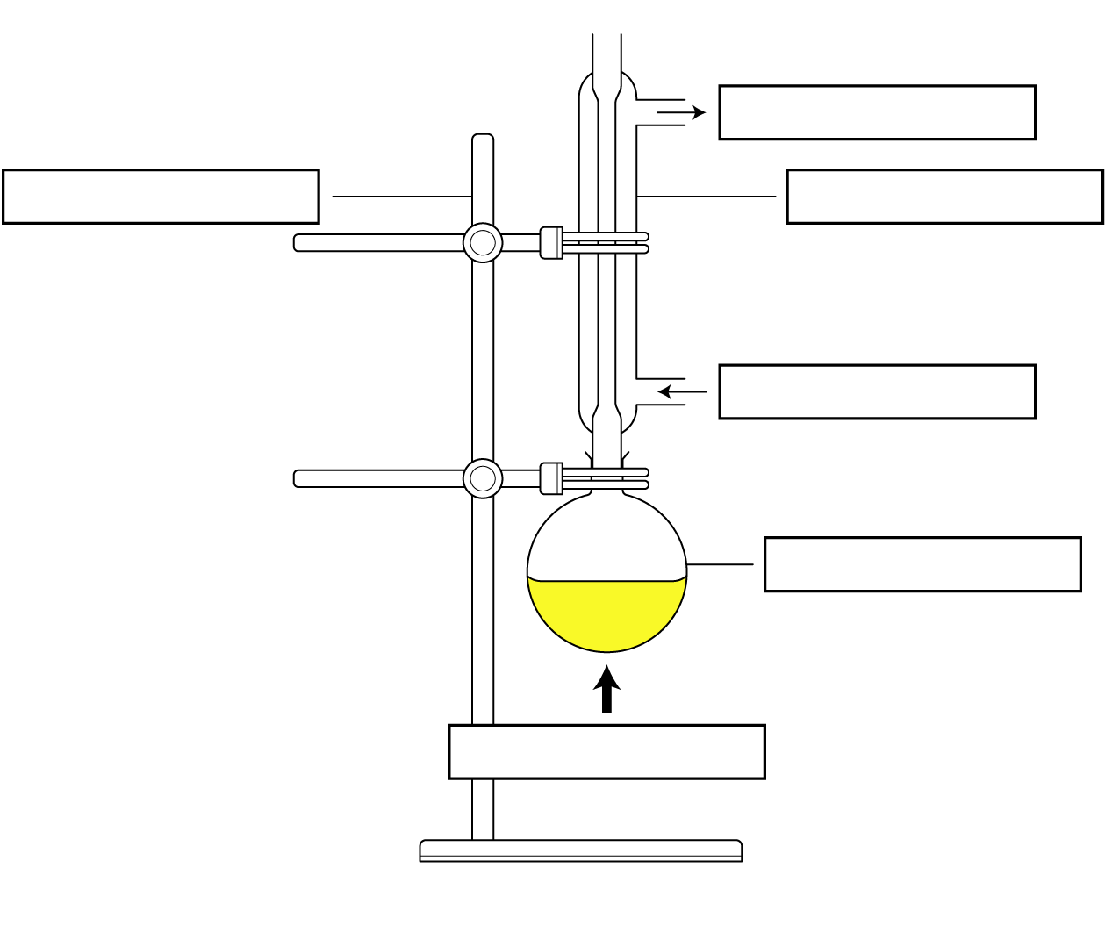
Fill in the labels on the diagram to complete the reflux setup.
Activity 1 – Reflux demonstration
Task 1: Explain briefly how reflux works. Include a description of the state changes.
Task 2:
- What is the definition of oxidation?
- Write the word and symbol equation for the oxidation of ethanol into ethanoic acid and water. (Use [O] to show the oxidising agent.)
- How can we verify that ethanoic acid was made in the reaction?
Activity 2 – Reflux in industry
Watch the video (https://vimeo.com/1060452181) and identify three different uses of reflux in industry.
Do some quick research to explain how the use of reflux is beneficial in each case.

Activity 3 – Troubleshooting reflux
Consider the reported problems/observations listed below relating to a reaction under reflux and suggest solutions or explanations for what is going wrong.

Reported problem/observation from chemists | Suggested solution
“I am not observing any drips falling from the condenser. Boiling is weak/not occurring. The equipment is heated with a stirrer hotplate set to 70°C and the solvent is ethanol.”
“The condenser is getting hot and vapour is escaping from the open (top) end.”
“The condenser is attached to the water and the water is on, but the condenser is not filling correctly, and there are a lot of bubbles and air space in the water jacket.”
“The boiling liquid is bubbling into the condenser and leaking from the joint between the flask and the condenser. I am using a 100 ml flask, and there is around 85 ml of liquid total in the reaction.”

Plenary
- State when a refluxing technique might be used during organic synthesis.
- Give the definition for oxidation in terms of loss or gain of oxygen, hydrogen, and electrons.
- In terms of loss or gain of oxygen and the loss or gain of hydrogen, explain whether the reaction to form hexanoic acid from hexanol is an oxidation or a reduction.
- Write the word equation and the symbol equation for the oxidation of butan-1-ol into a carboxylic acid.
- Describe the purpose and positioning of the condenser in a basic laboratory reflux setup, including the water flow in and out.
- Explain why the drip rate from the condenser back into the flask below is important when performing a reflux.
- Explain the use of anti-bumping granules in a reflux setup.
- Explain why the position of the condenser and the open system are important for high yields and safety within a reflux.

